

**DHI BizAPP Database System User Manual**

Table of Contents

1. System Access 3

2. Login 3

3. Landing Page Upon Successful Login 4

4. Training Information Management 5

4.1. Training Notification 5

4.2. Update Training Provider 6

4.3. Create Shortlisting Panel 7

4.4. Update Interview Panel 8

4.5. Apply For Training 9

4.6. Screen Applications 11

4.7. Shortlisting 12

4.8. Schedule Interview 14

4.9. Interview 15

4.10. Final Results 16

4.11. Post Training Status 17

5. Funding 17

5.1. Announcements 17

5.2. Create Shortlisting Panel 18

5.3. Presentation Penal Member 19

5.4. Submit Application 19

5.5. Screening 20

5.6. Shortlisting 21

5.7. Presentation 23

5.8. Contract Signing Schedule 25

6. First Time Login By Entrepreneur 28

7. Update Business Information 28

8. Submit Fund Release Request 29

9. Review Fund Release Application 31

10. Fund Release Application Review by Associate Director 32

11. Approve Fund Request by Accounts Head 32

12. Disbursement Order 33

13. Repayment Update 34

14. Repayment Review 35

15. Site Visit 36

# System Access

To Access the system, enter the URL <https://bizap.dhi.bt>. Following landing page is provided. The landing page is public page that provides information on Training Programs Notification, Funding Program Notifications and the Results of Training and Funding Results.

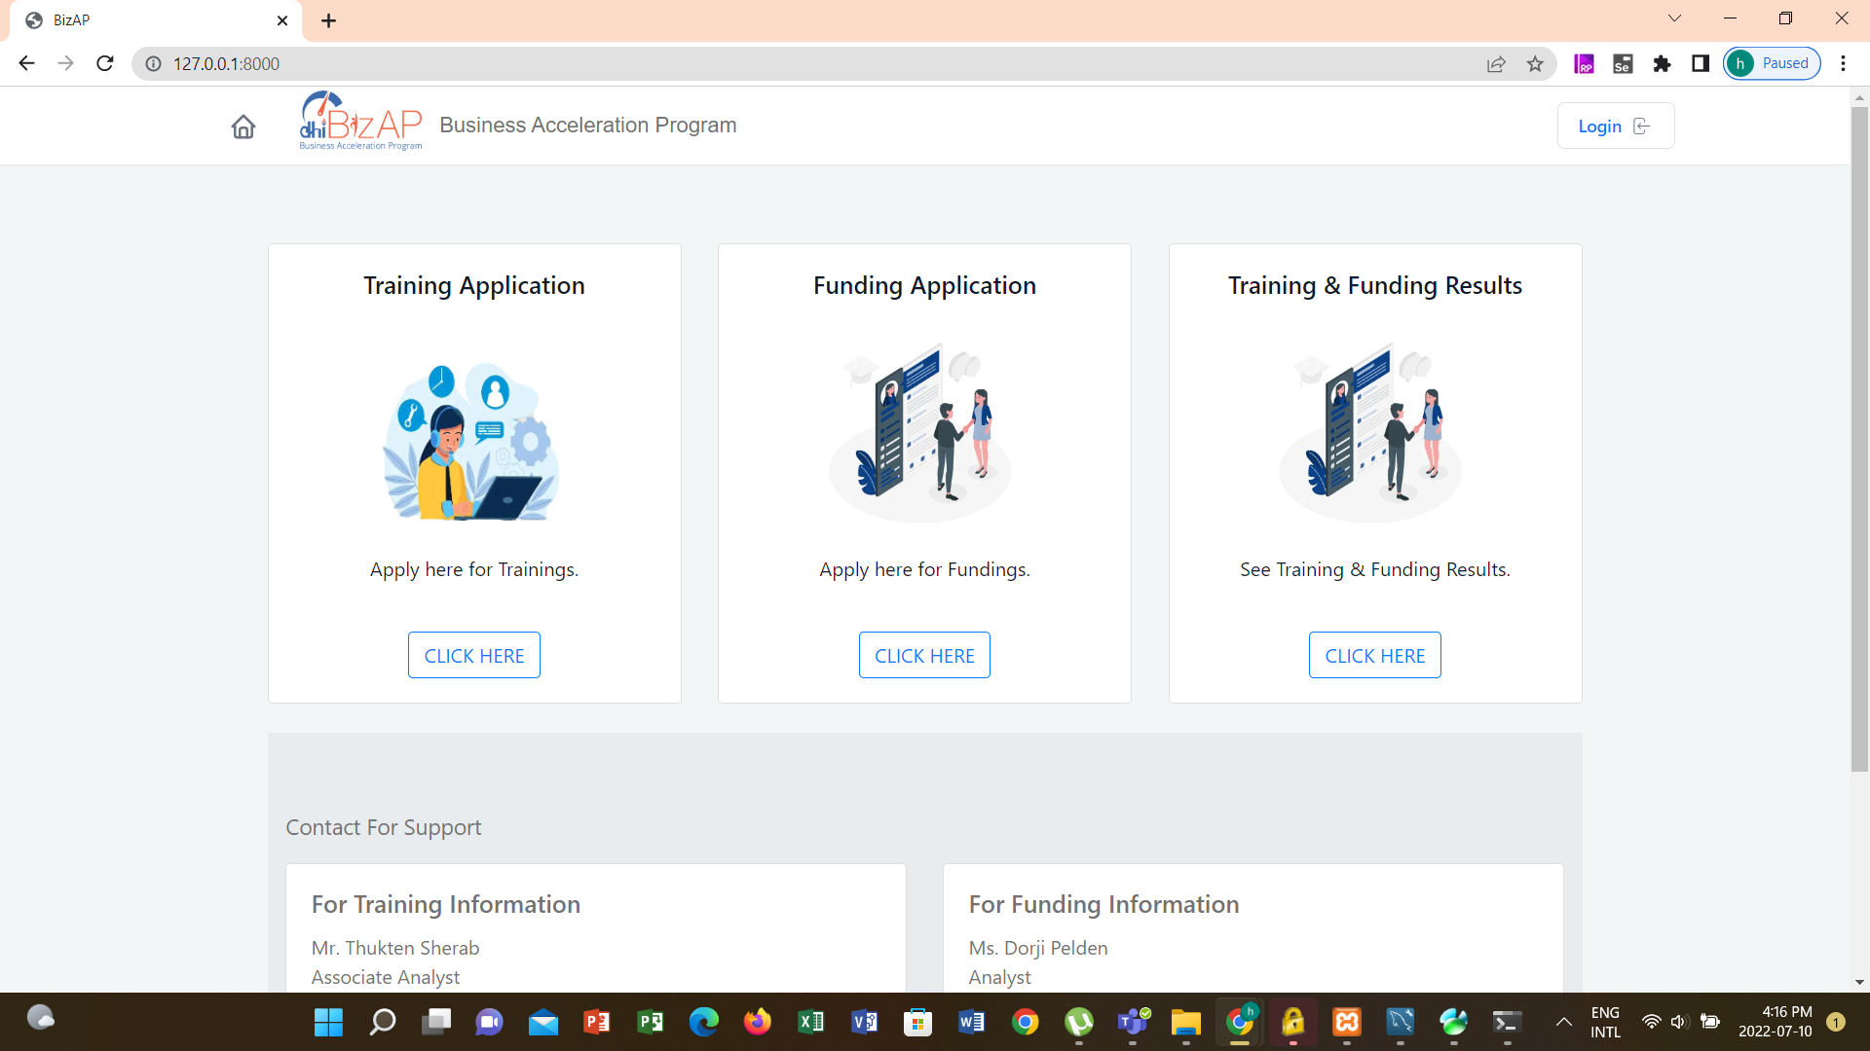

Applicants can navigate to relevant section to submit applications or navigate to access the results of shortlisting / selection for training or funding programme.

# Login

DHI user and entrepreneurs who are selected for funding can login to view relevant information and also update information in the system.

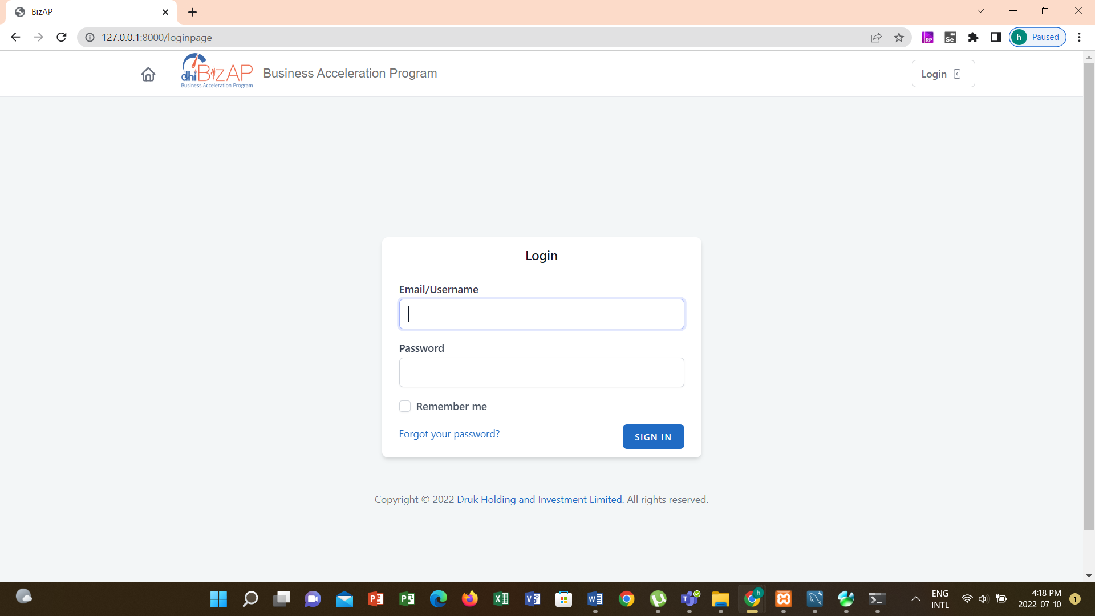

Users are created as follows:

1. DHI users will be created by the system administrator
2. Entrepreneur user will be created by the system when contract signing is complete

# Landing Page Upon Successful Login

Upon successful login landing page is provided based on the role in the system. Users responsible for managing information in the system are provided with the following landing page.

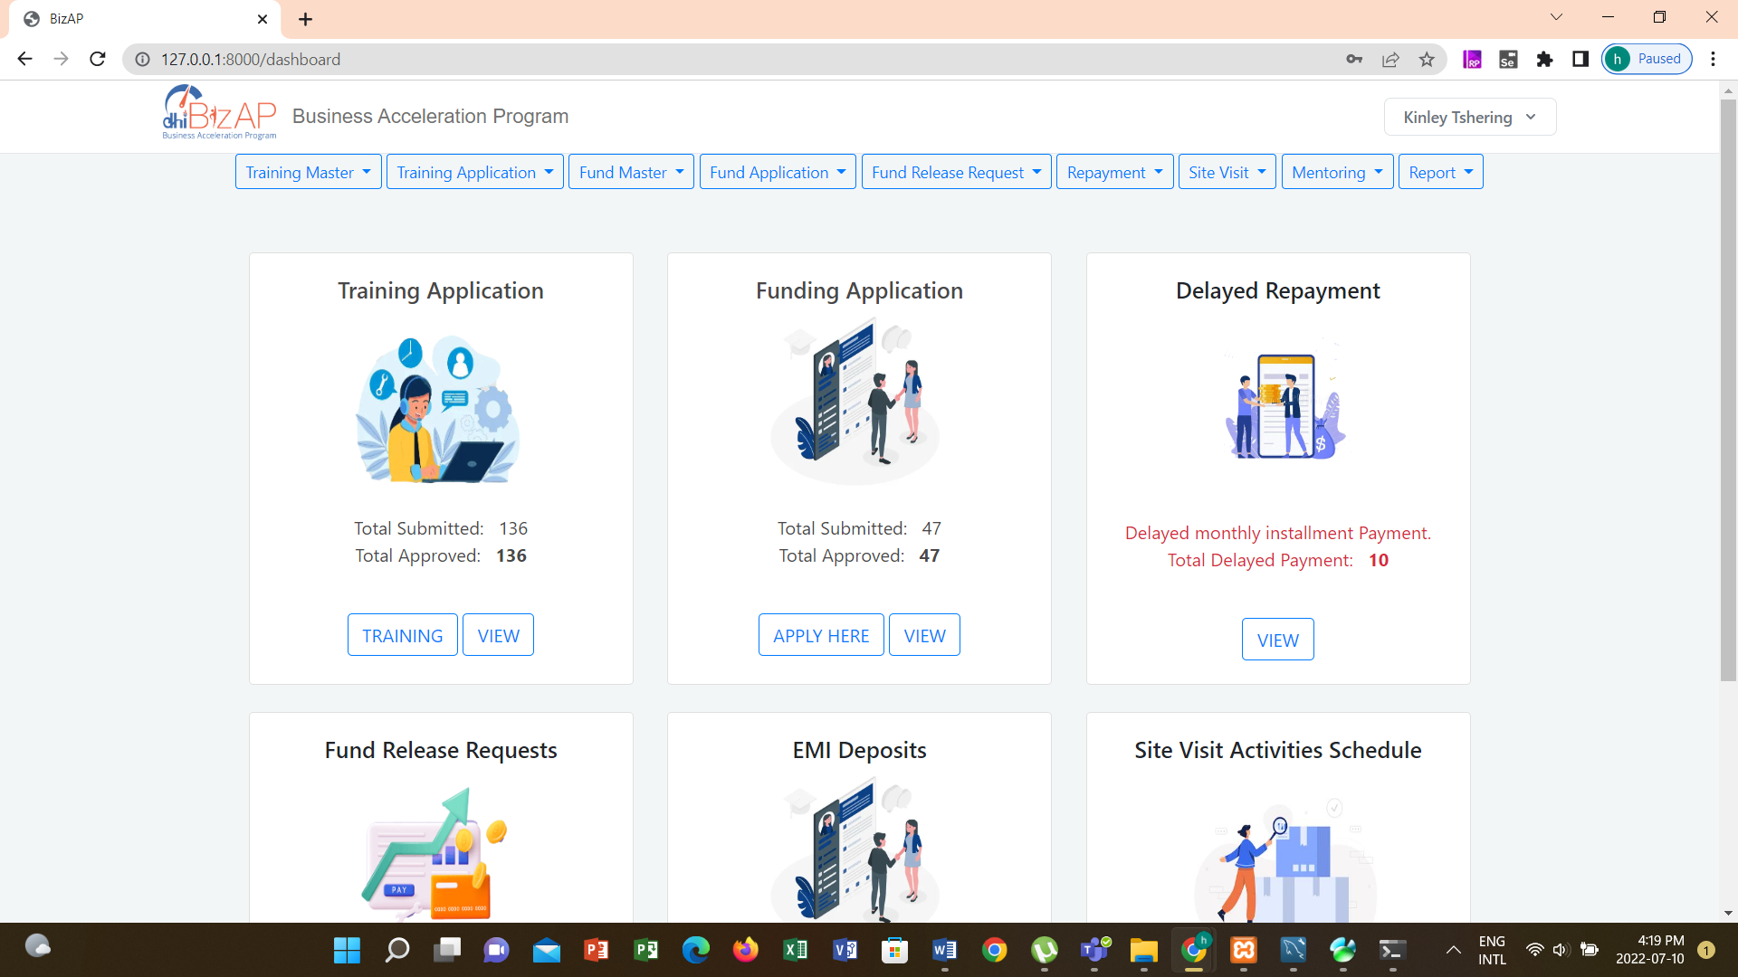

DHI users who have approving authority of fund release applications are provided with the following landing page. The landing page provides the list of pending applications that requires approval from the logged user.

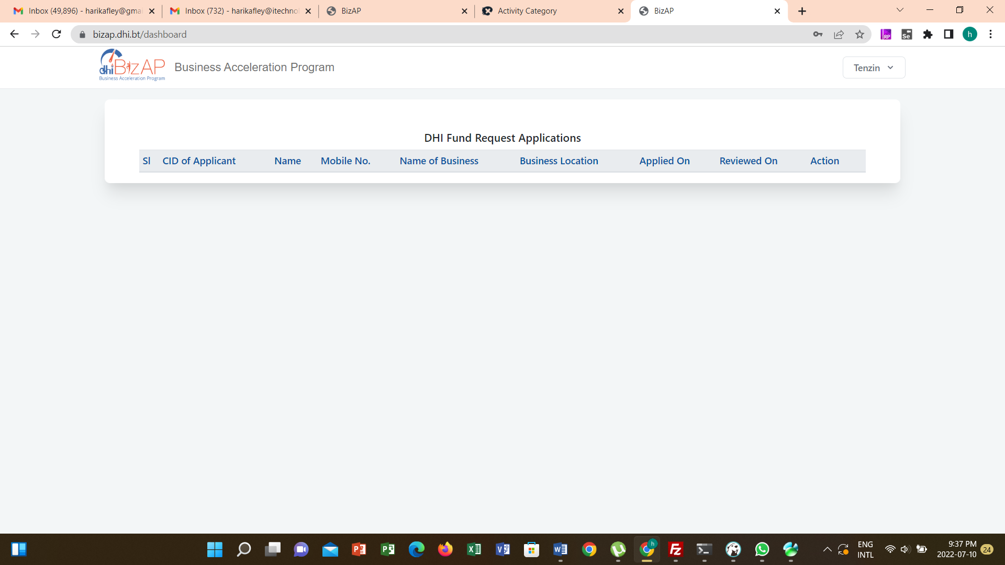

Entrepreneurs are provided with the following landing page.

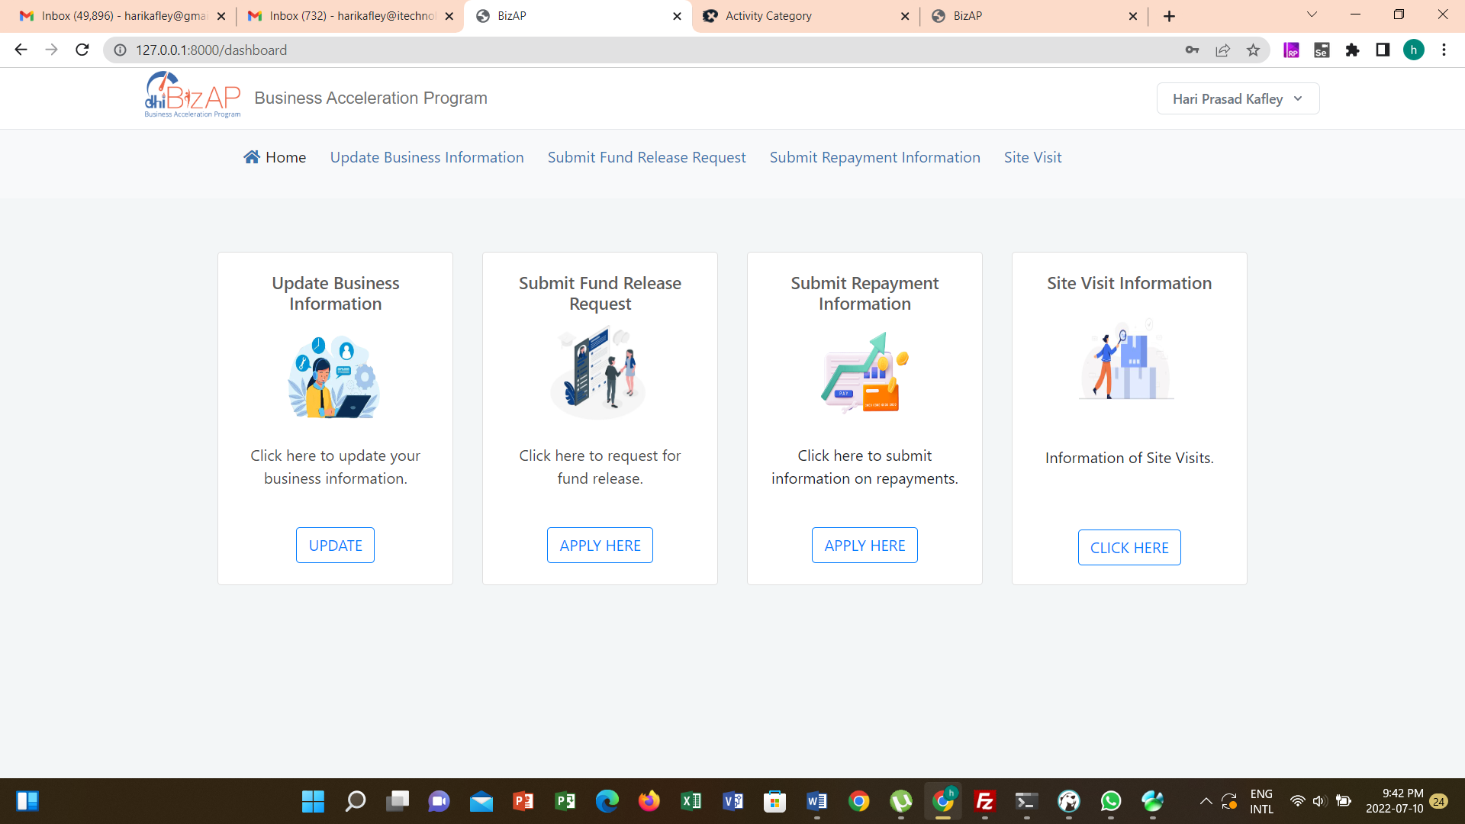

# Training Information Management

The Training information management module provides features for the following:

1. Create Training Notification – When new training program is to be implement, DHI user can post the notification for application to attend training.
2. Update Training Provider information
3. Update Shortlisting Panel Members
4. Update Interview Panel Members
5. Screen Training Applications
6. Shortlist Training Applications
7. Update interview scores and selection information
8. Update post training information

## Training Notification

DHI user has the right to update the training notification. Upon successful posting of training notification, the notification is available for aspiring participants to submit application online. To update training notification:

1. Access the system
2. Login using access credentials provided by the system administrator
3. Navigate **Training Master 🡪 Create Training Notification.**

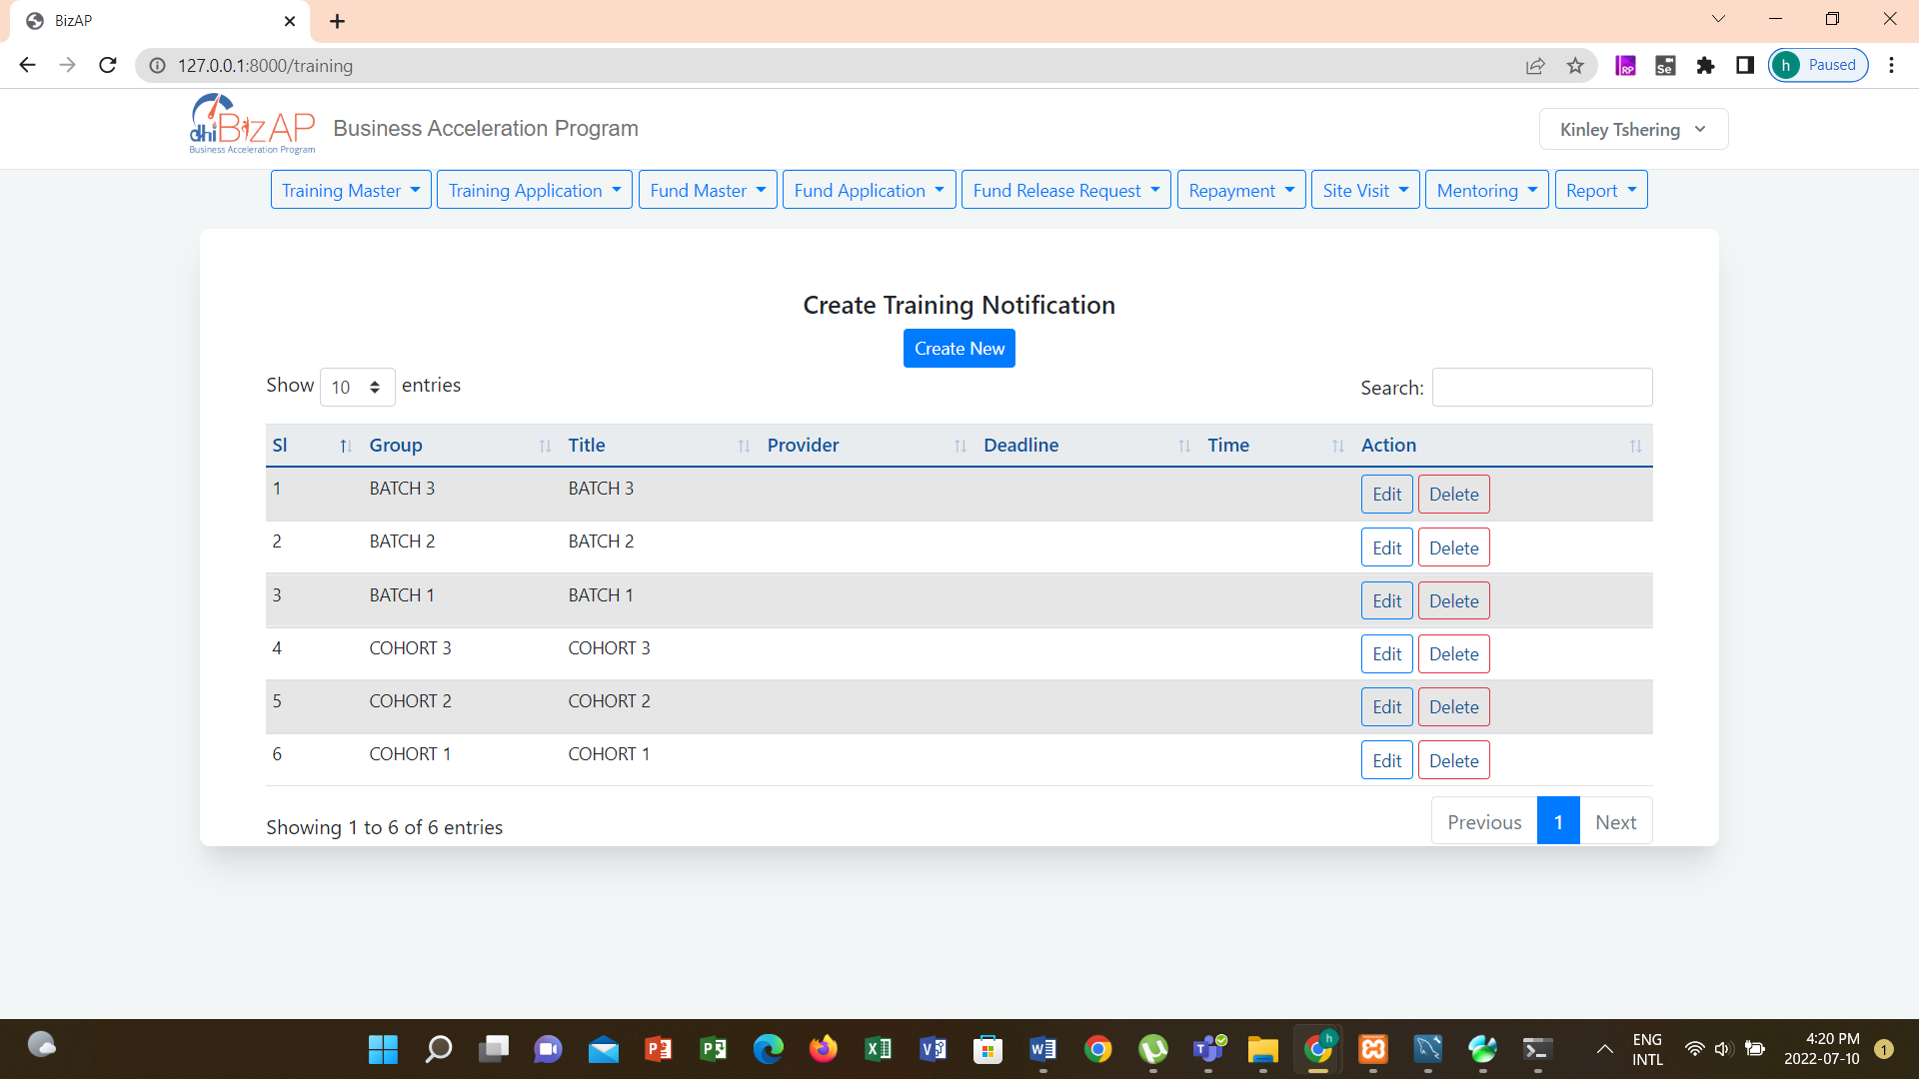

To add new notification click **Create New** button. Page to record new training details is provided as follows.

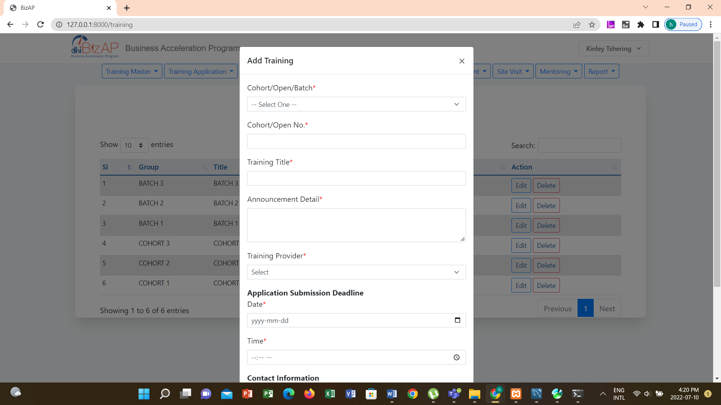

Enter required information and click **Submit** to publish the training notification or click **Cancel** to abort publishing new training notification details.

If there is a need to extend the application deadline or modify any other details of training notification, click **Edit** button under Action column. Existing details will be loaded on the form. Make required modifications and then click **Save** button to save modified information or click **Cancel** button to abort saving modified information.

To delete posted training notification click **Delete** button. A confirmation message is provided. Click **OK** confirm data delete.

## Update Training Provider

DHI user has the right to update the Training Provider details. To update Training Provider details:

1. Access the system
2. Login using access credentials provided by the system administrator
3. Navigate **Training Master 🡪 Training Provider.**

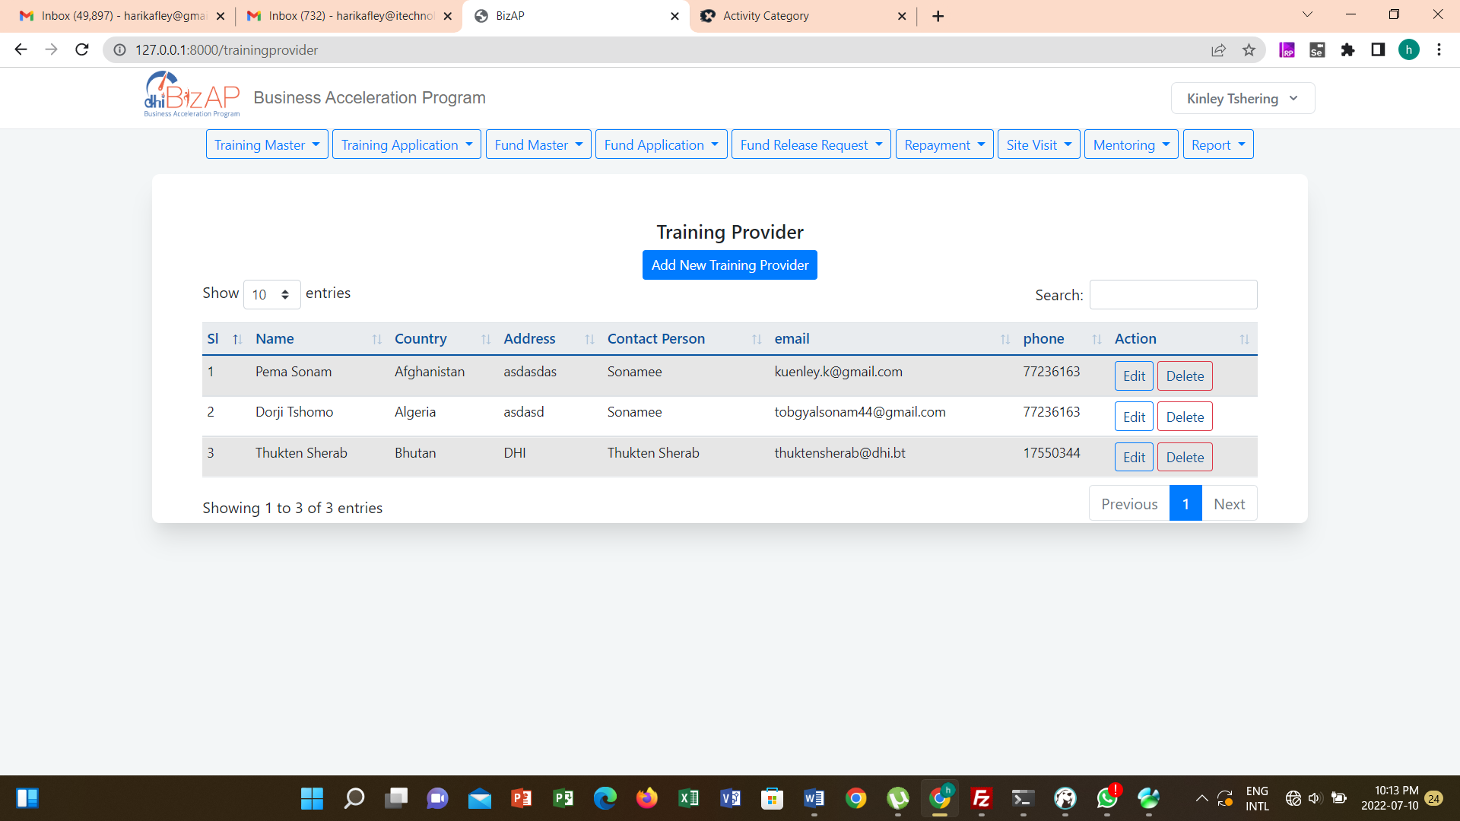

To add new notification click **Add New Training Provider** button. Page to record new training provider details is provided as follows.

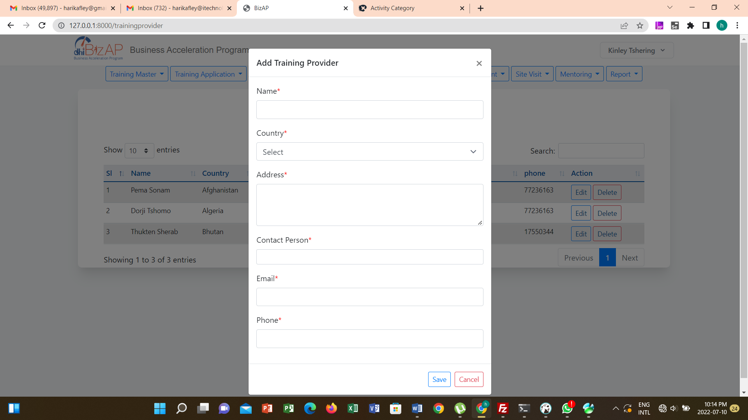

Enter required information and click **Submit** to publish the training notification or click **Cancel** to abort publishing new training notification details.

If there is a need to modify any other details of training providers, click **Edit** button under Action column. Existing details will be loaded on the form. Make required modifications and then click **Save** button to save modified information or click **Cancel** button to abort saving modified information.

To delete posted training notification click **Delete** button. A confirmation message is provided. Click **OK** confirm data delete.

## Create Shortlisting Panel

DHI user has the right to create shortlisting panel. To create shortlisting panel:

1. Access the system
2. Login using access credentials provided by the system administrator
3. Navigate **Training Master 🡪 Shortlist Panel Members**

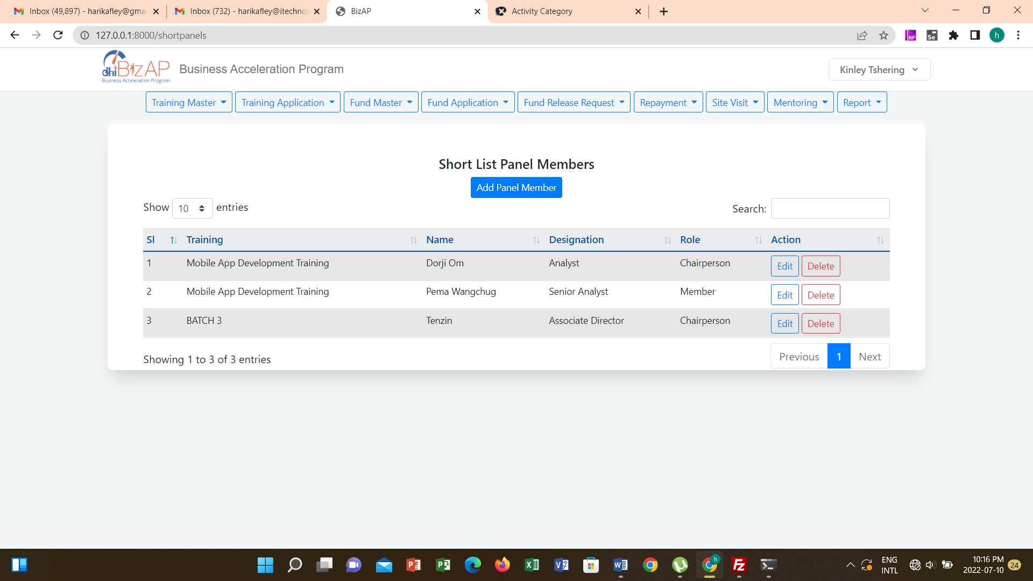

To add new penal member click **Add Panel Member** button. Page to record new penal member is provided as follows.

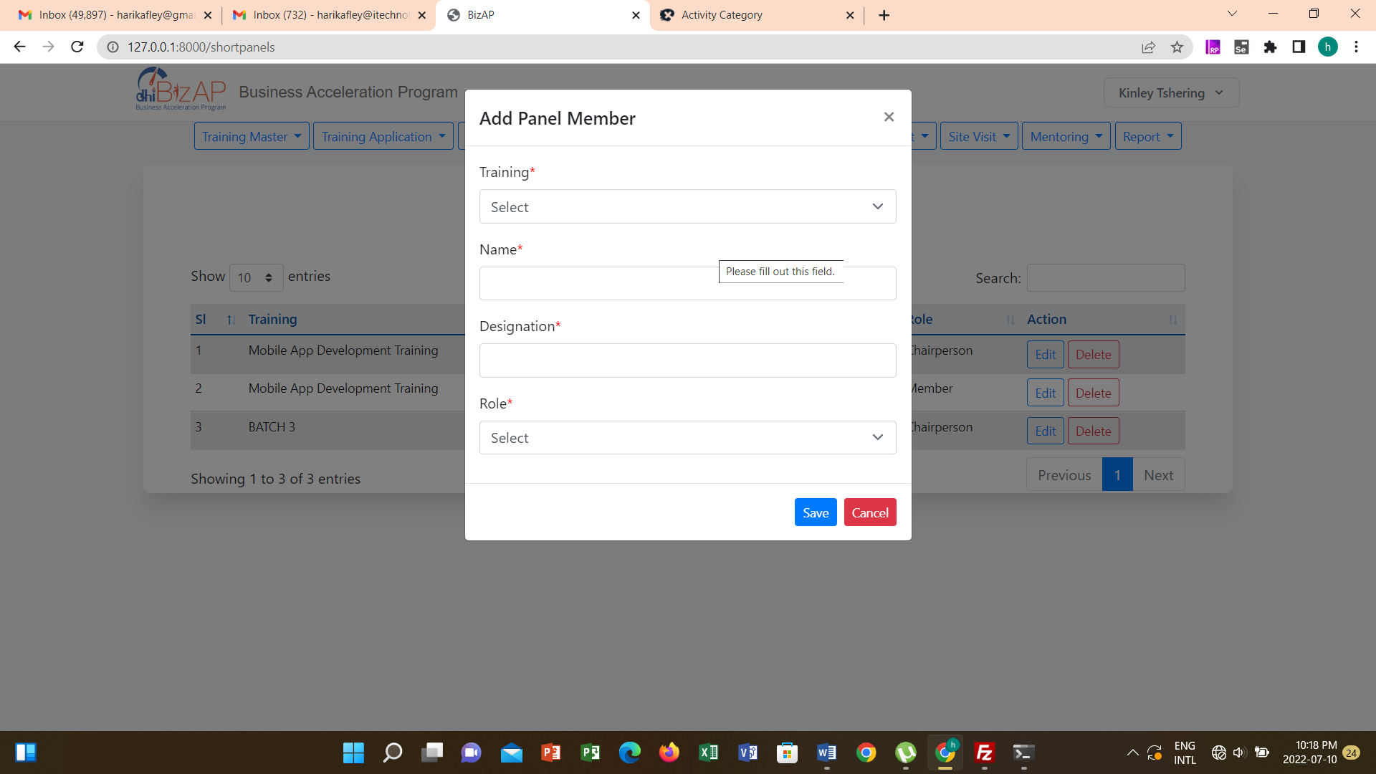

Enter required information and click **Submit** to publish the training notification or click **Cancel** to abort publishing new panel member details.

If there is a need modify any other details of training notification, click **Edit** button under Action column. Existing details will be loaded on the form. Make required modifications and then click **Save** button to save modified information or click **Cancel** button to abort saving modified information.

To delete posted training notification click **Delete** button. A confirmation message is provided. Click **OK** confirm data delete.

## Update Interview Panel

DHI user has the right to create shortlisting panel. To create shortlisting panel:

1. Access the system
2. Login using access credentials provided by the system administrator
3. Navigate **Training Master 🡪 Shortlist Panel Members**



To add new penal member click **Add Panel Member** button. Page to record new penal member is provided as follows.



Enter required information and click **Submit** to publish the training notification or click **Cancel** to abort publishing new panel member details.

If there is a need modify any other details of training notification, click **Edit** button under Action column. Existing details will be loaded on the form. Make required modifications and then click **Save** button to save modified information or click **Cancel** button to abort saving modified information.

To delete posted training notification click **Delete** button. A confirmation message is provided. Click **OK** confirm data delete.

## Apply For Training

Training notification is available to general site visitors. Site visitors can navigate to Training Application tile. List of training notifications list provided.



Those notifications that are closed for application submission show message “**Submission time is over**”. Notification for valid training shows option to “**Apply**”. To apply for training click **Apply** button. Application form is provided as follows:

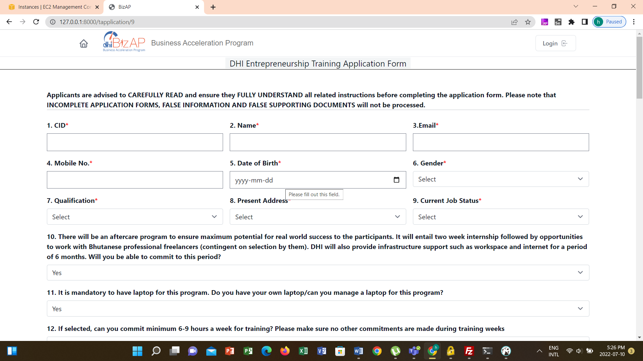

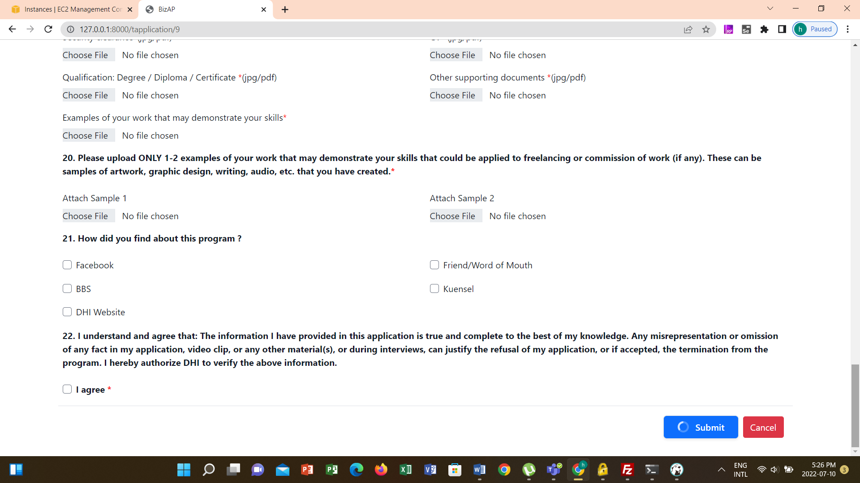

Provide the required information and then click **Submit** button to submit the application for attending training or click **Cancel** to abort submitting the application.

## Screen Applications

Submitted applications are listed for DHI user to review the application and update screening results. To access submitted applications:

1. Access the system
2. Login using access credentials provided by the system administrator
3. Navigate **Training Application 🡪 Screening.**

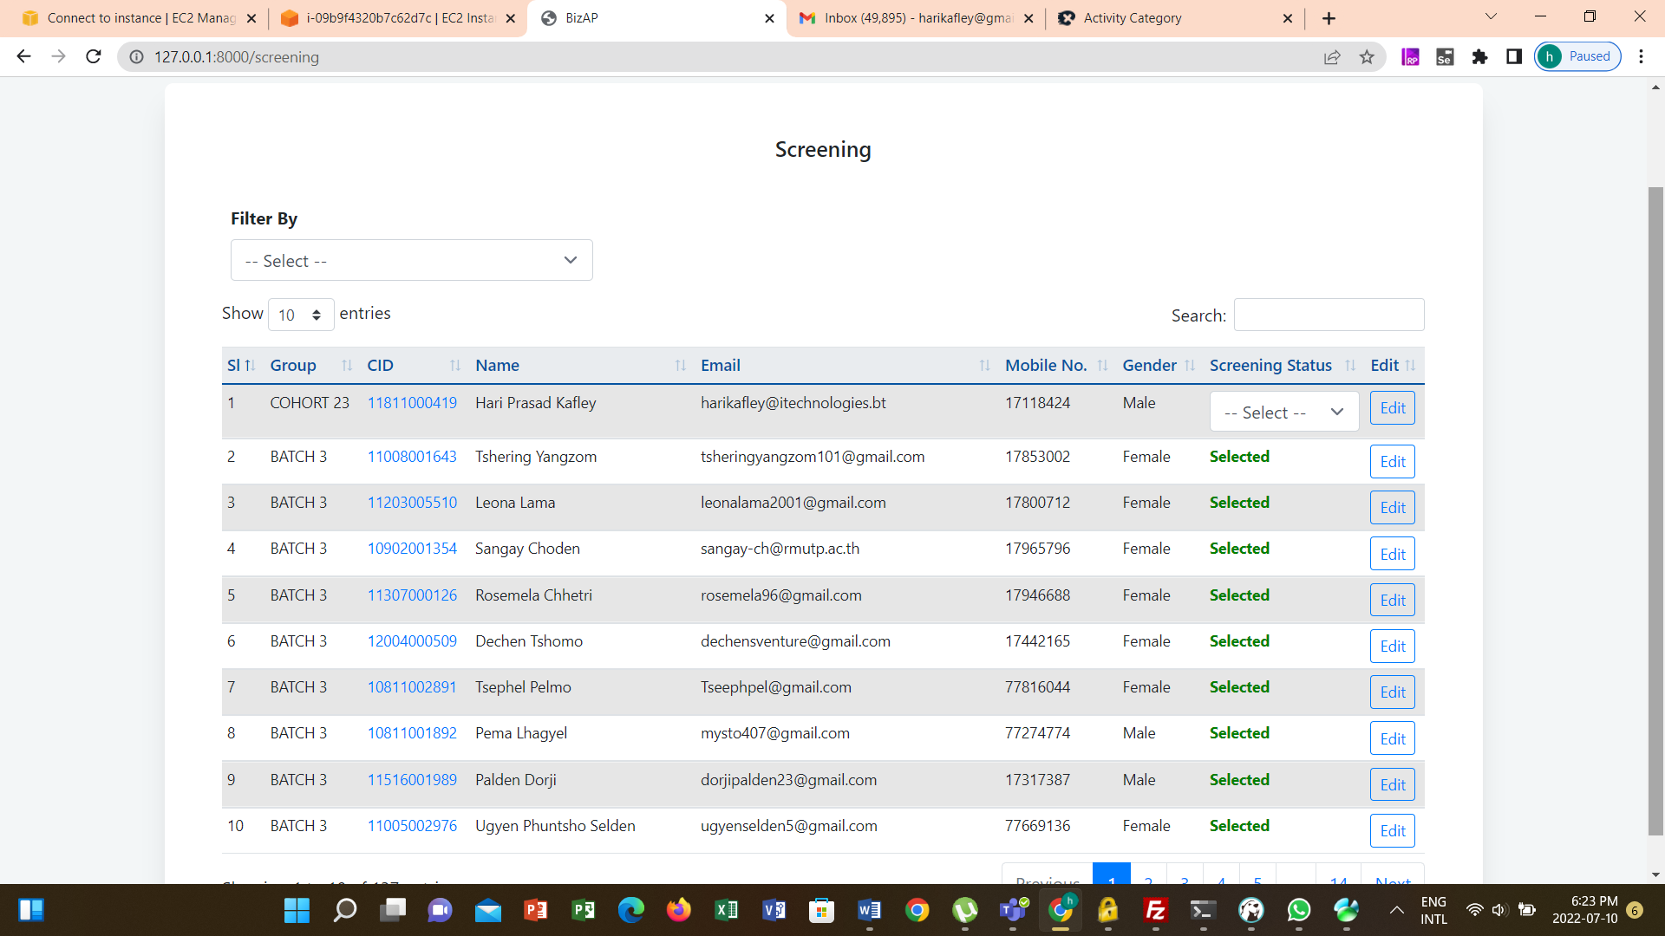

To view details of the application, click on the CID of the applicant. To edit submitted information user is required to click **Edit** button under Edit column. Details of the application is provided as follows.

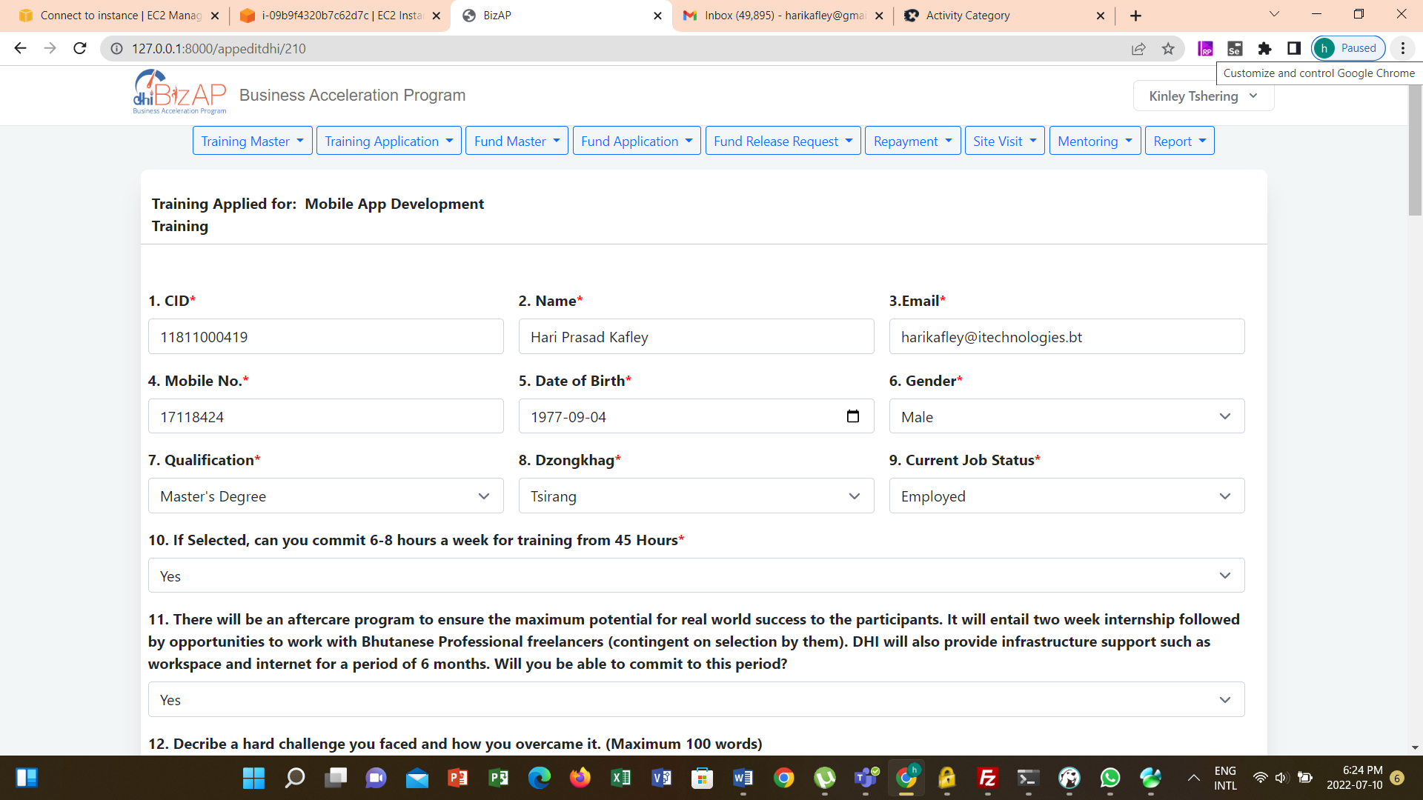

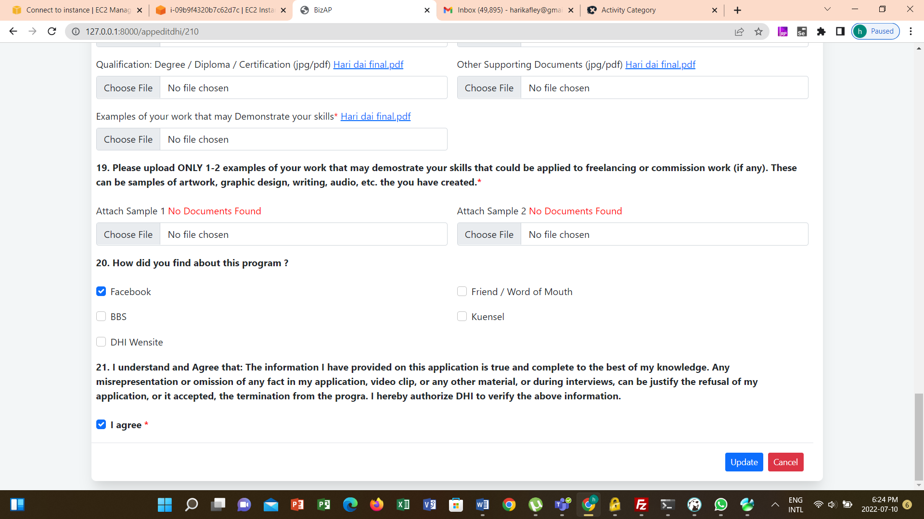

To Update Screening Status user can either user the view details option or select Yes / No under screening status.

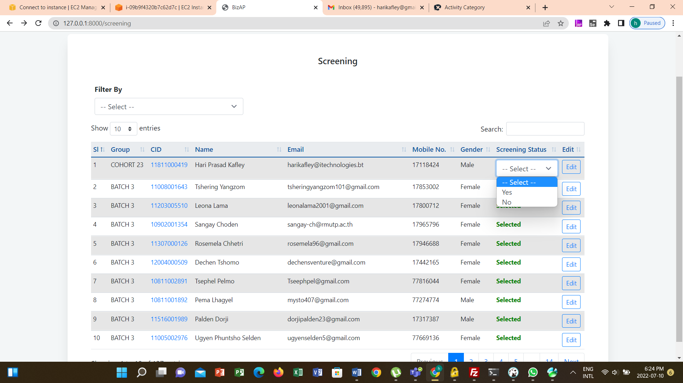

Once the screening status is updated then values for Screening status will become Selected or Rejected based on the status.

## Shortlisting

Submitted applications that cleared during screening are listed for DHI user to review the application and update shortlisting results. To access selected applications during screening:

1. Access the system
2. Login using access credentials provided by the system administrator
3. Navigate **Training Application 🡪 Short Listing**

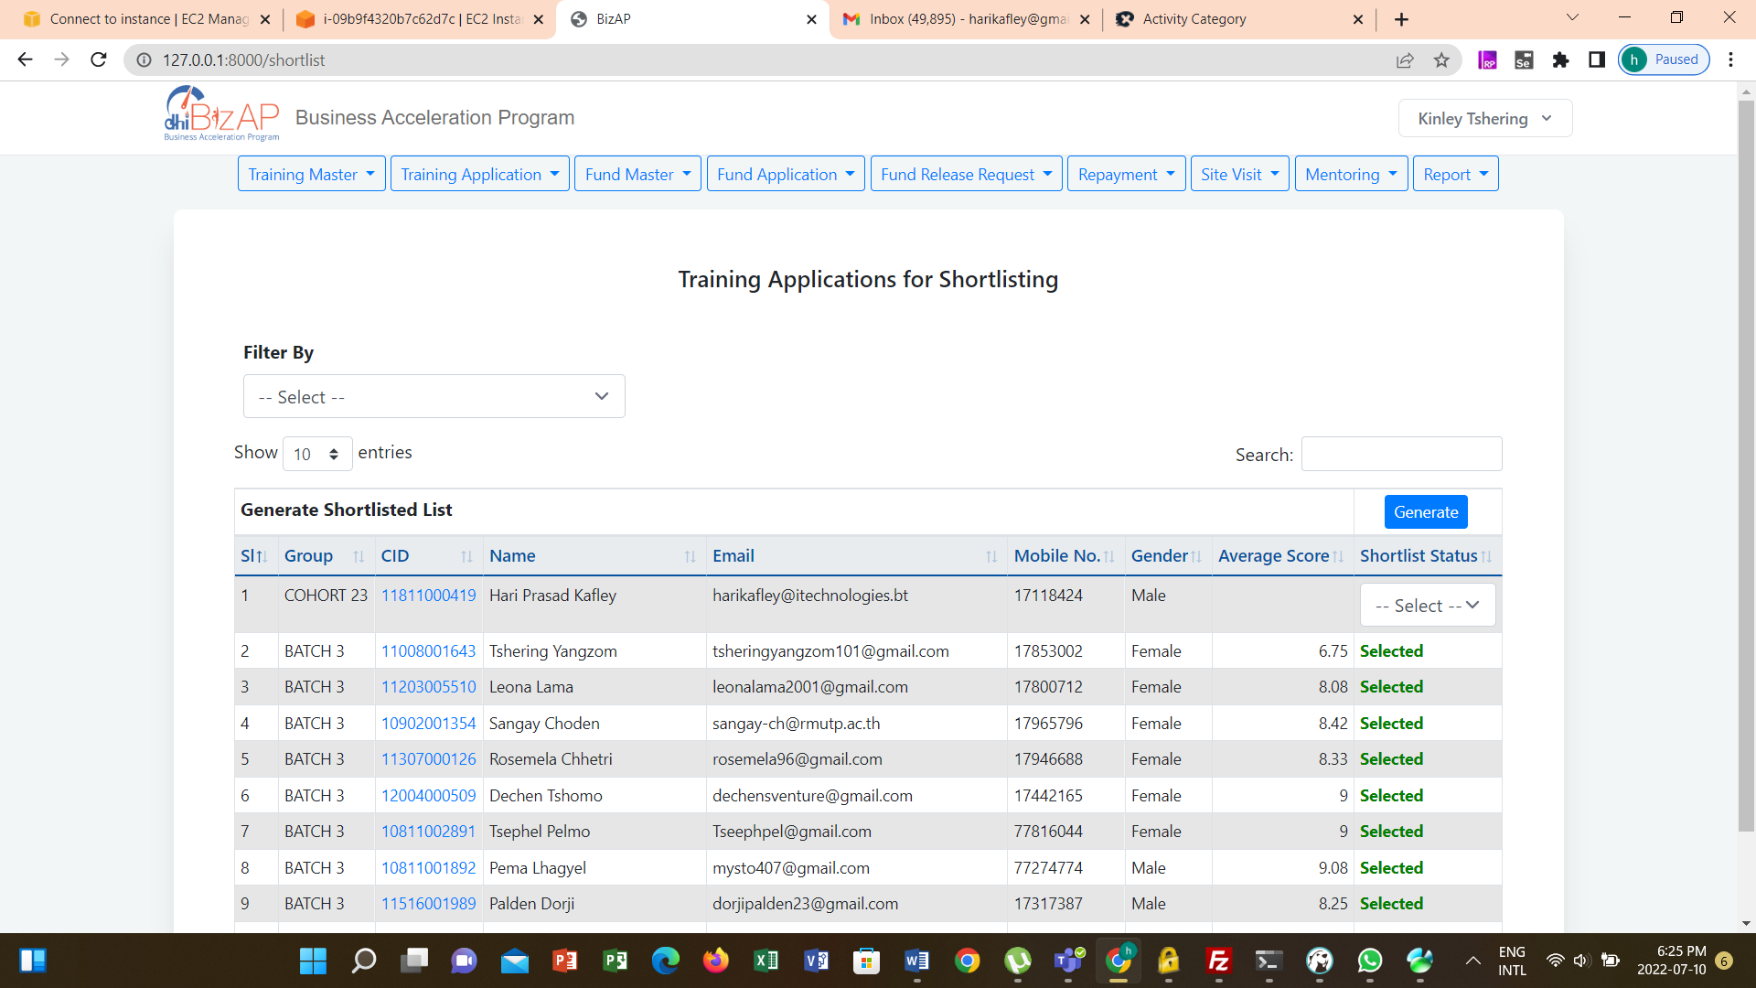

To view details of the application, click on the CID of the applicant. Details of the application is provided.

To update the Update Shortlisting Score, user is required to use the view details (i.e. click on the CID). Option to record the shortlisting score is provided if the logged in user is shortlisting panel member.

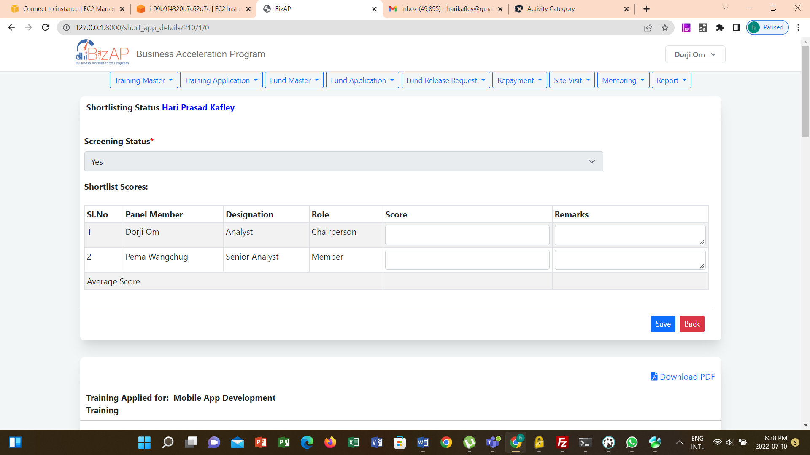

After the short-listing scores are updated, authorized user can Update Shortlisting Status by selecting Selected for shortlisted and Not selected for those not shortlisted.

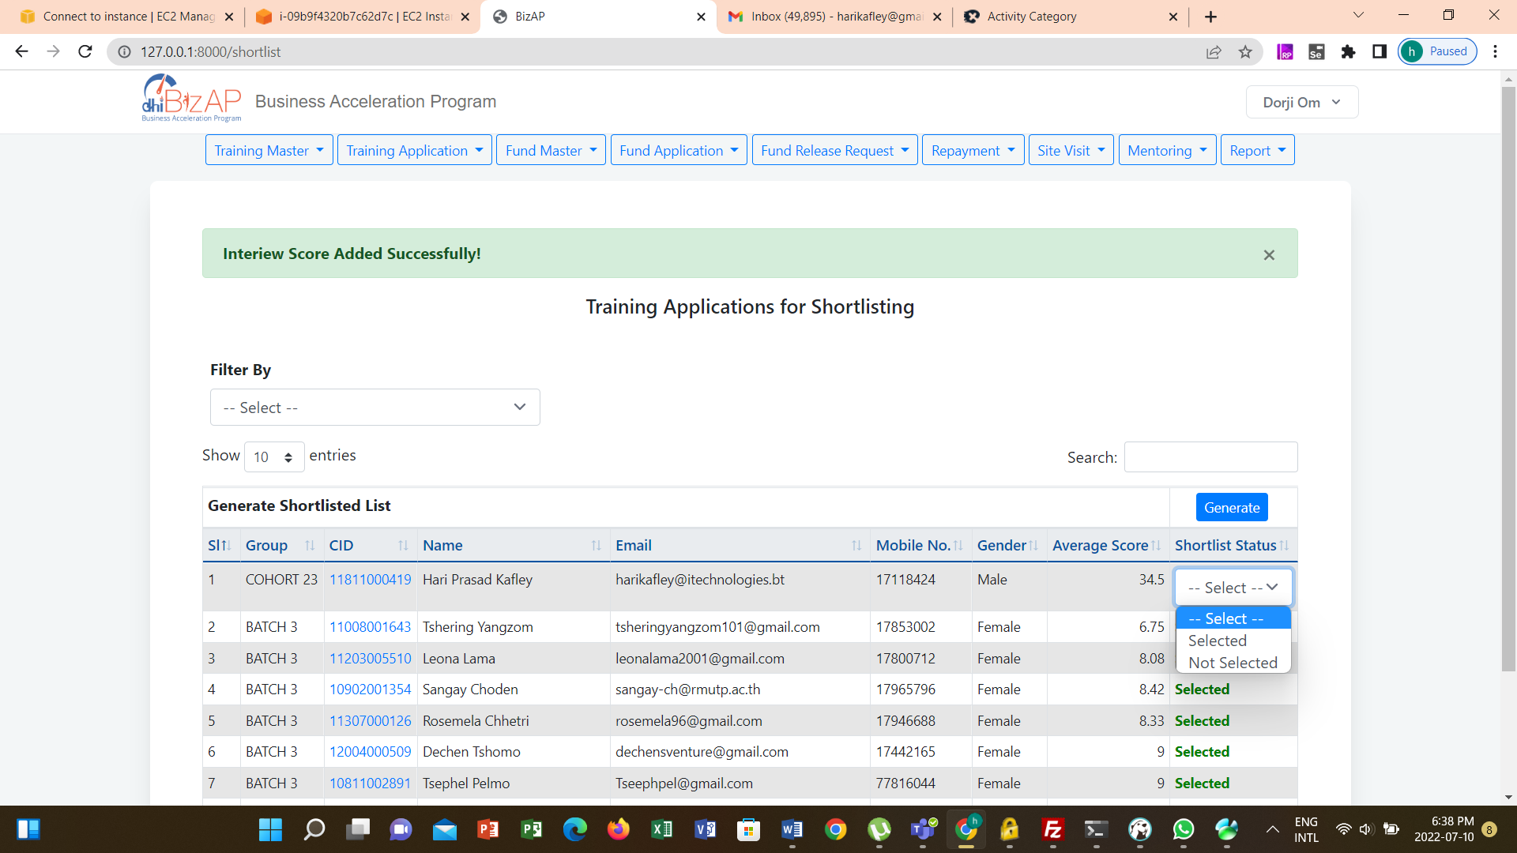

Shortlisting Notification – After updating the shortlisting status, click on the **Generate** button. System provides the option to select whether Cohort or Batch and then Specify Cohort No. / Batch No. After selecting the required data user can generate the shortlisting notification as follows.

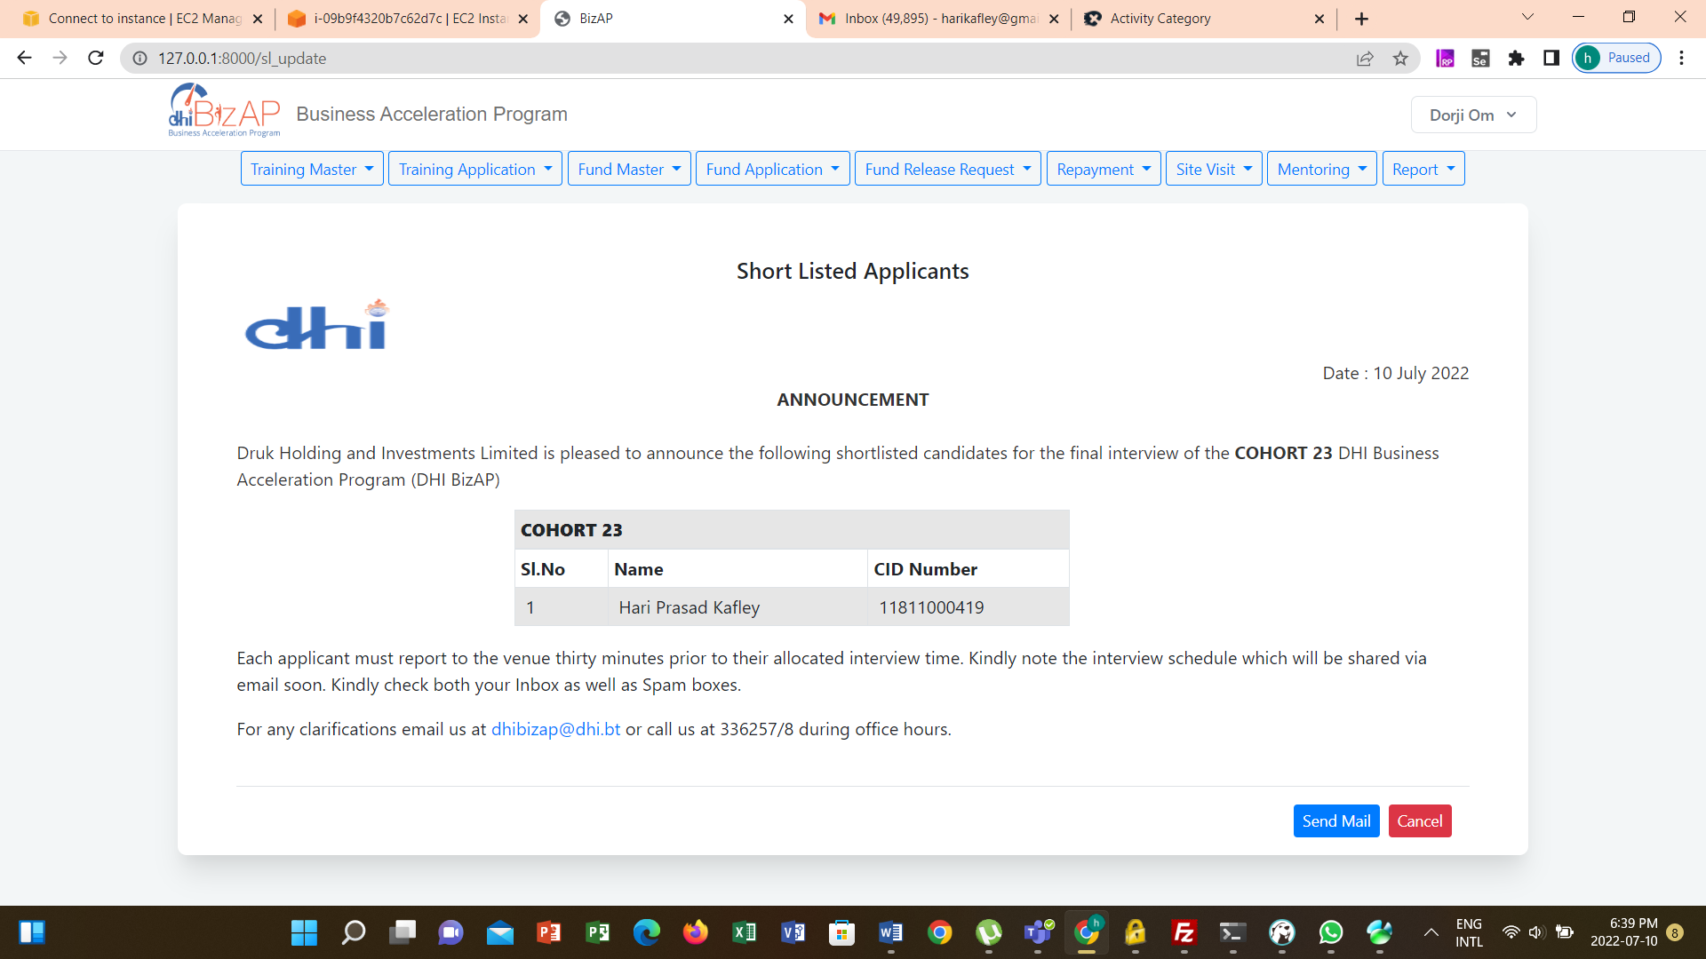

User is required to click **Send Mail** button to send the notification to IT for uploading in the DHI website.

## Schedule Interview

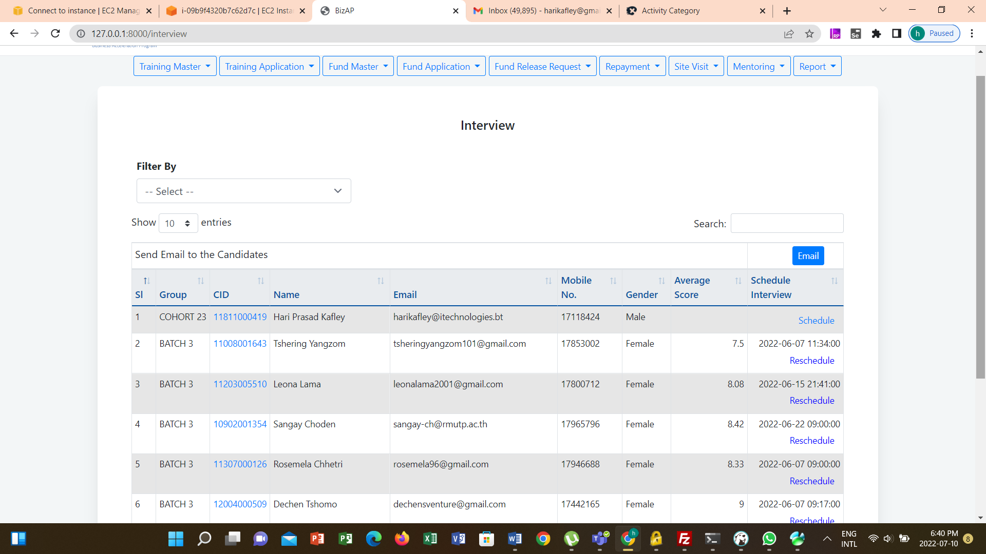

Interview Schedule

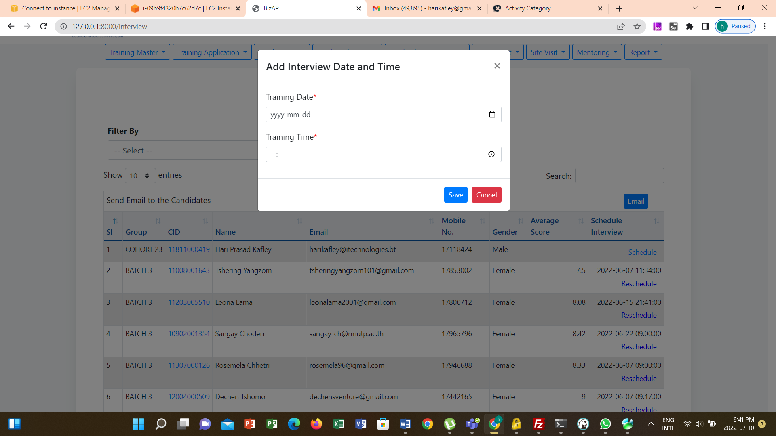

Interview Reschedule

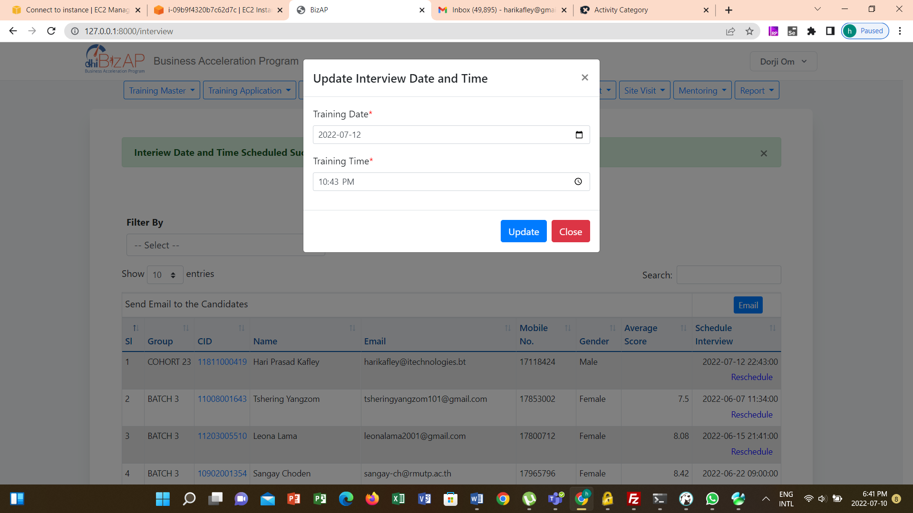

## Interview

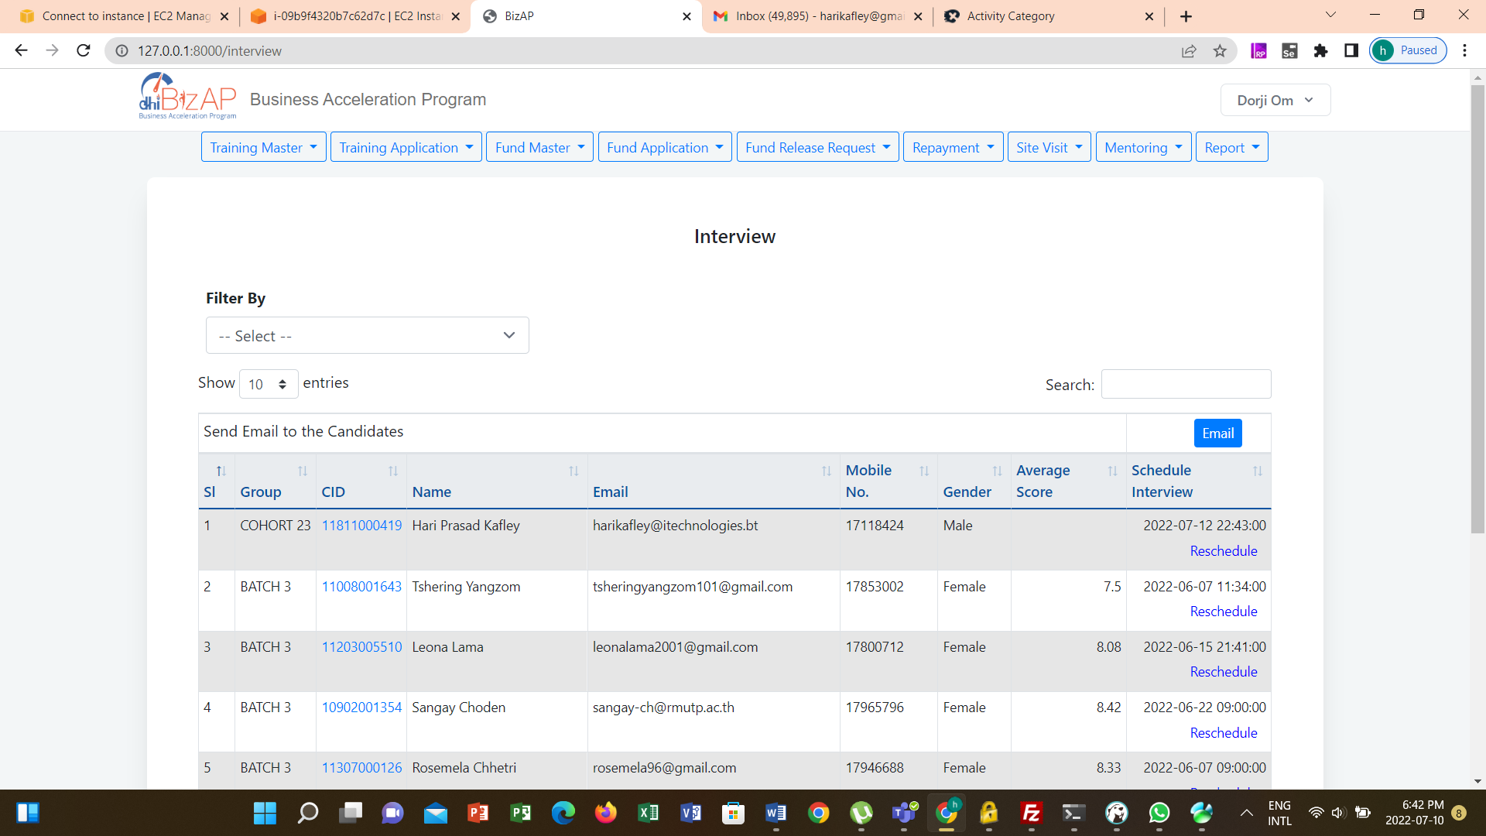

Interview Scores

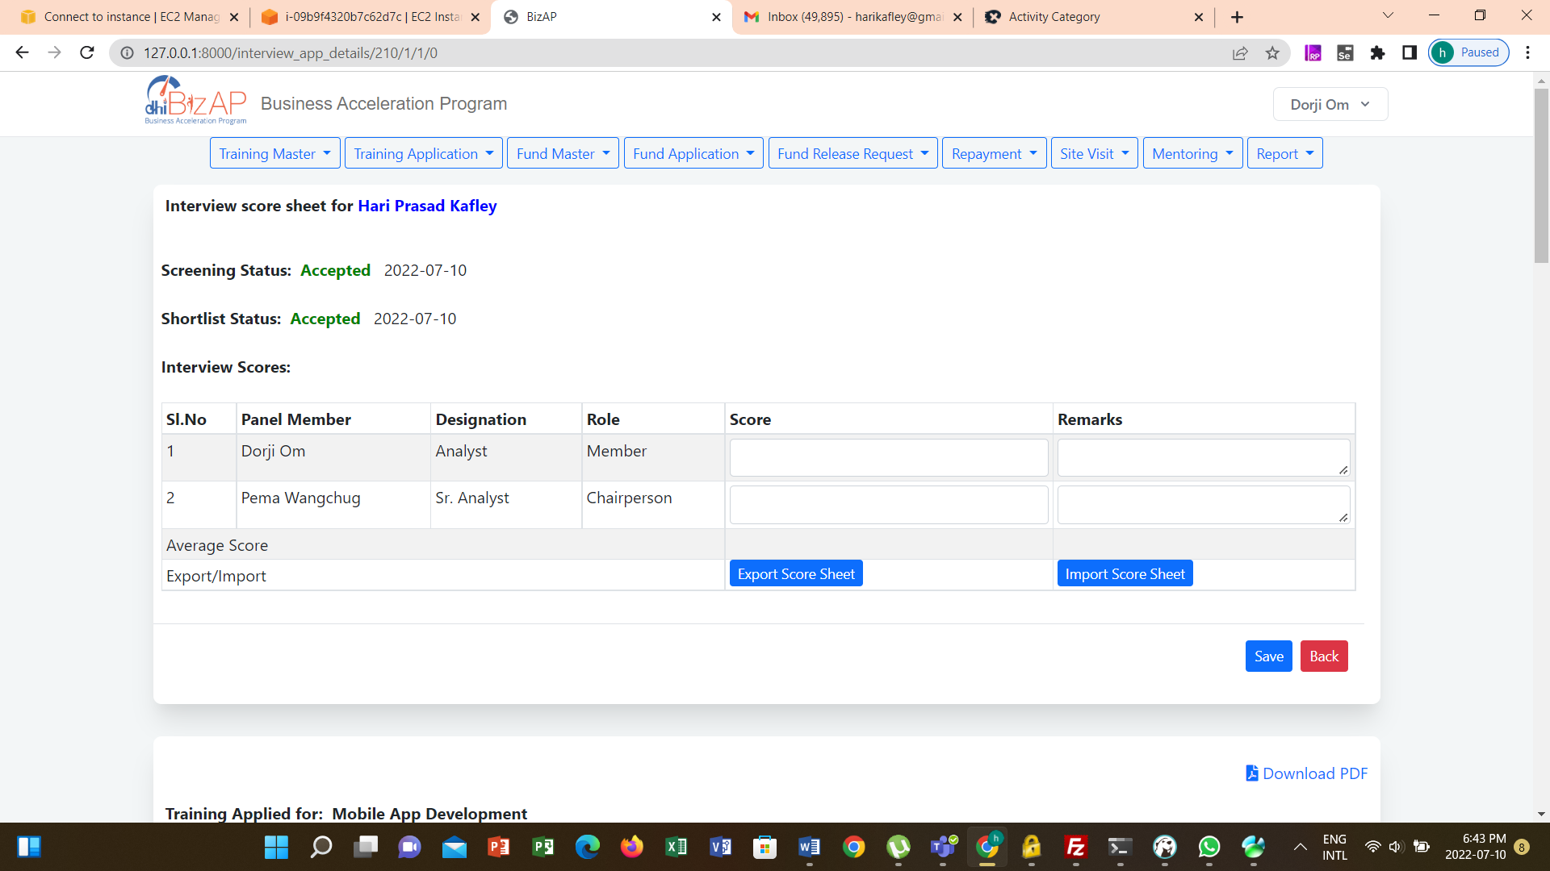

## Final Results

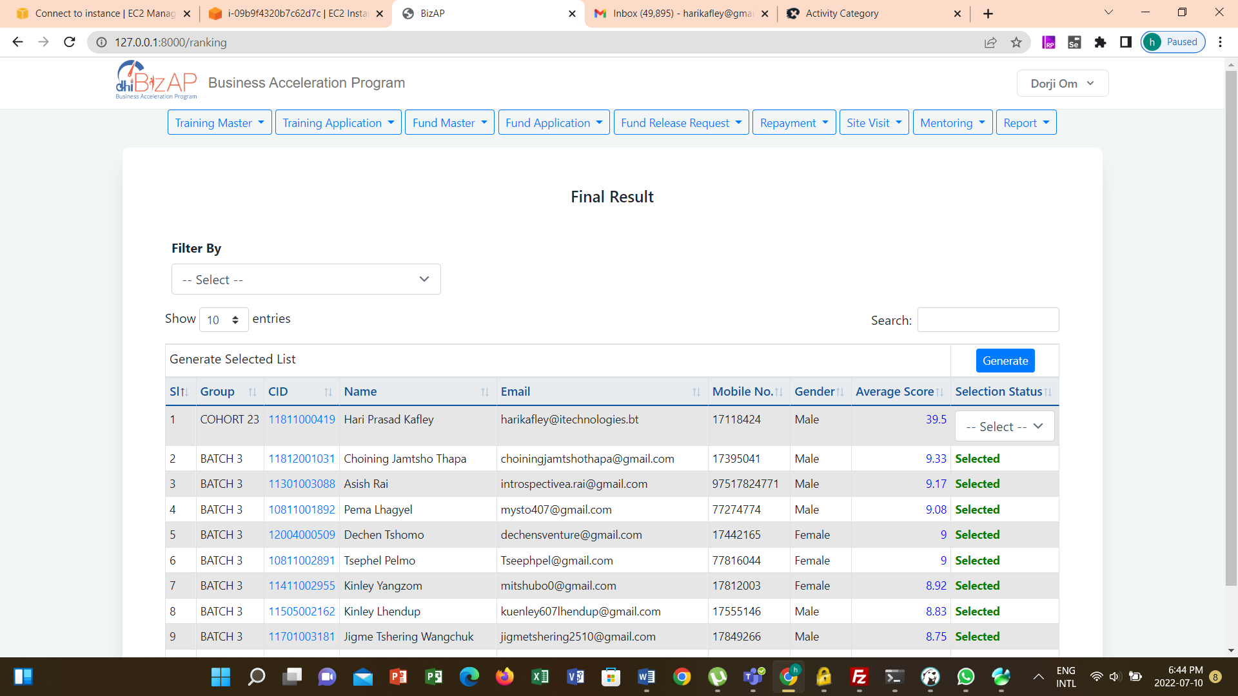

Generate Notification

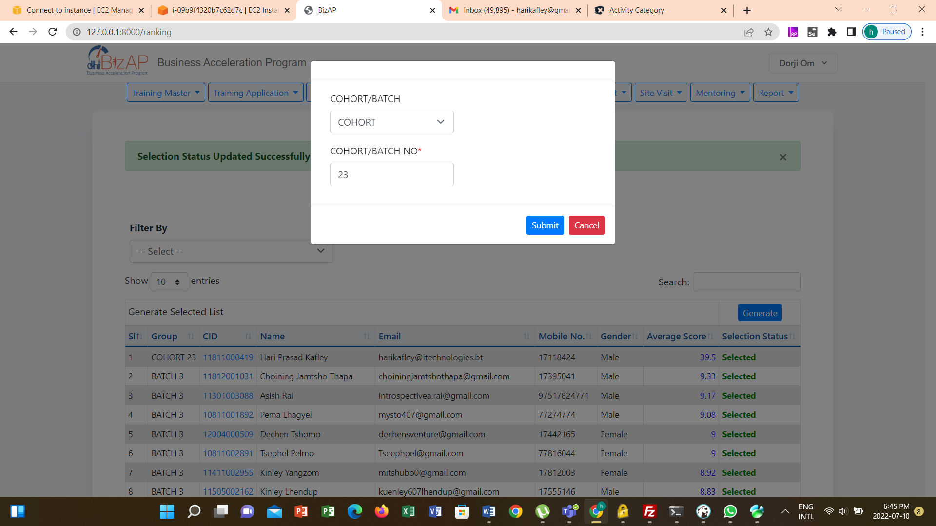

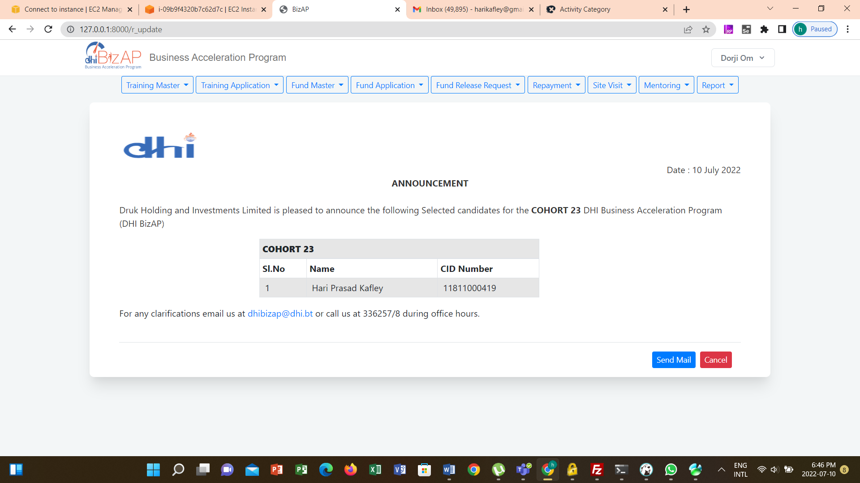

## Post Training Status

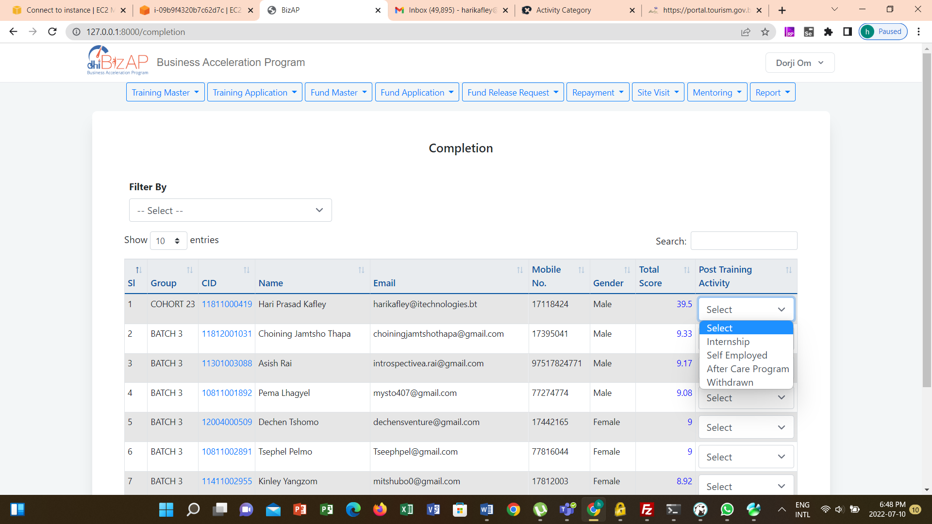

# Funding

## Announcements

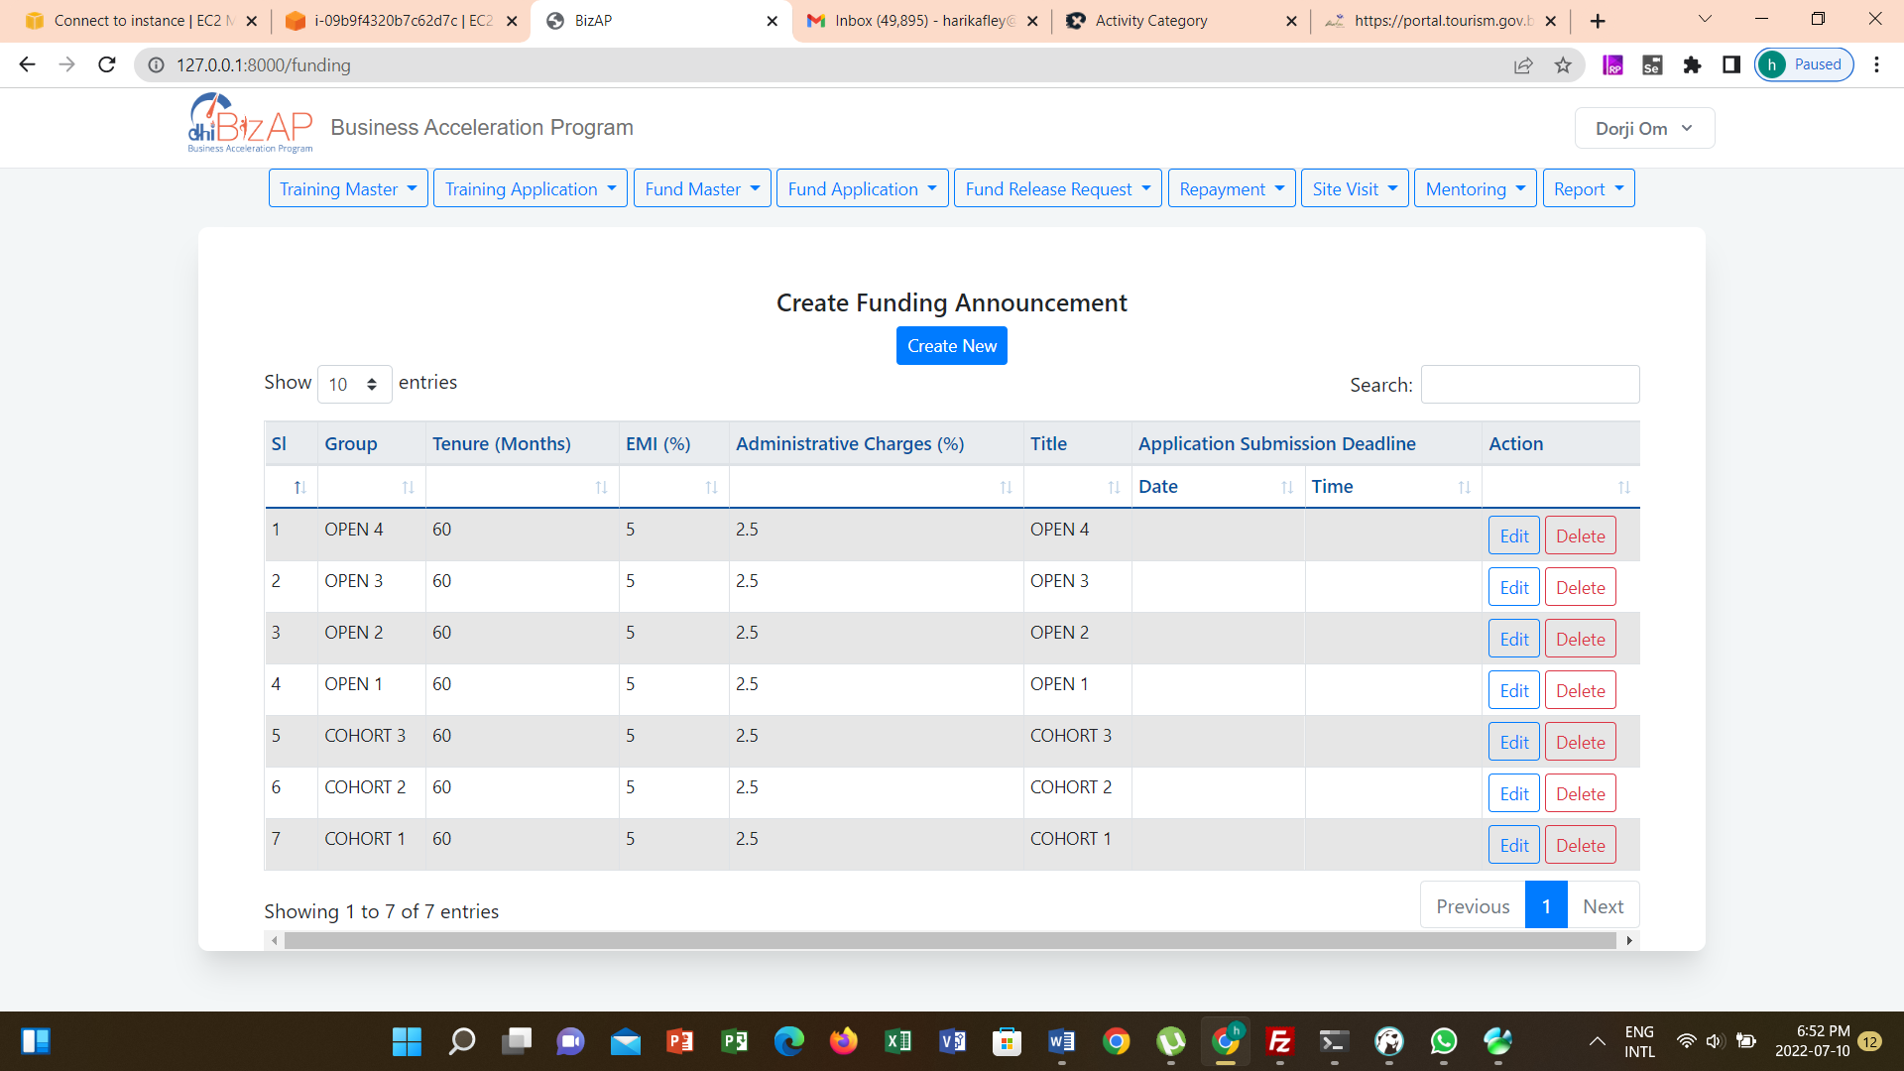

New Announcement

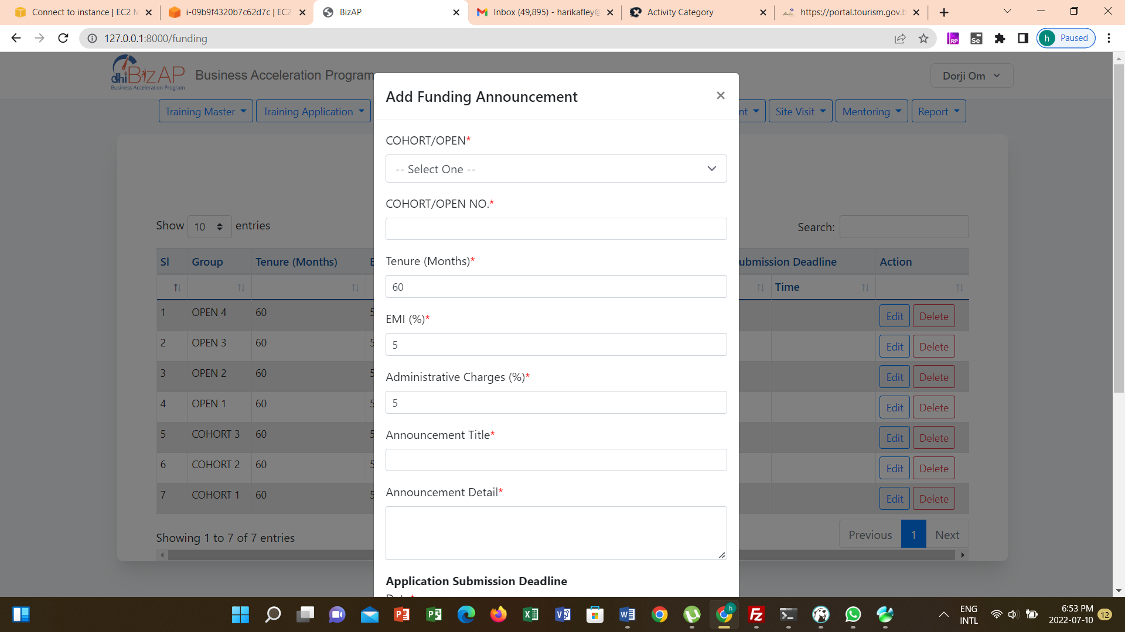

Edit Announcement

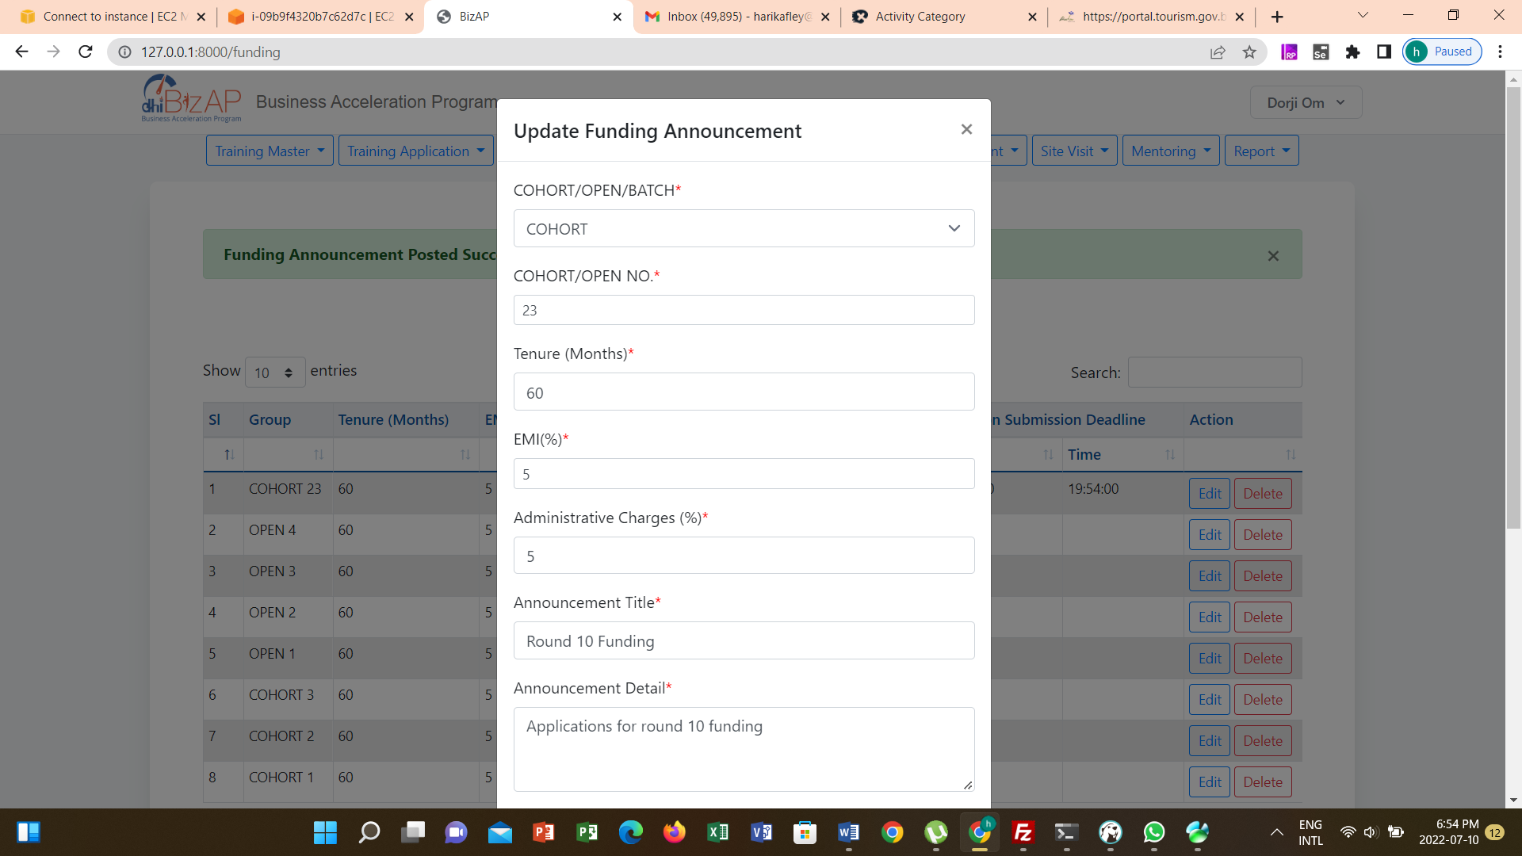

## Create Shortlisting Panel

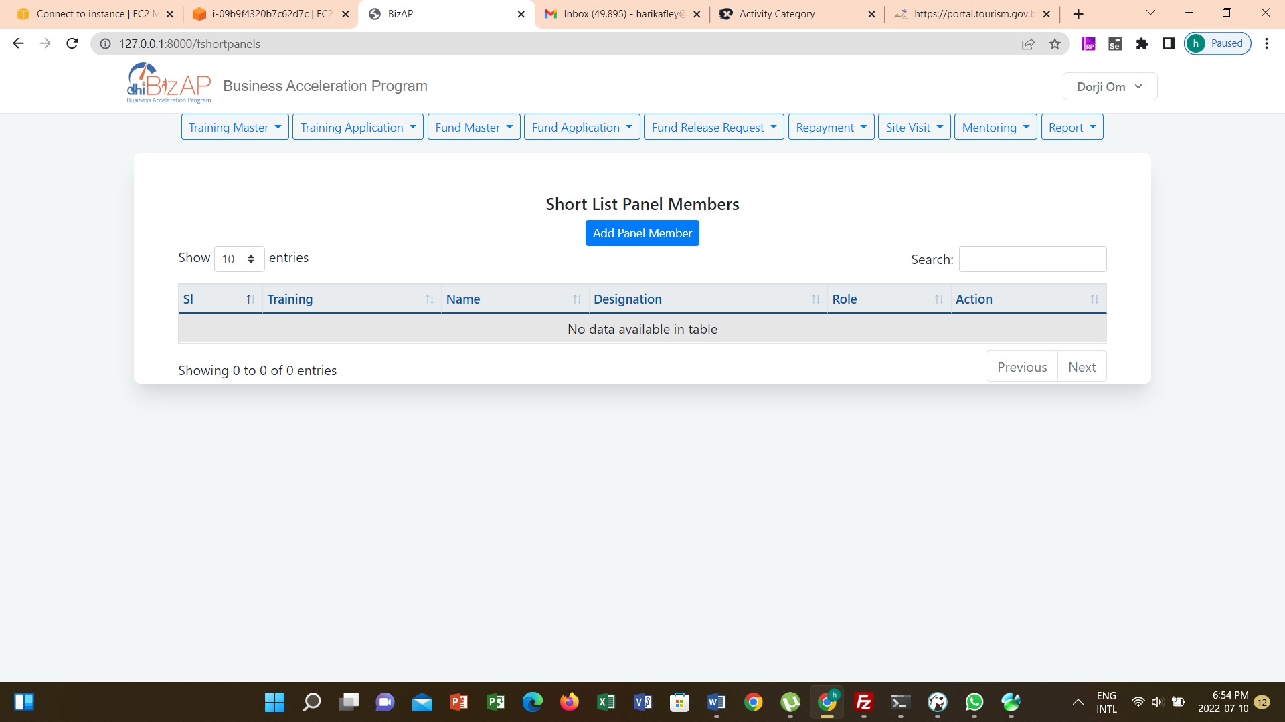

New Member

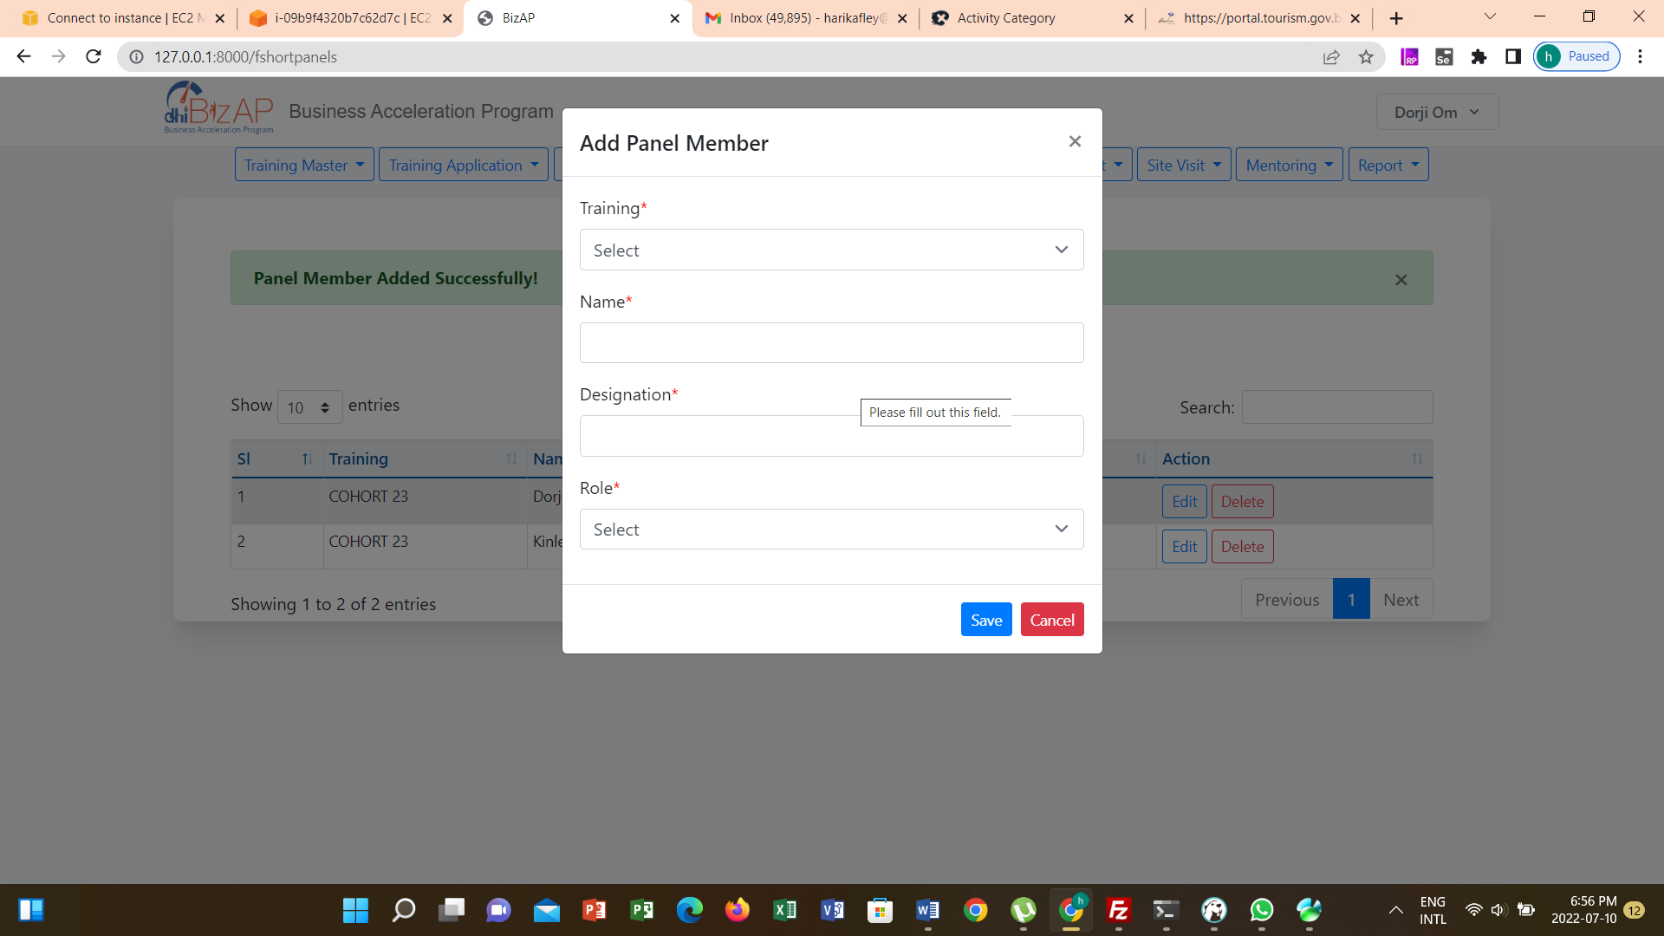

## Presentation Penal Member

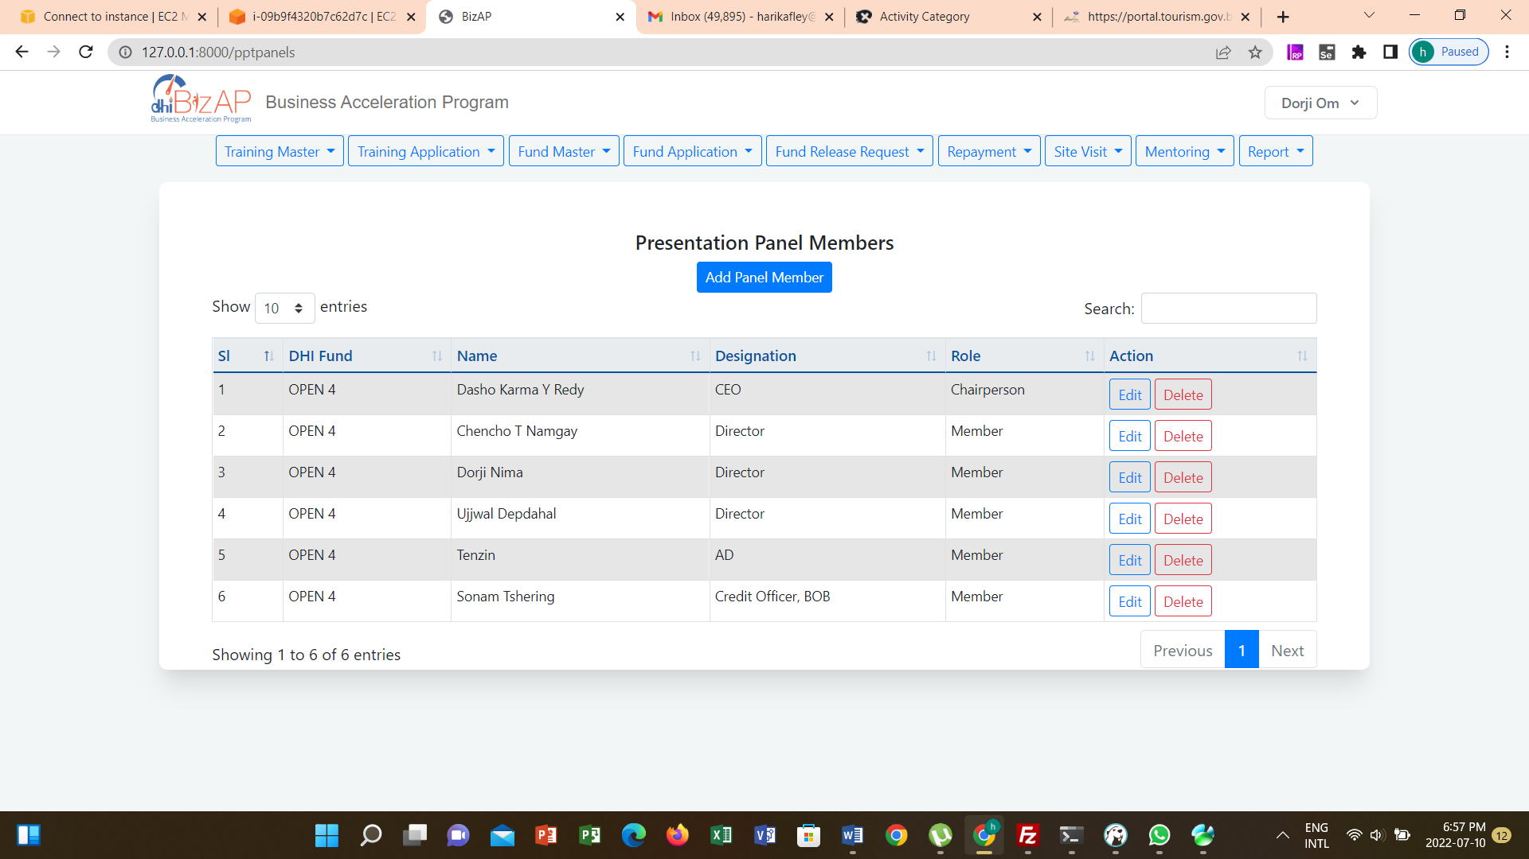

## Submit Application



Application Form

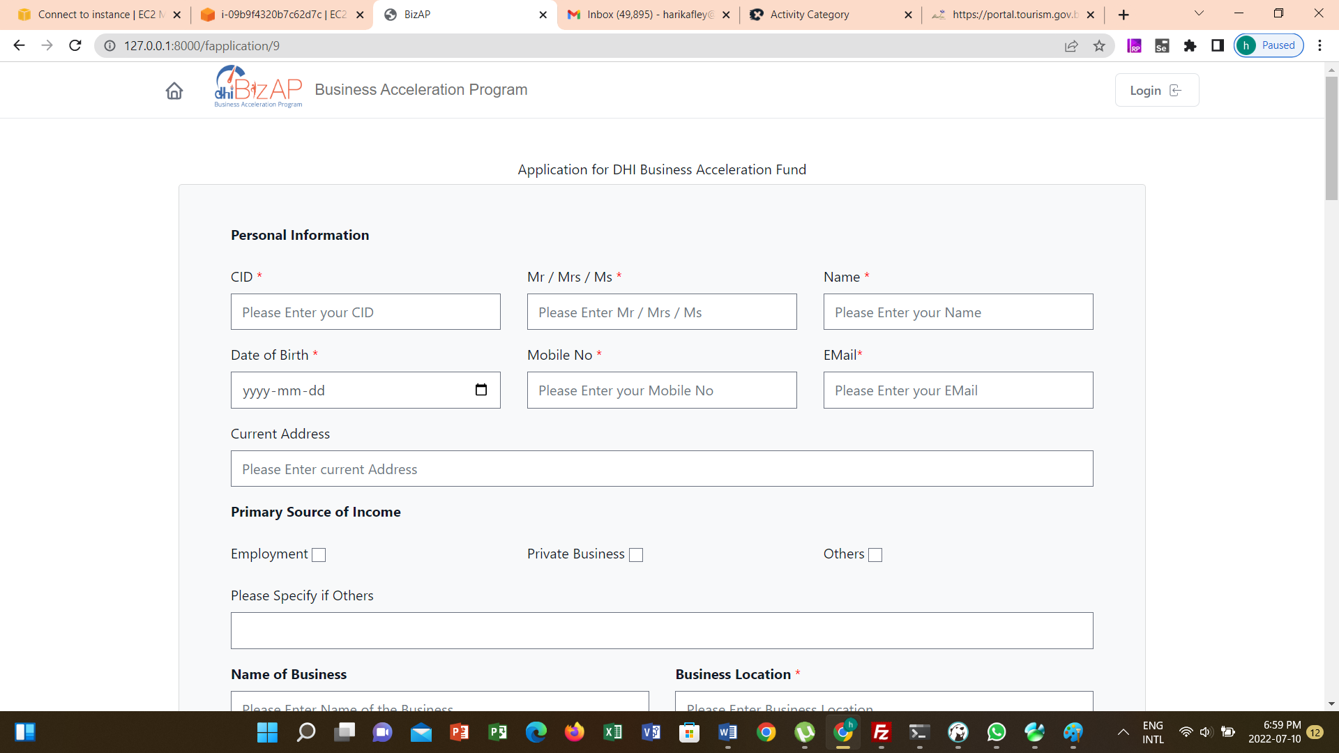

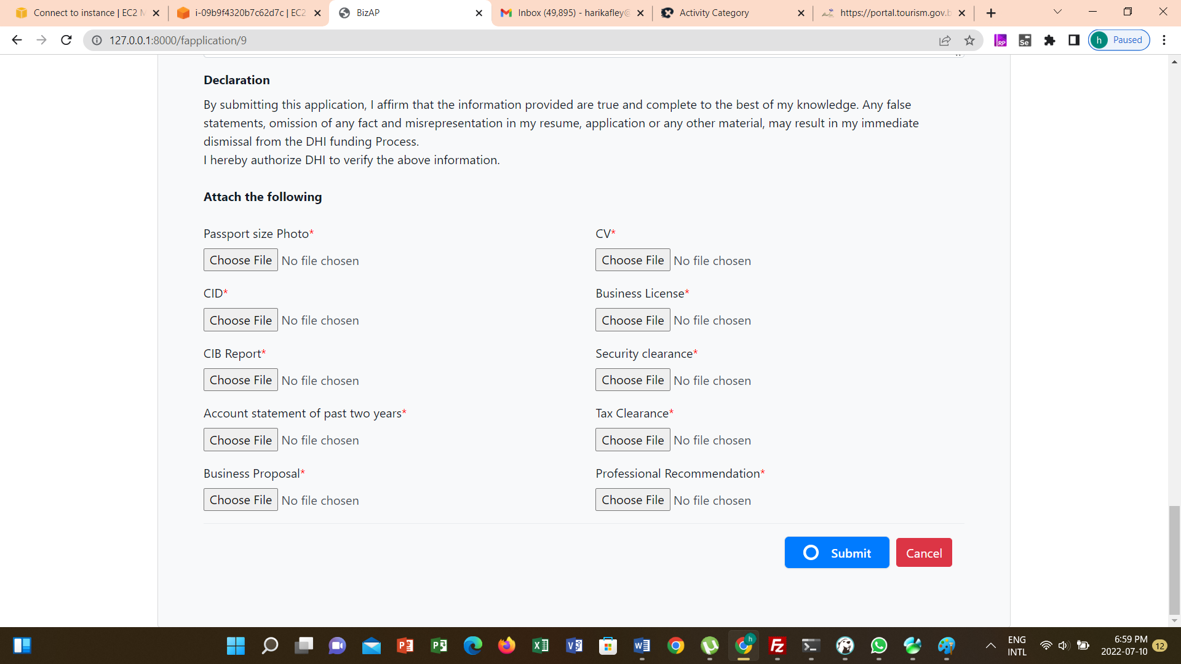

## Screening

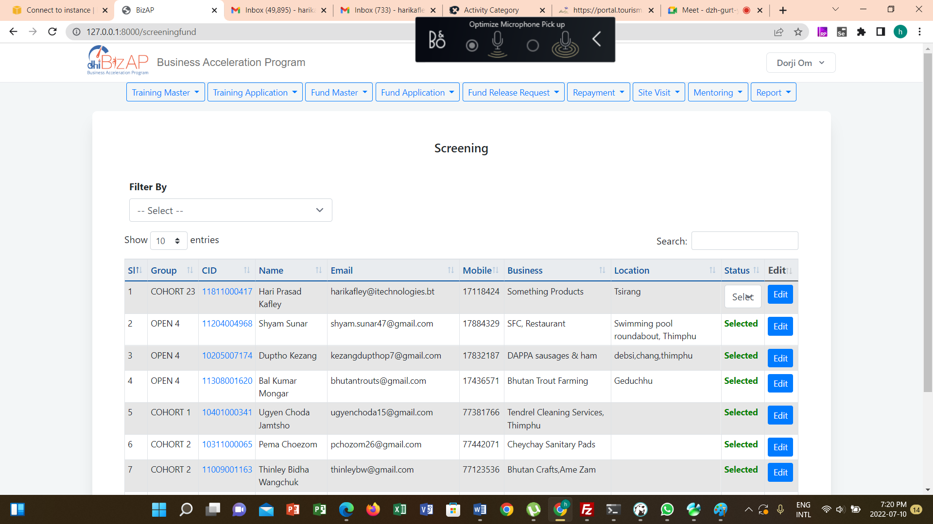

View Details

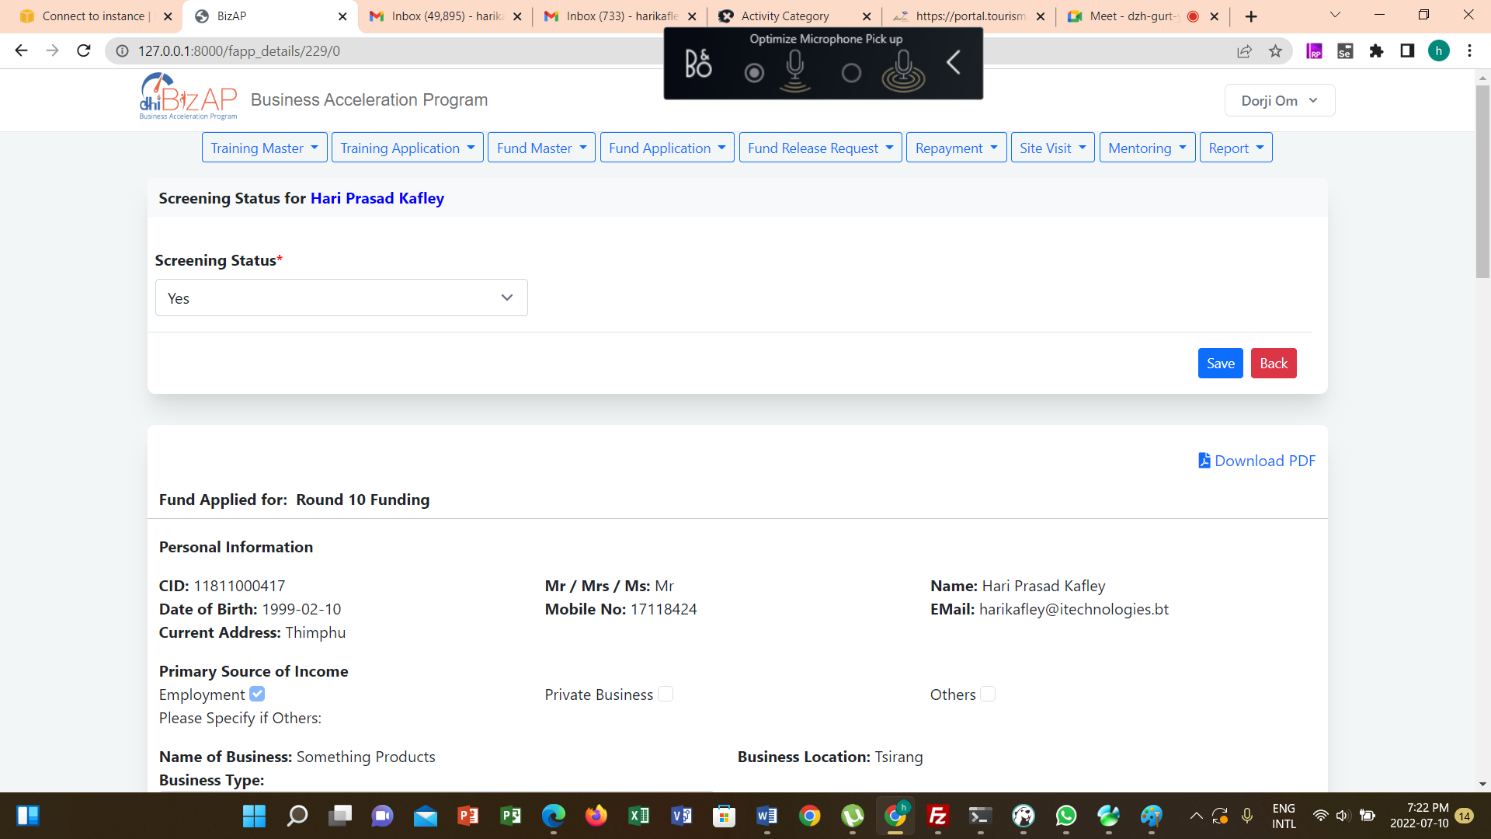

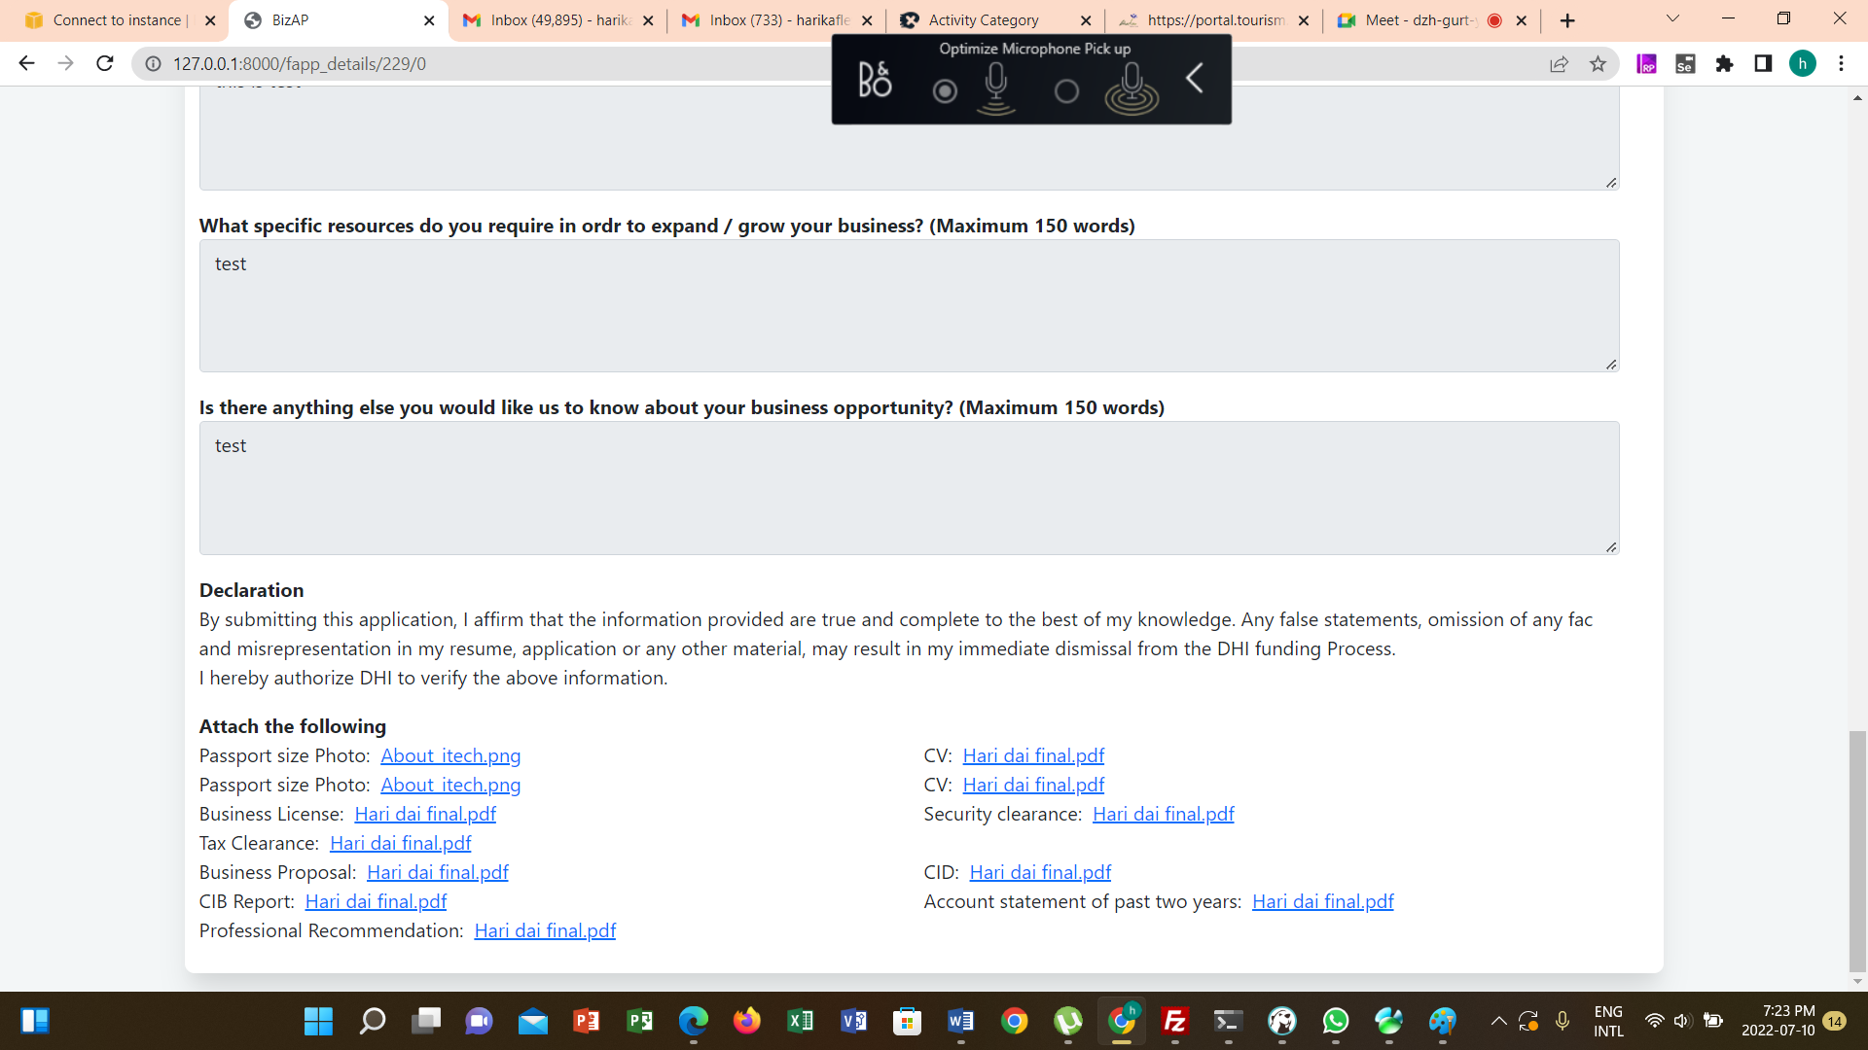

Screening Status Update

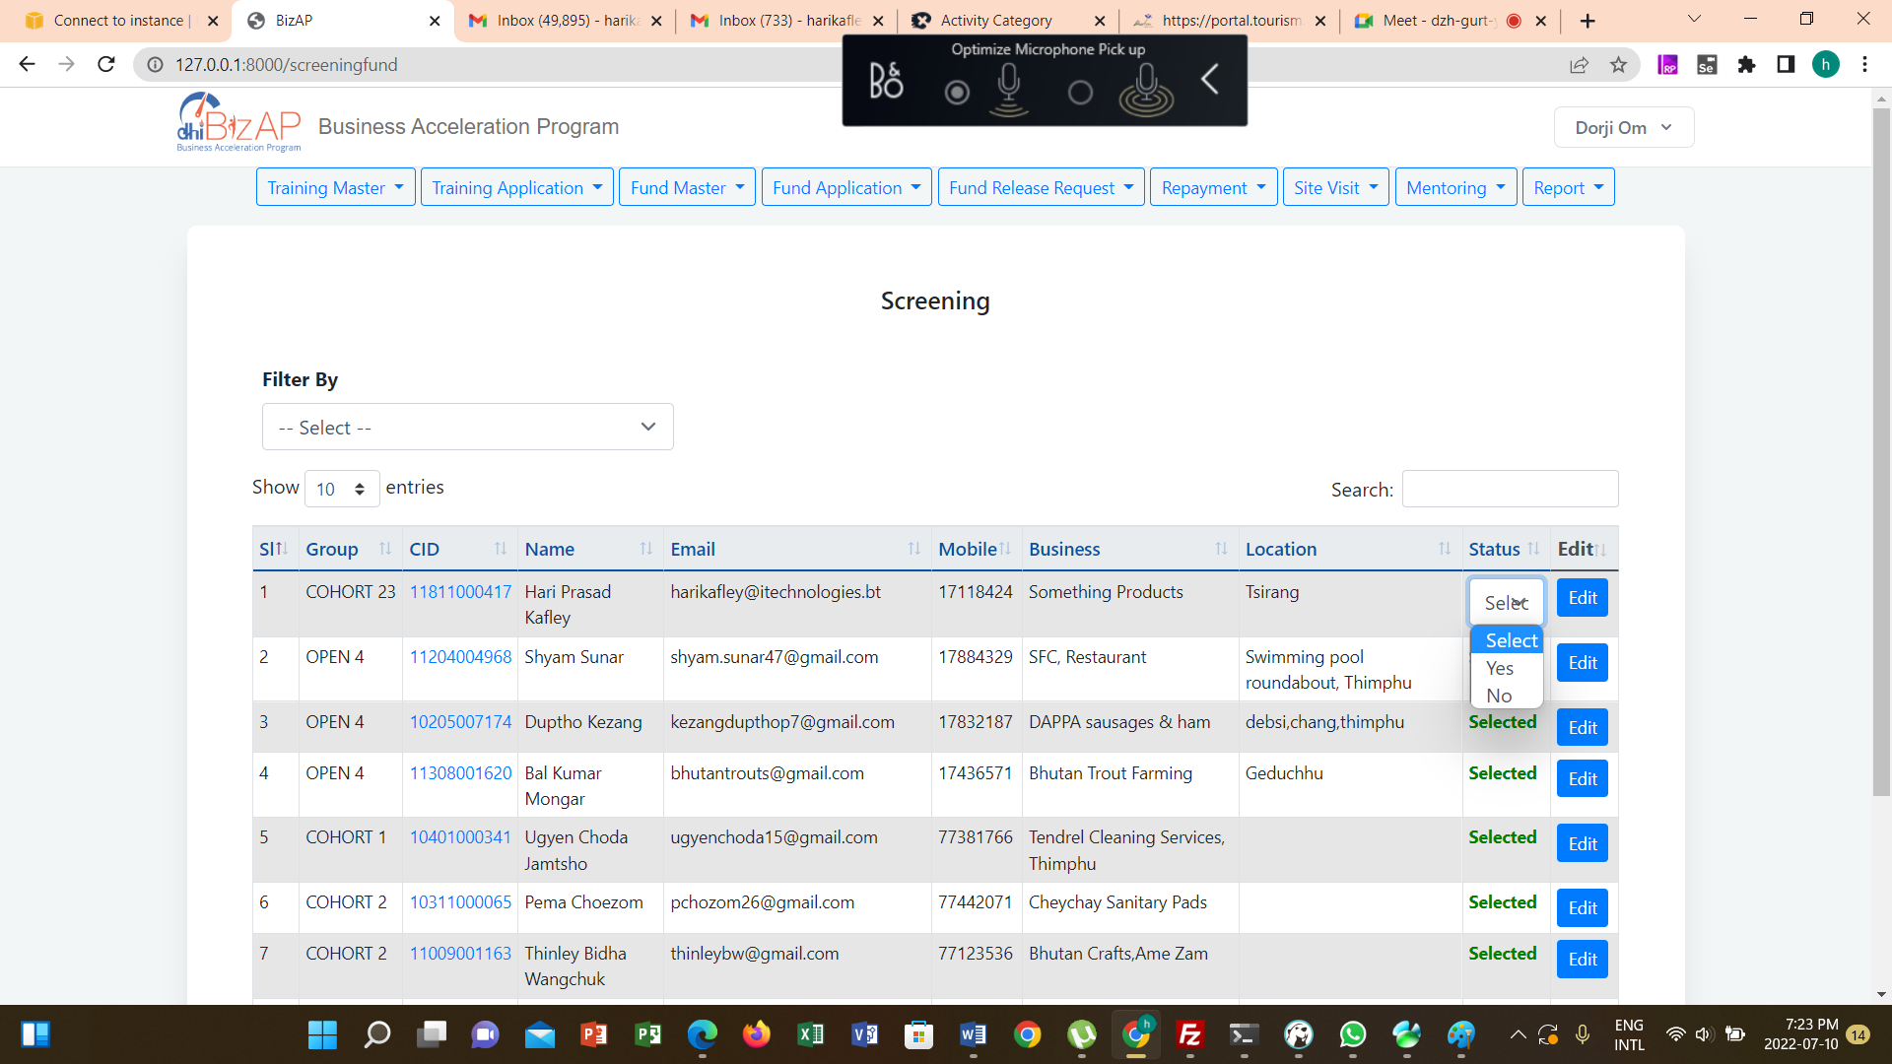

## Shortlisting

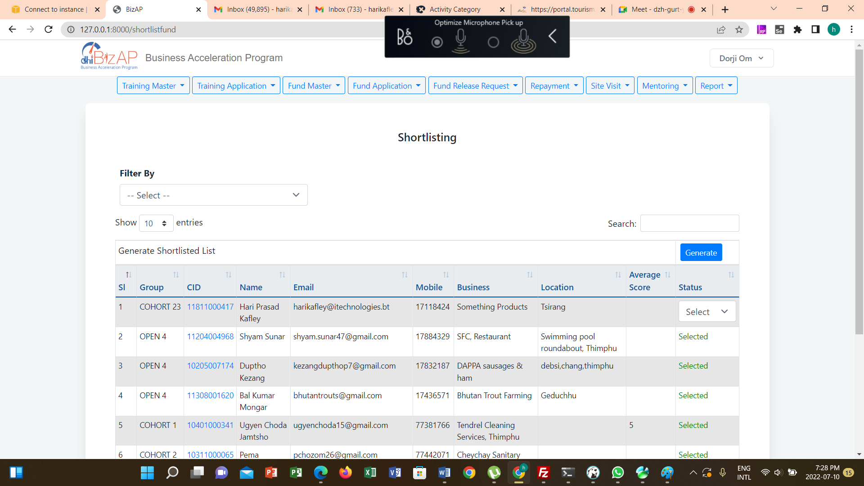

Update Shortlisting Scores

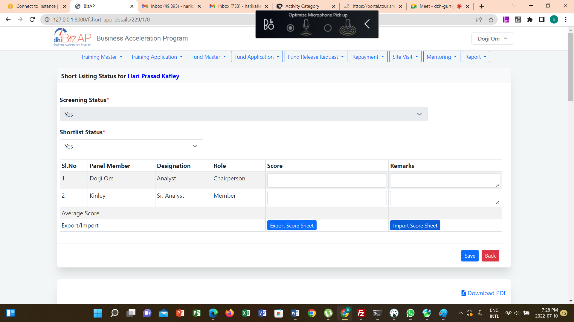

Updated Shortlisting Status

Generate Shortlisting Notification

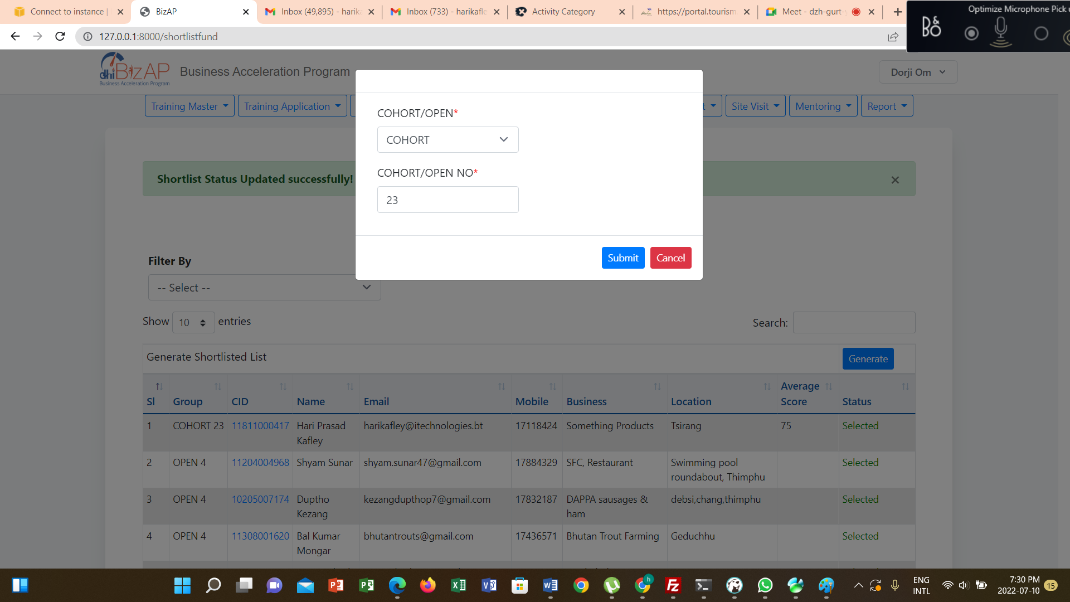

Notification

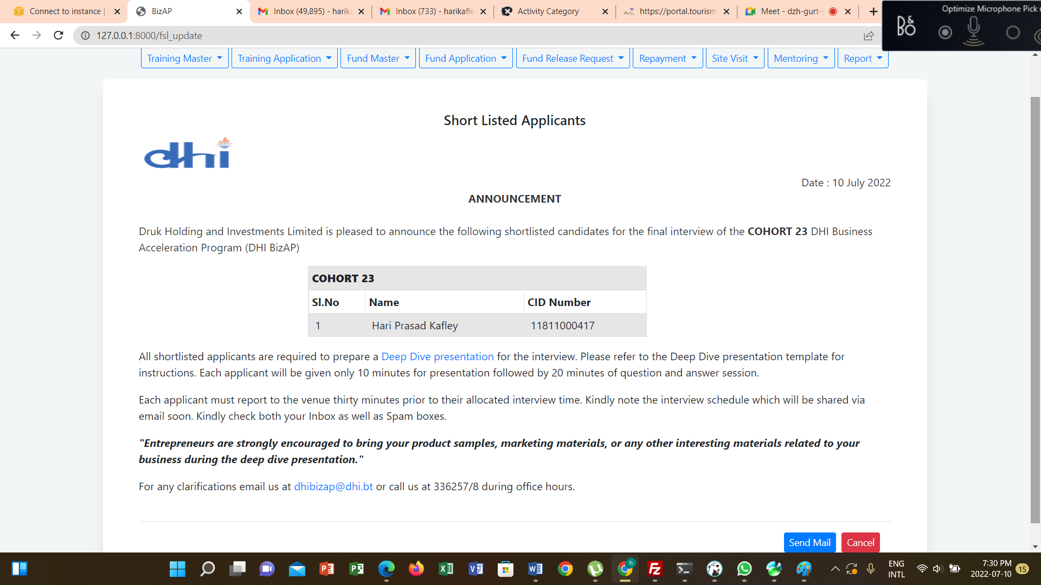

## Presentation

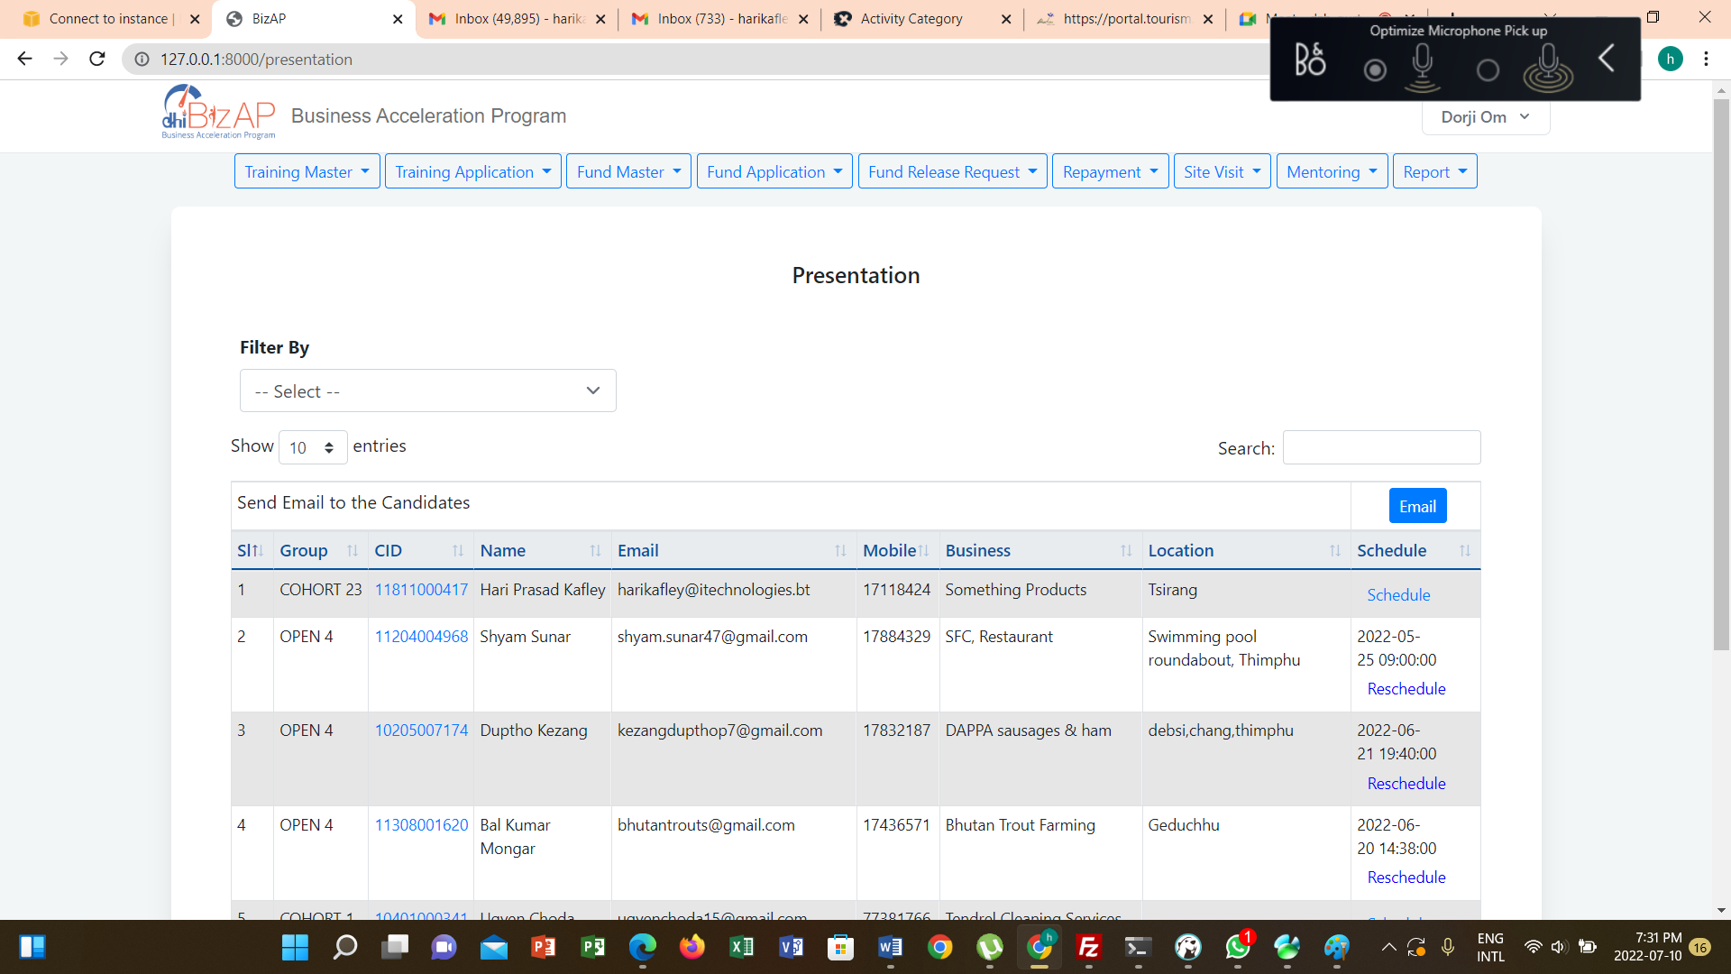

Schedule Presentation

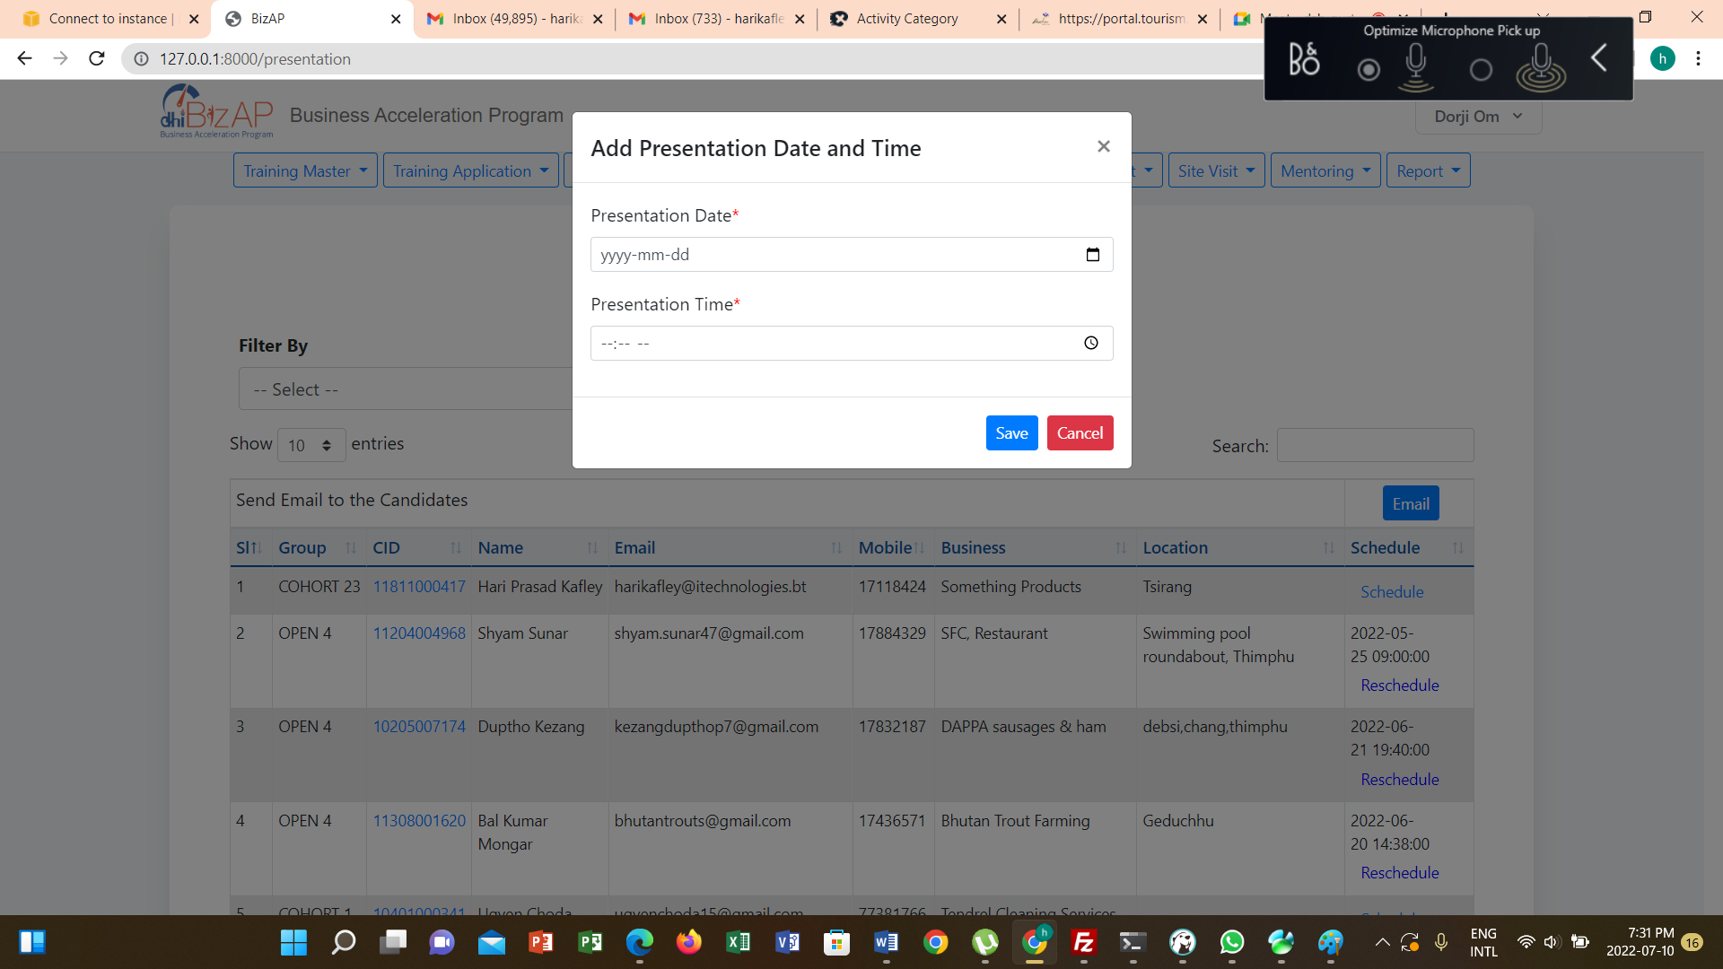

Reschedule Presentation

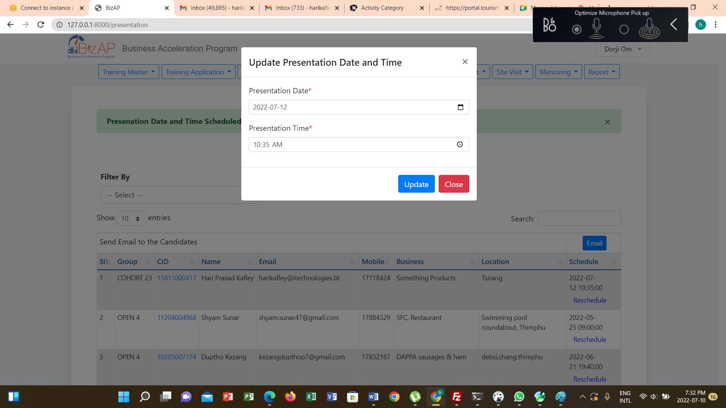

Email Candidates

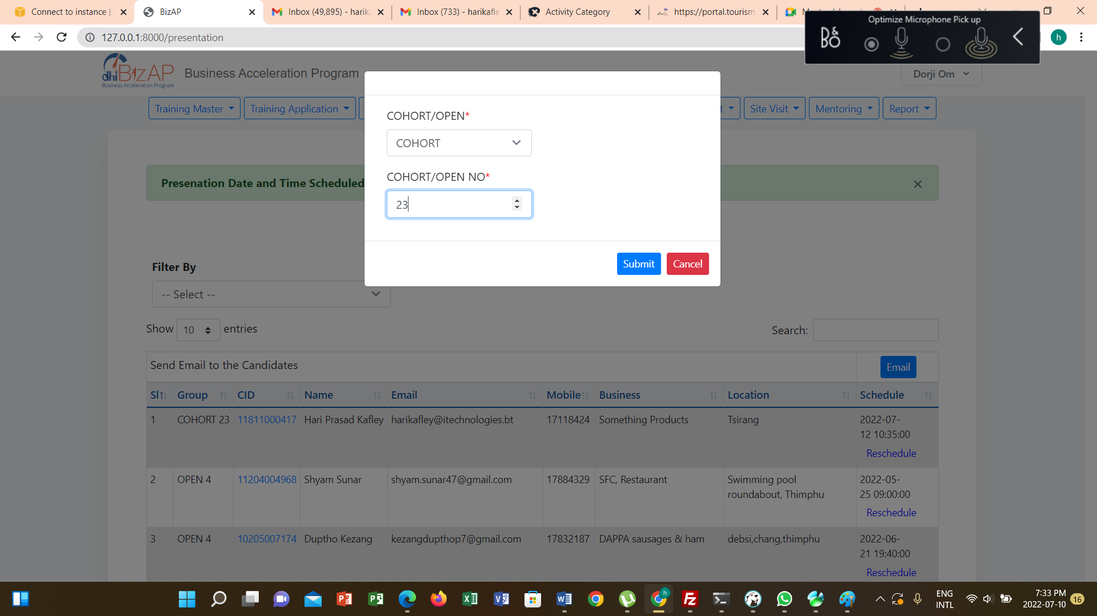

Update Presentation Scores

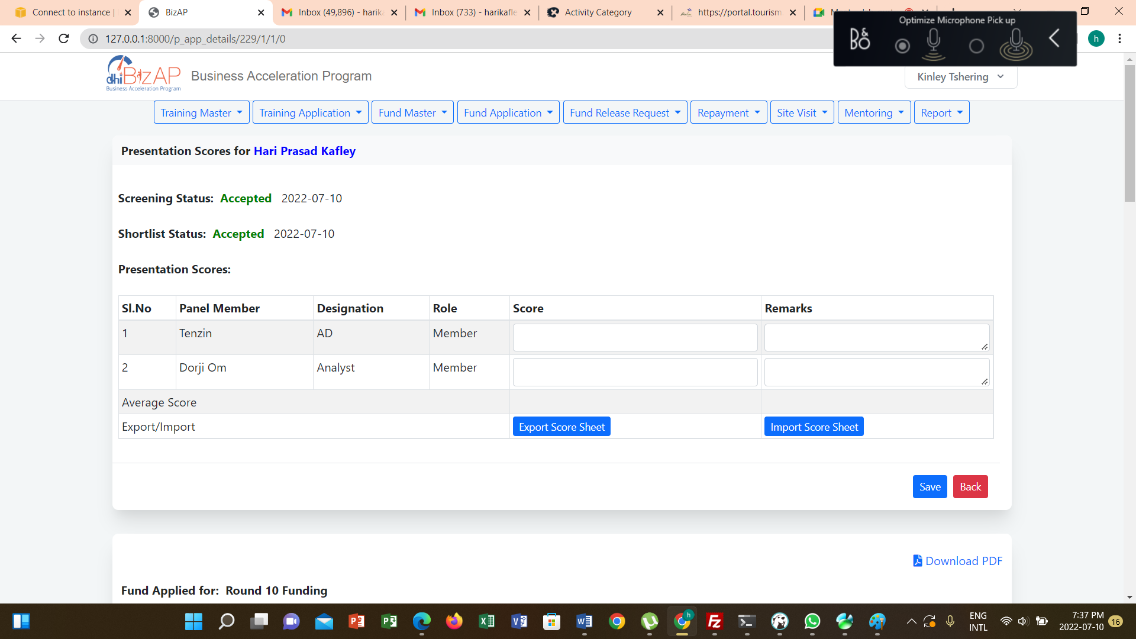

Presentation Results

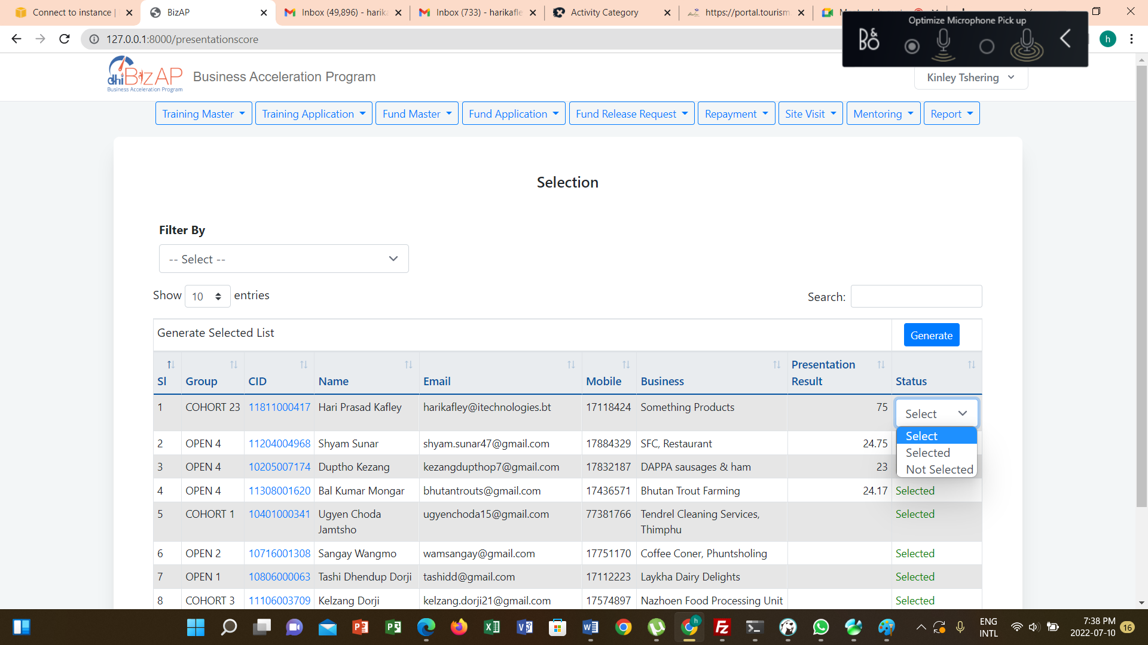

Notification

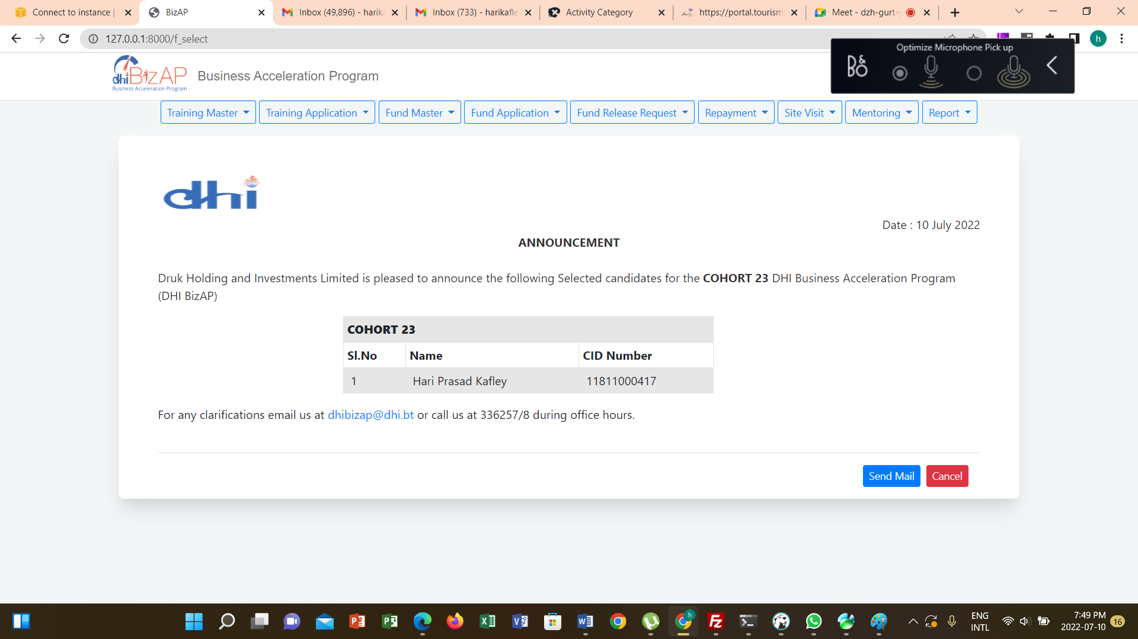

## Contract Signing Schedule

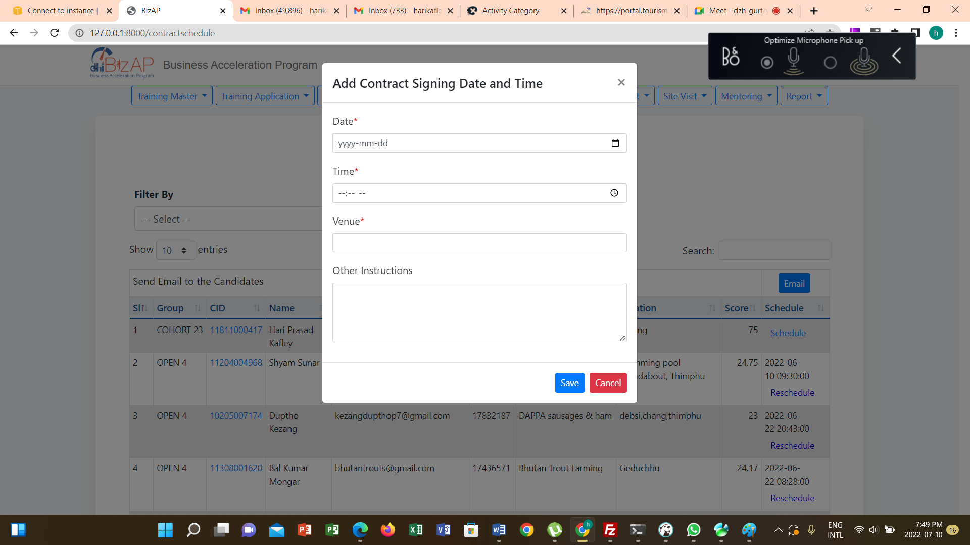

Contract Signing Communication

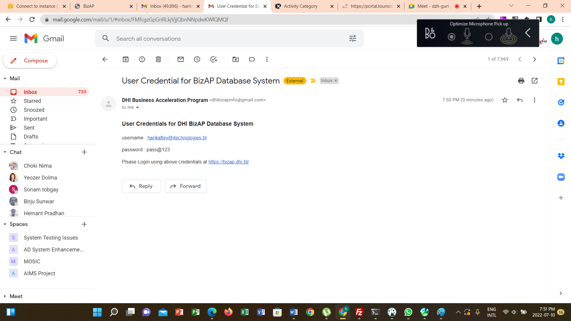

Contract Signing

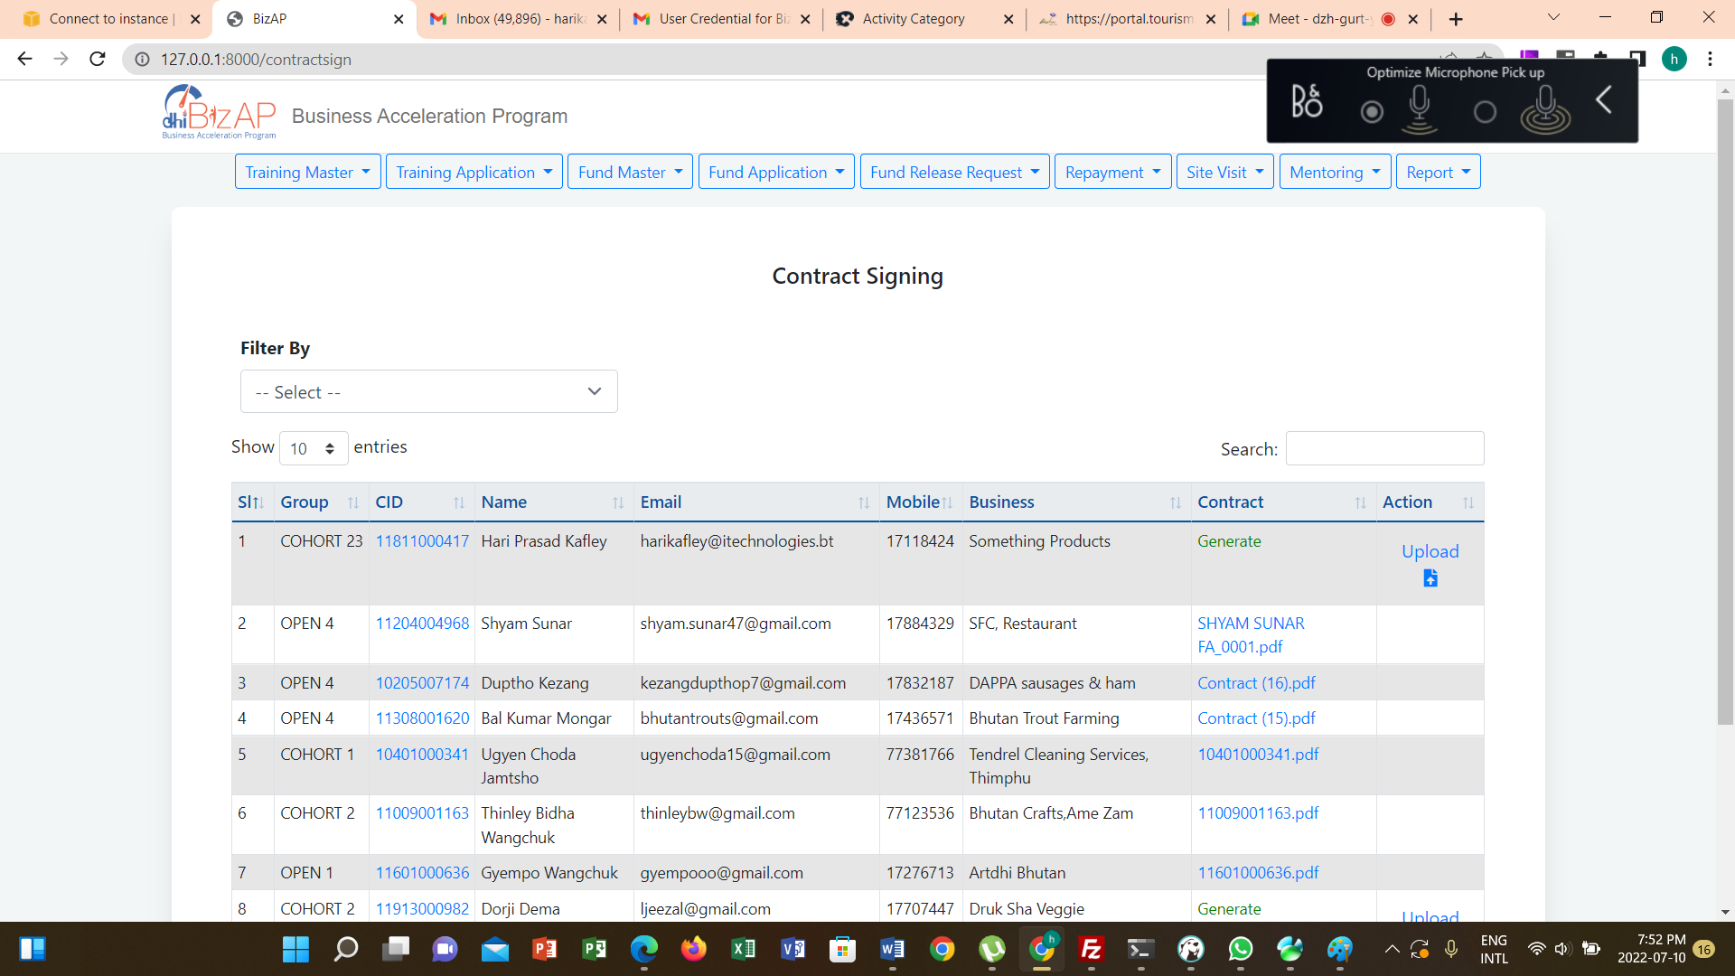

Generate Contract

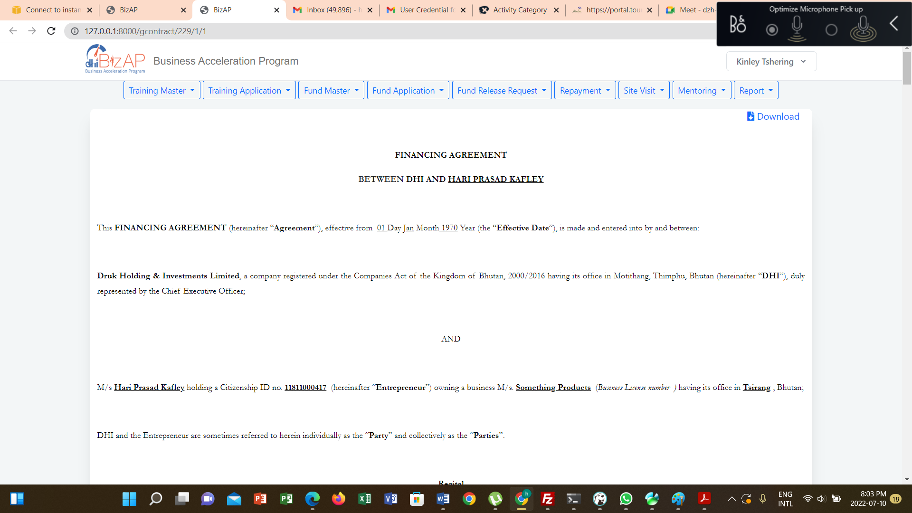

Download Contract

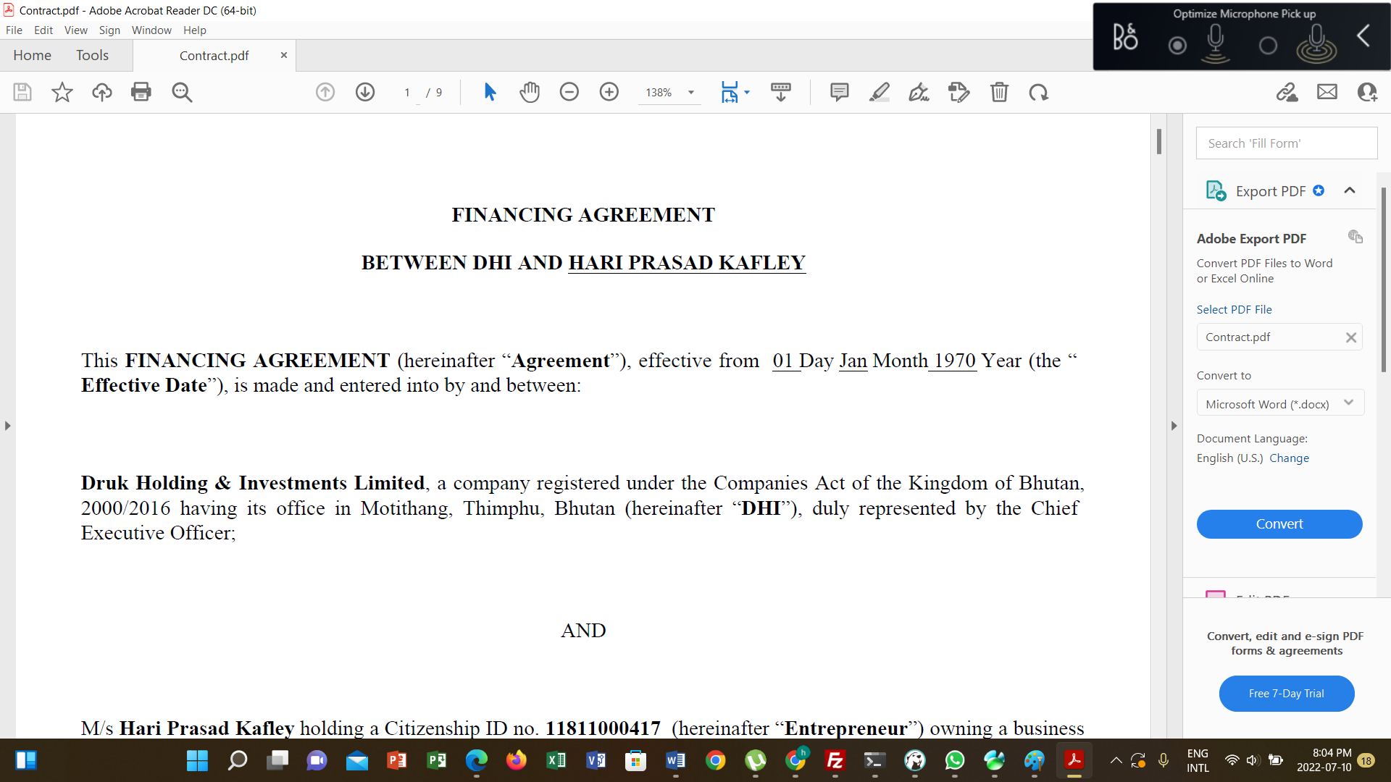

Upload Contract

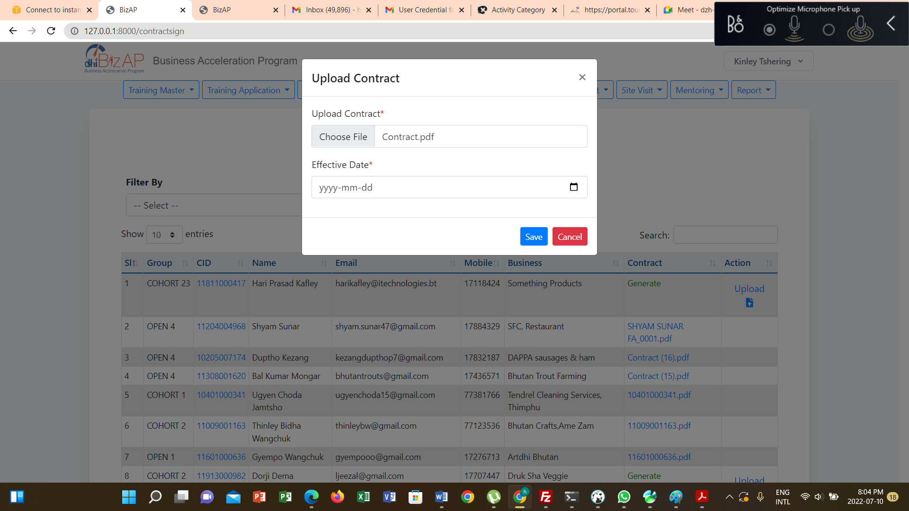

# First Time Login By Entrepreneur

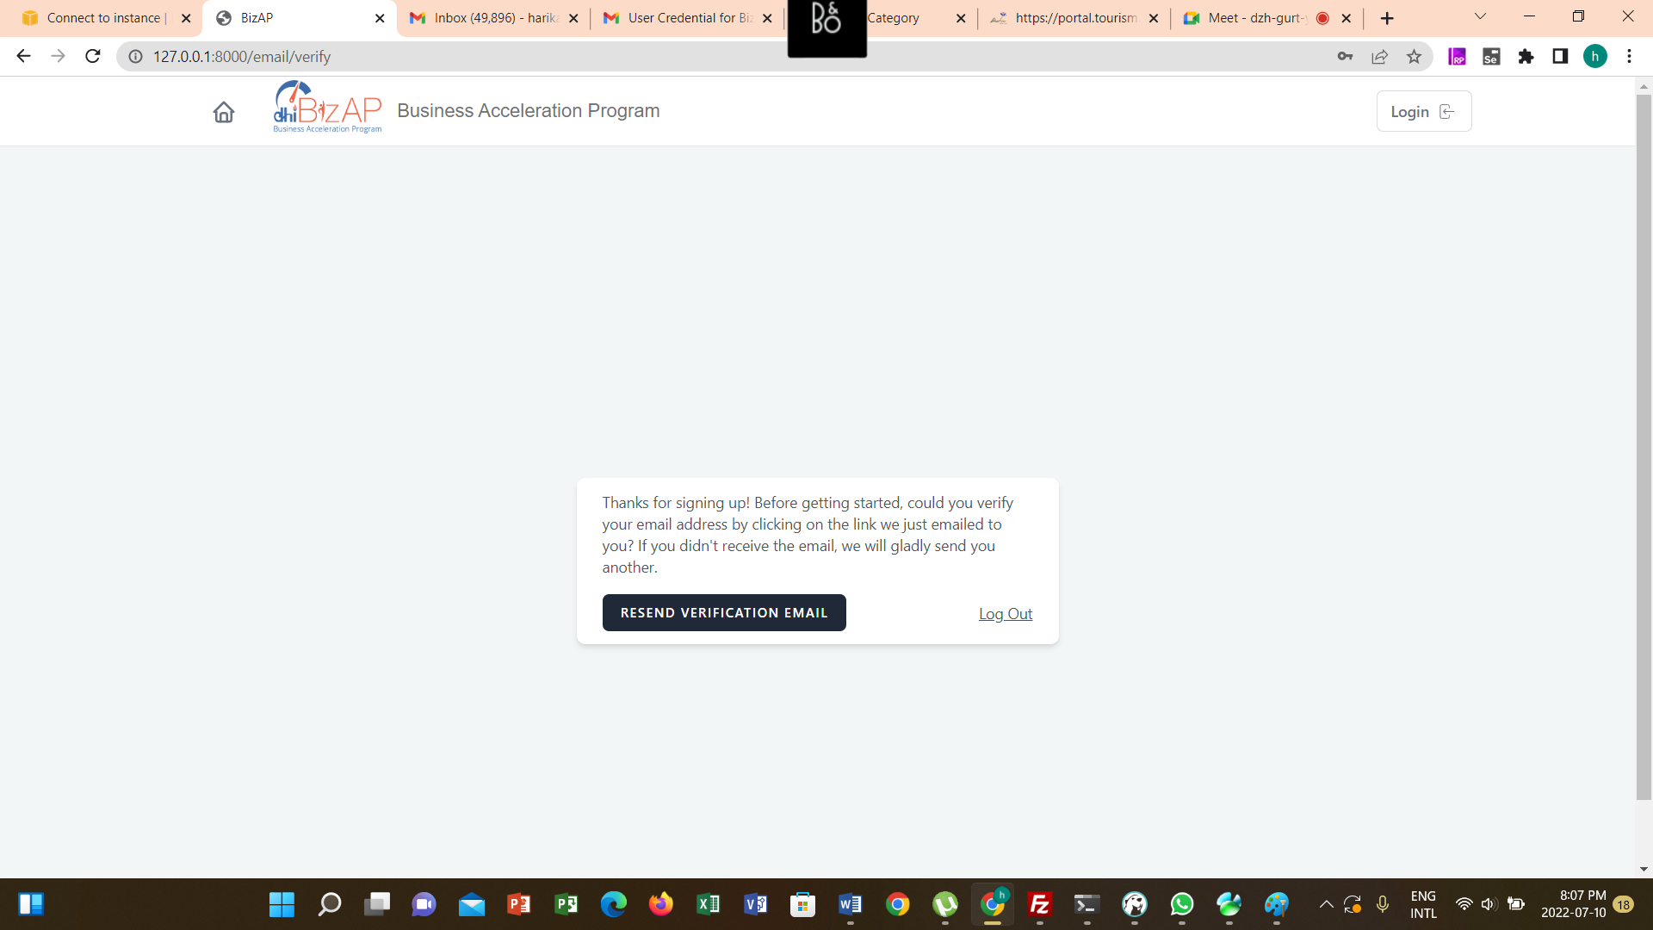

Email Verification

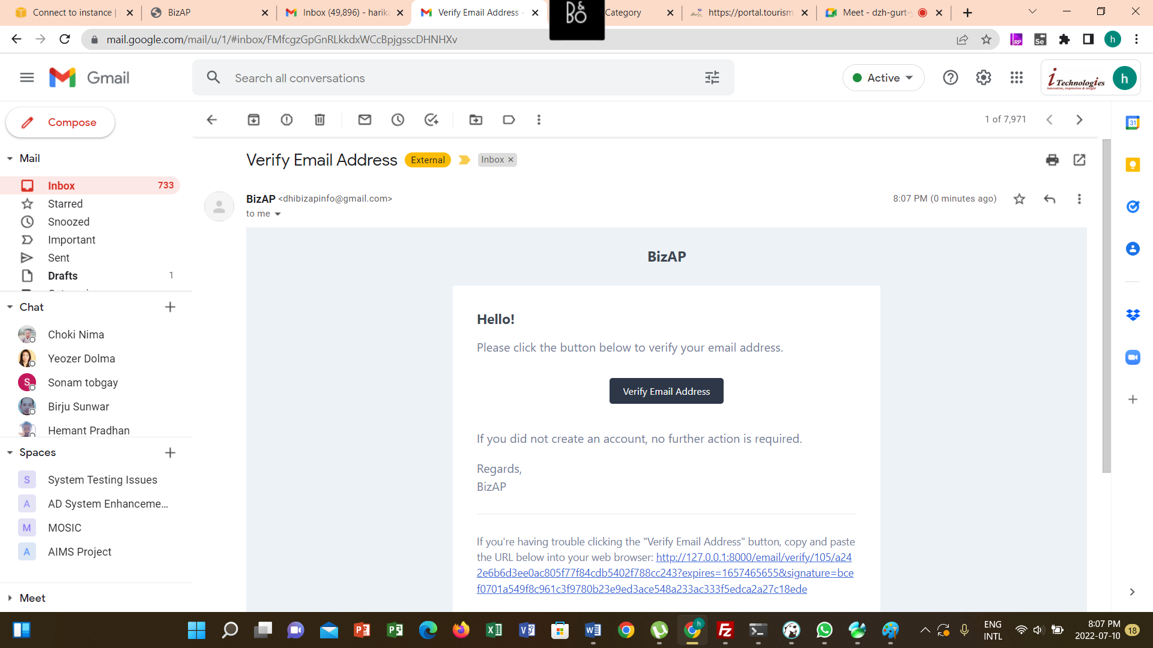

Dashboard

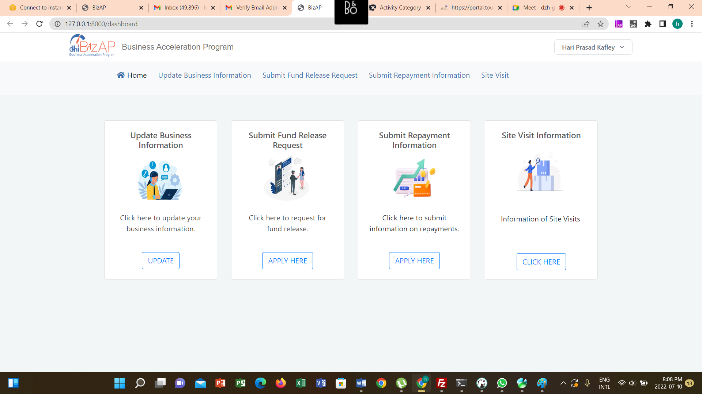

# Update Business Information

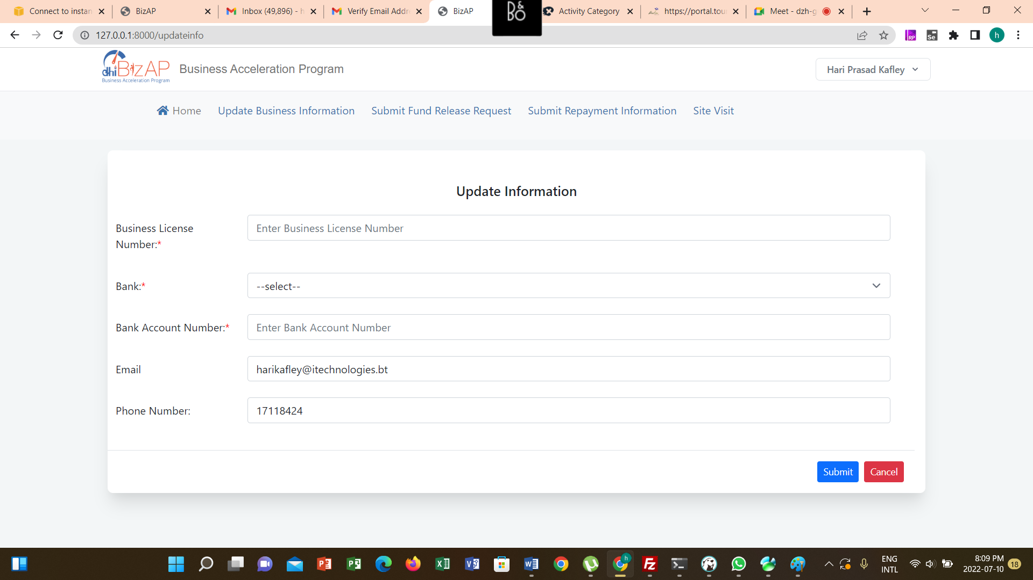

# Submit Fund Release Request

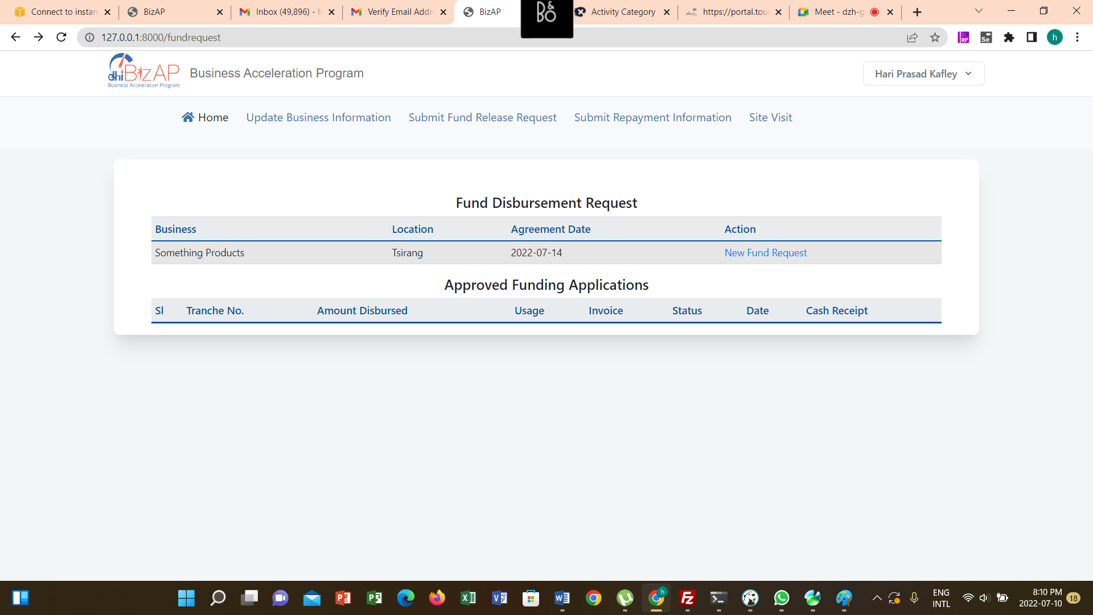

New Fund Request

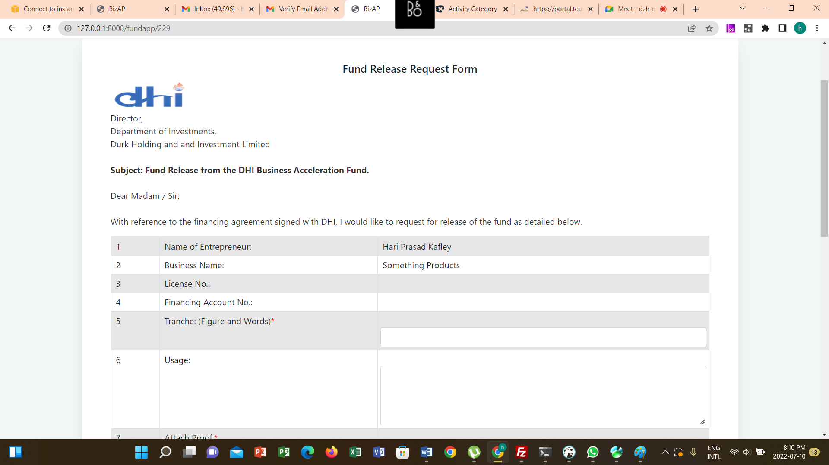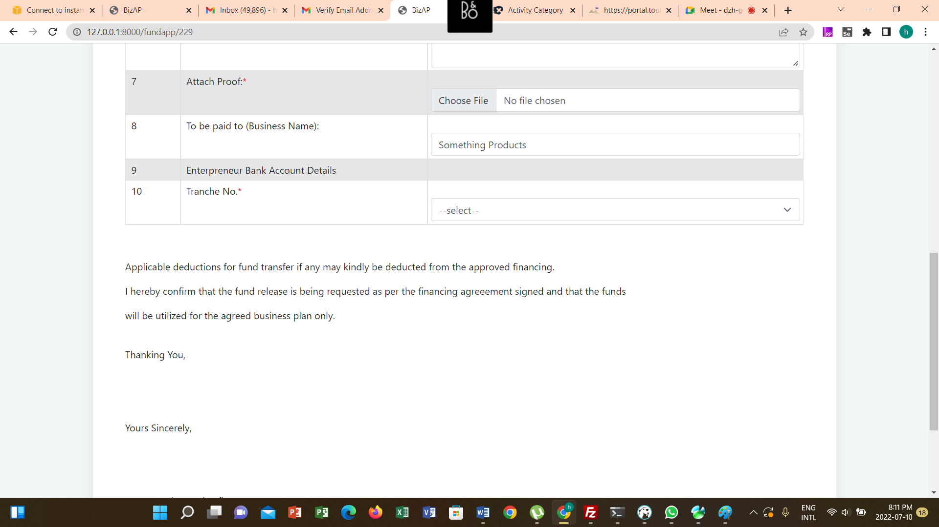

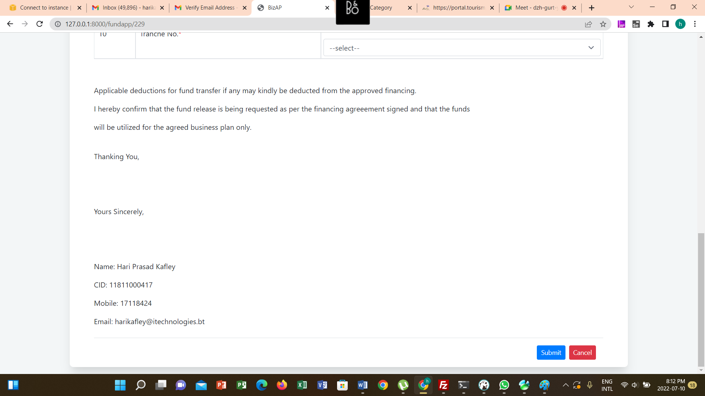

Once the fund application is submitted.

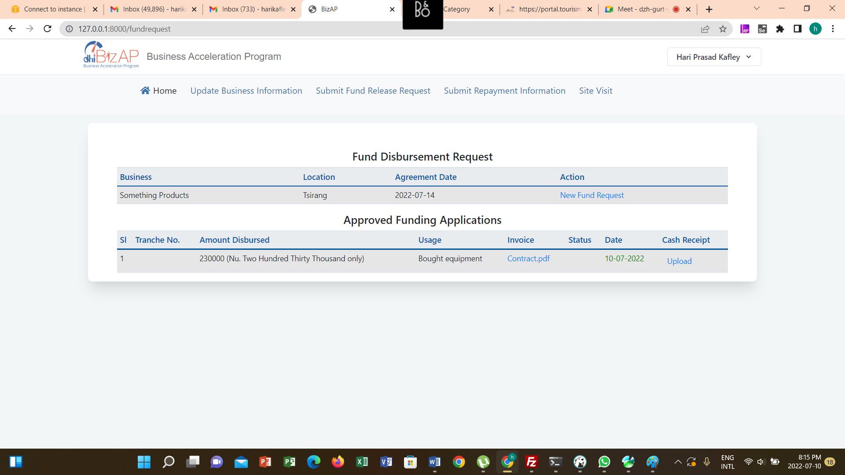

# Review Fund Release Application

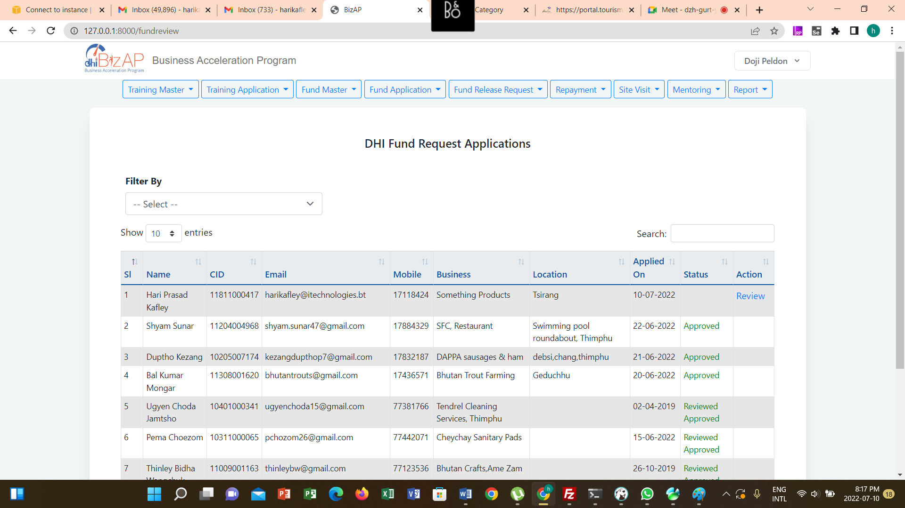

Update Details

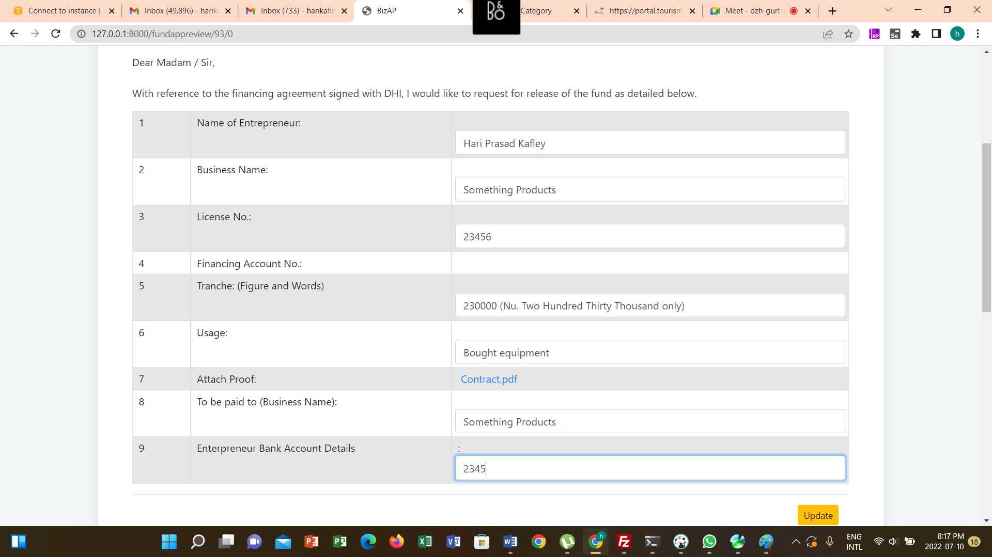

Review Status Update

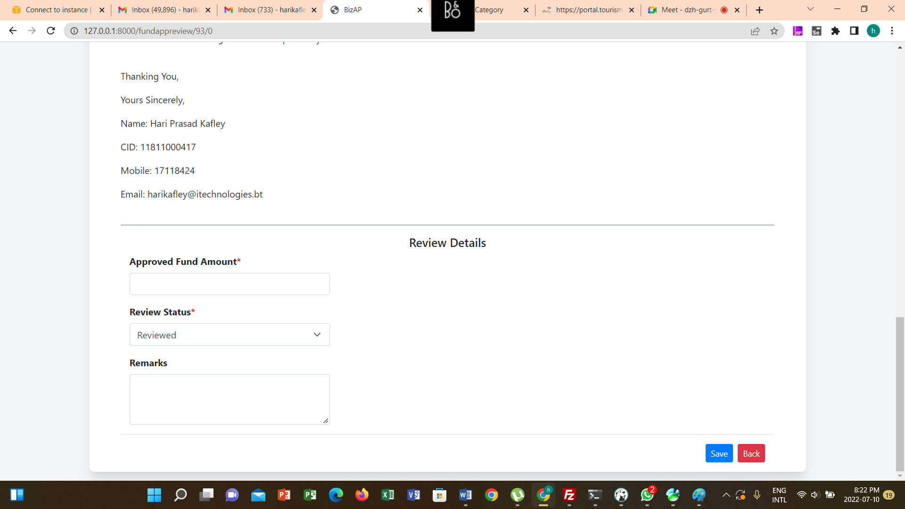

# Fund Release Application Review by Associate Director

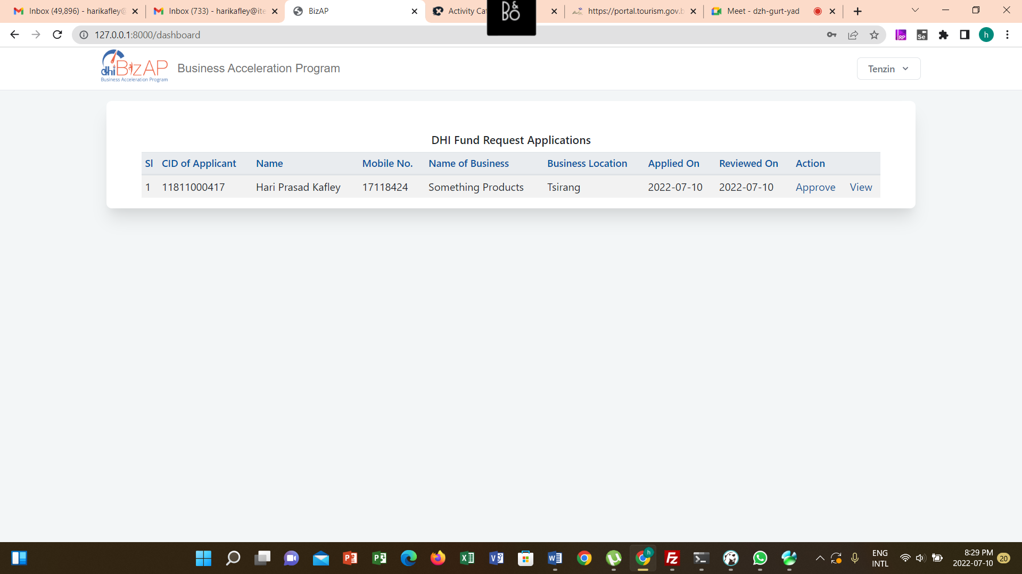

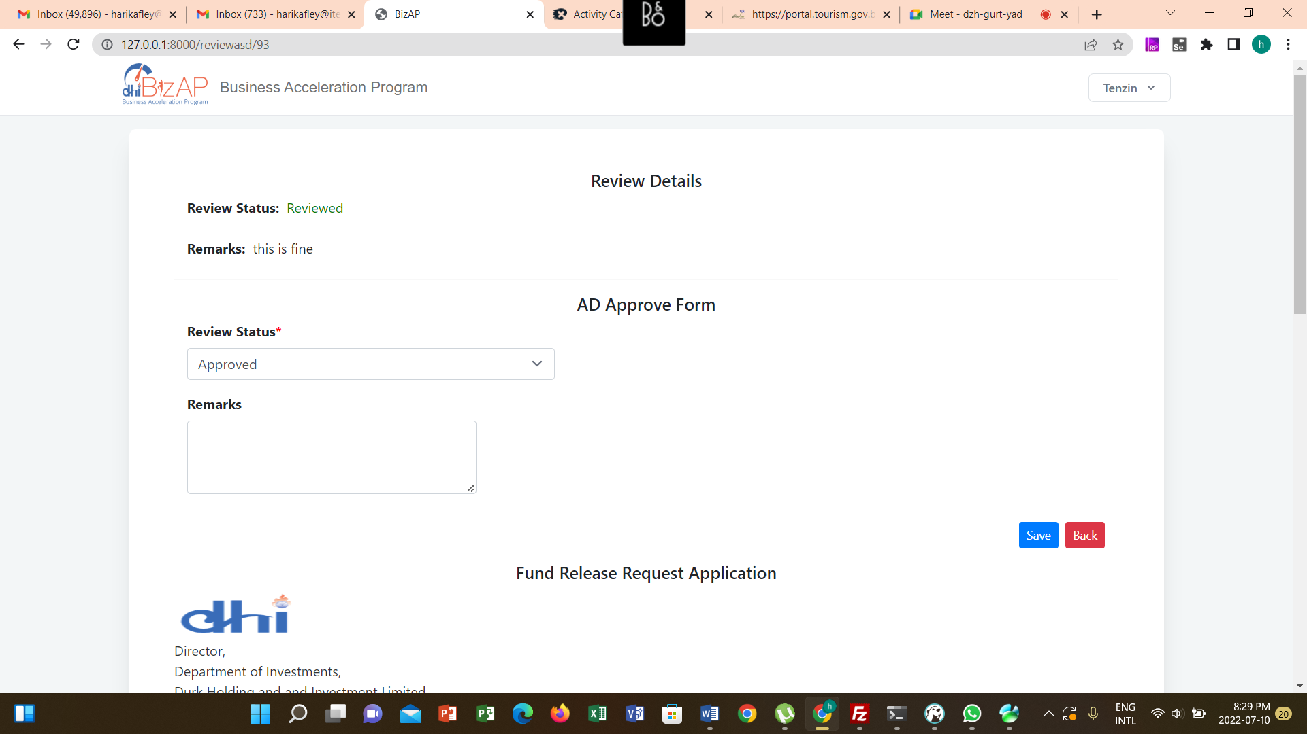

# Approve Fund Request by Accounts Head

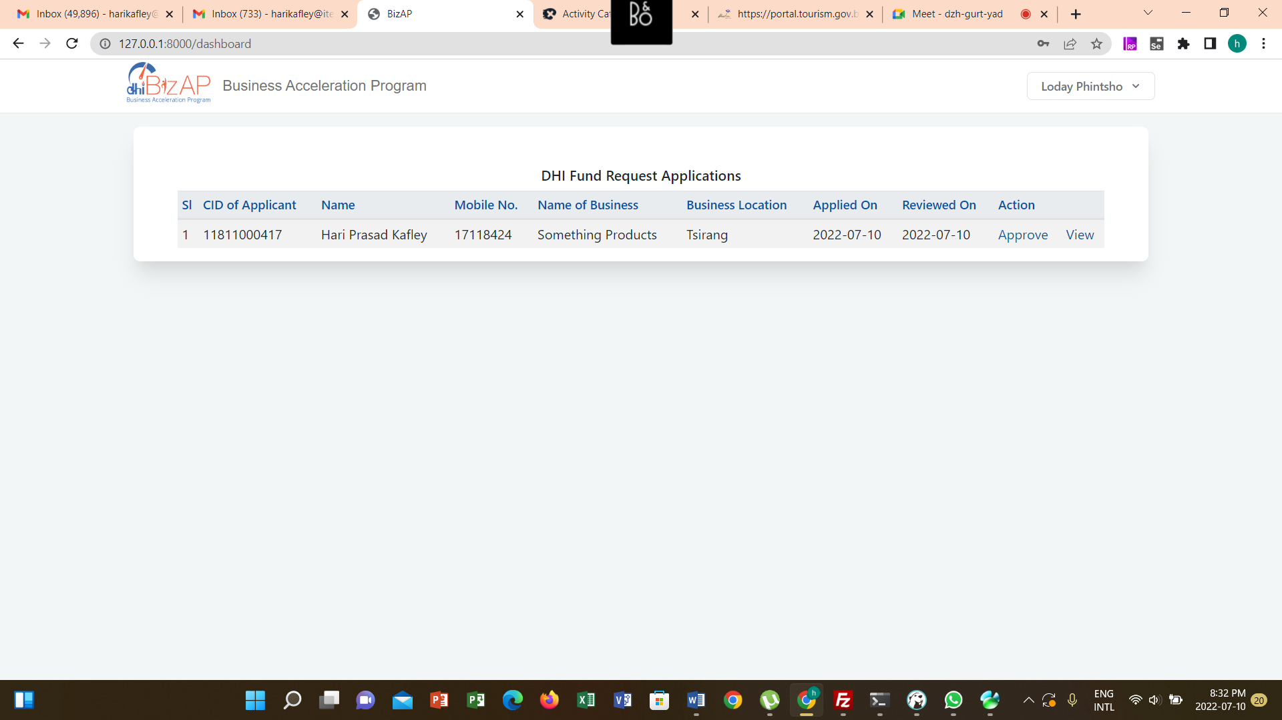

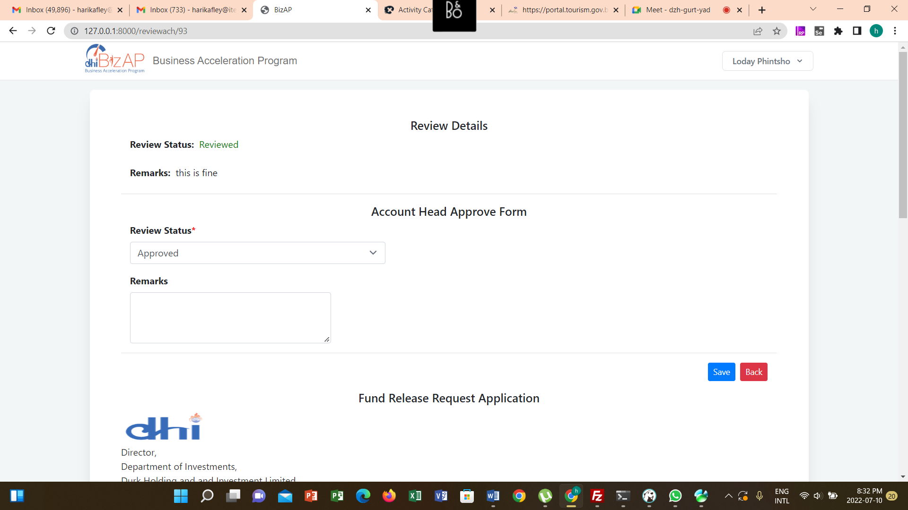

# Disbursement Order

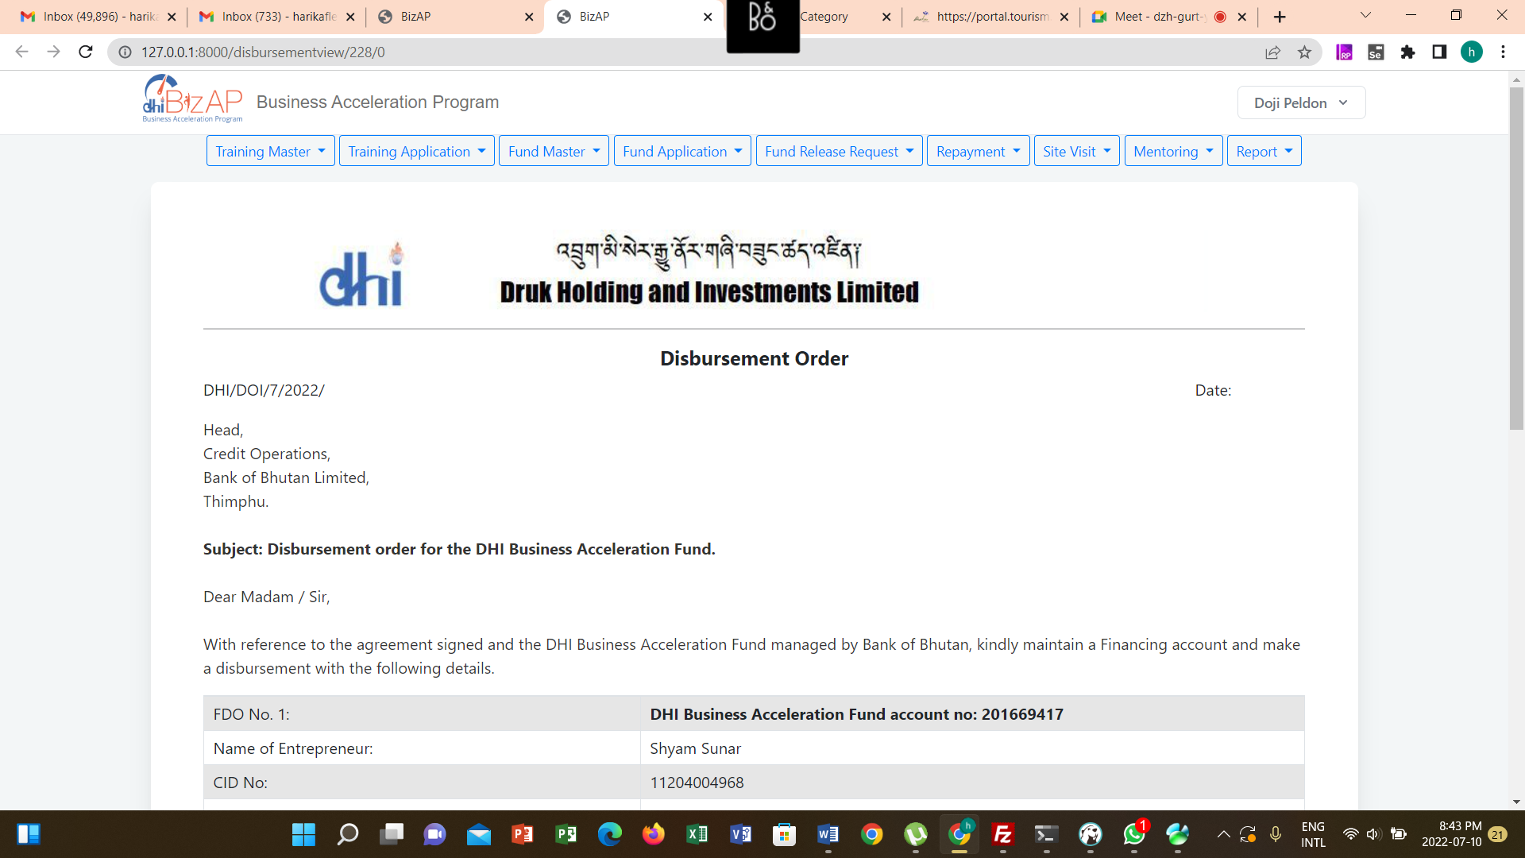

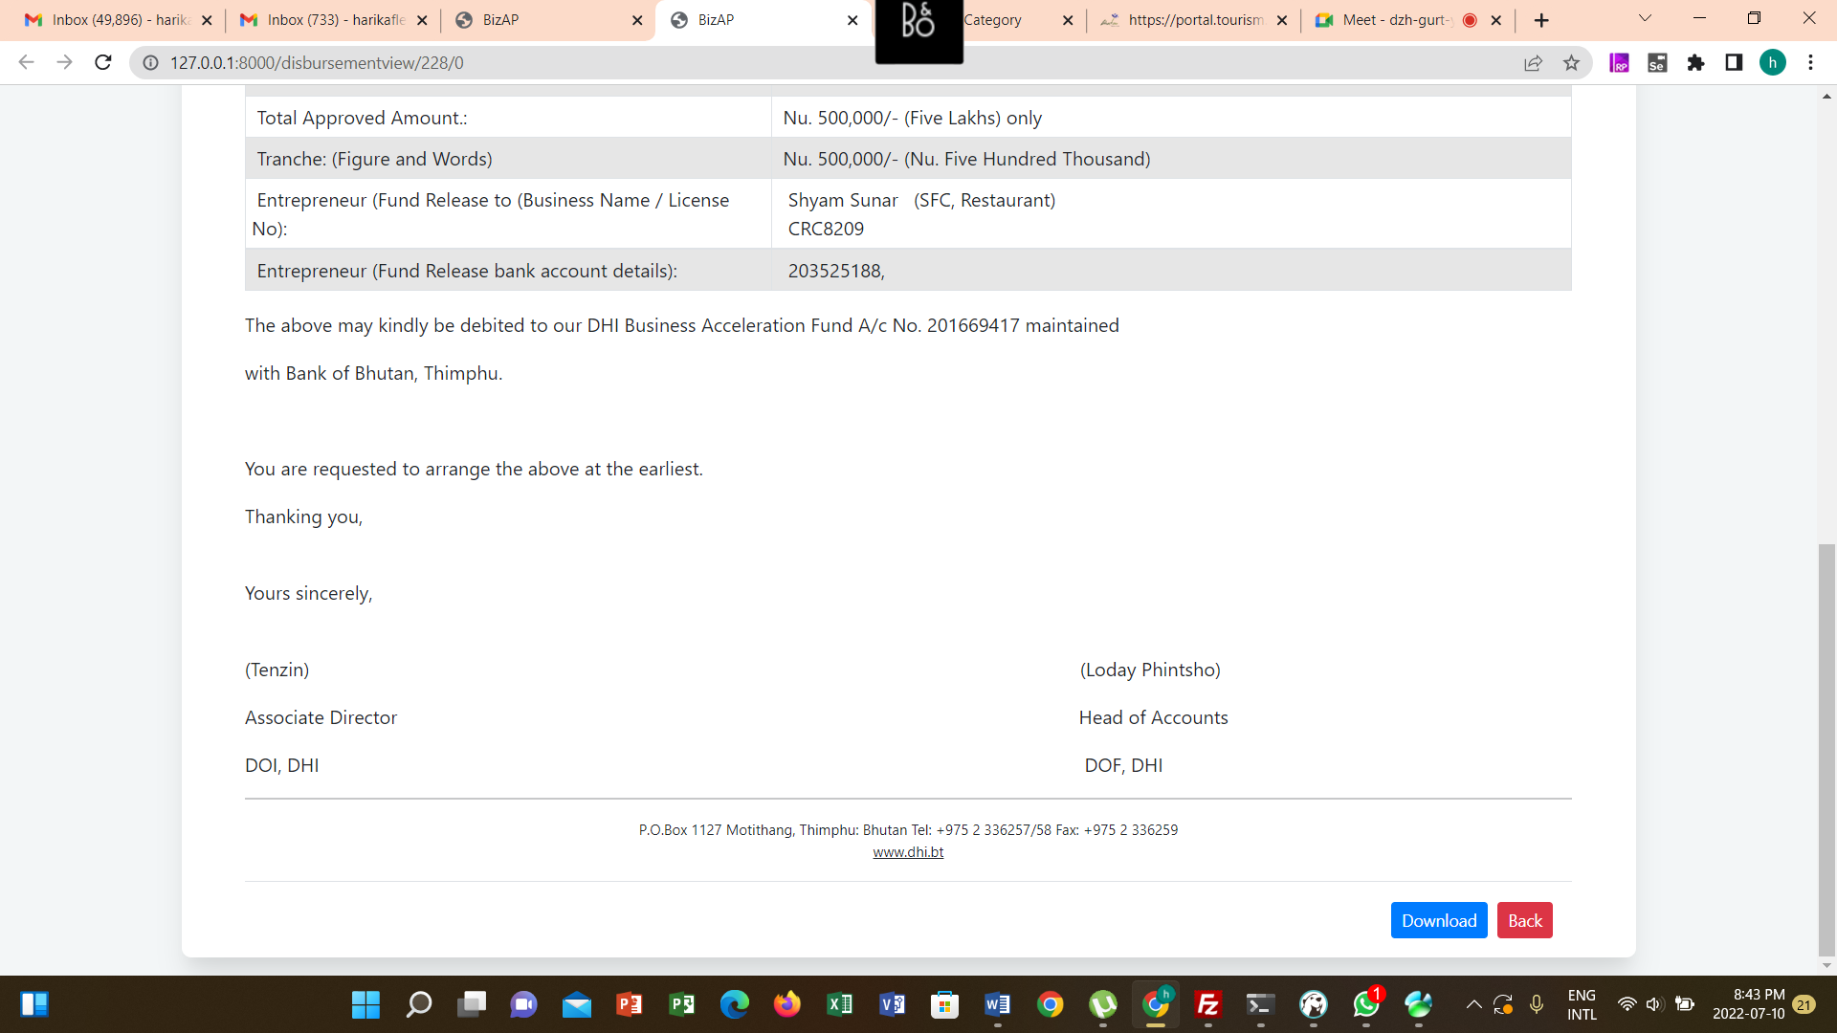

# Repayment Update

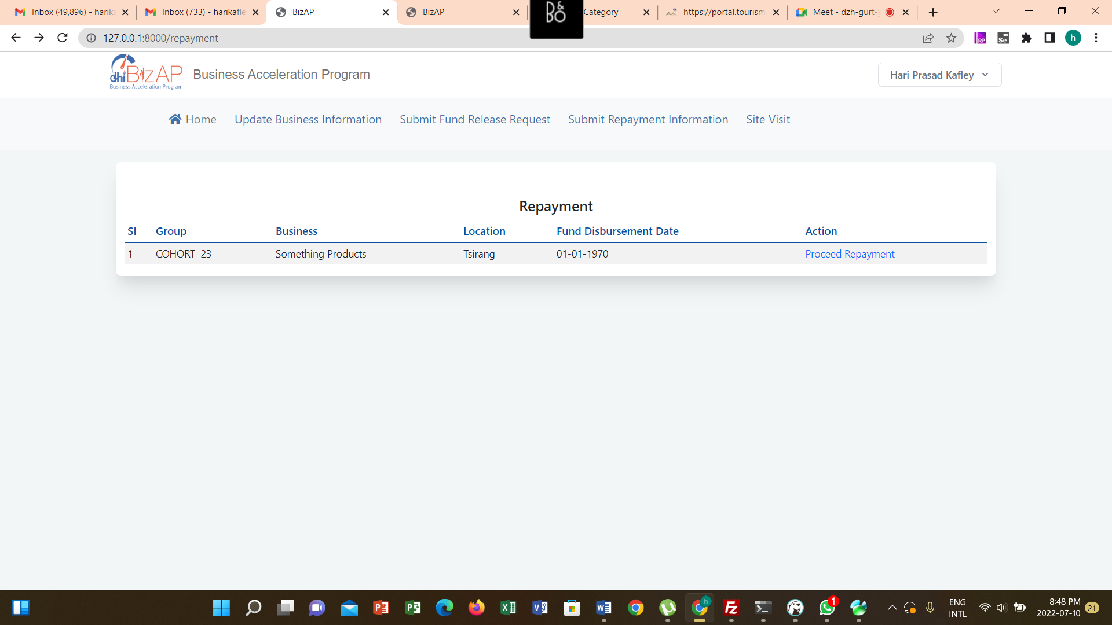

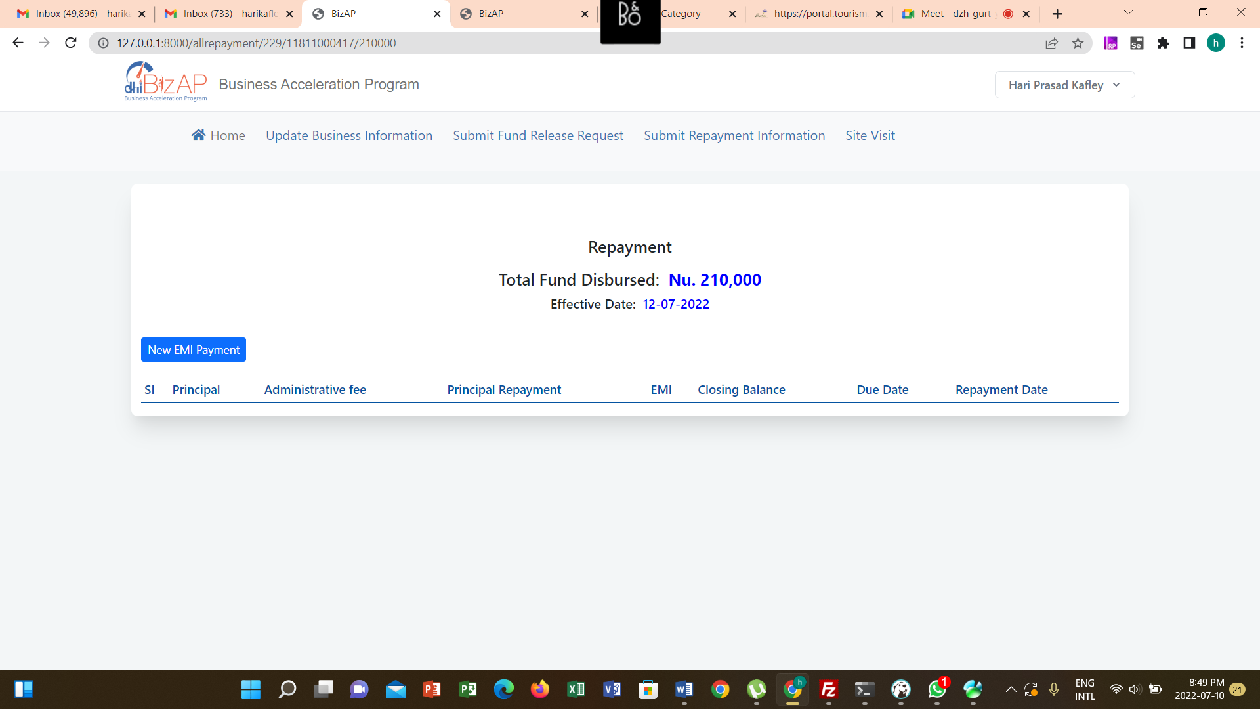

New EMI Details

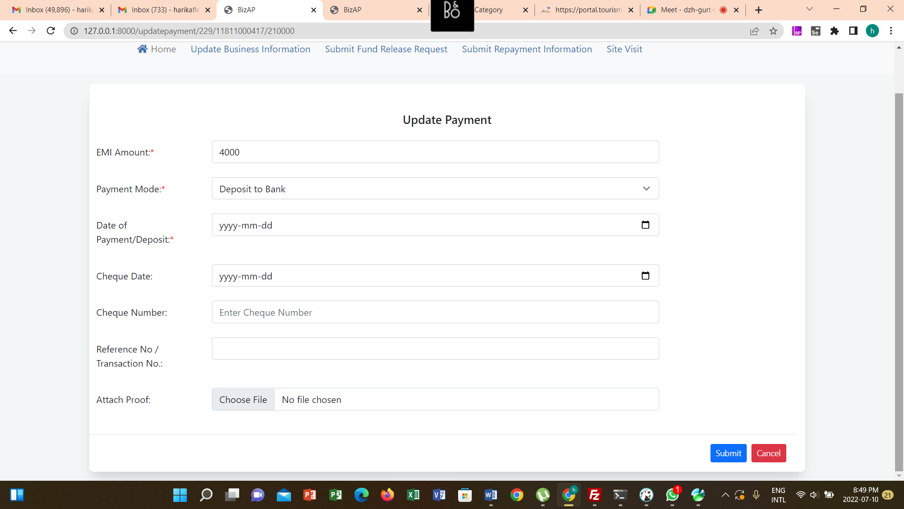

# Repayment Review

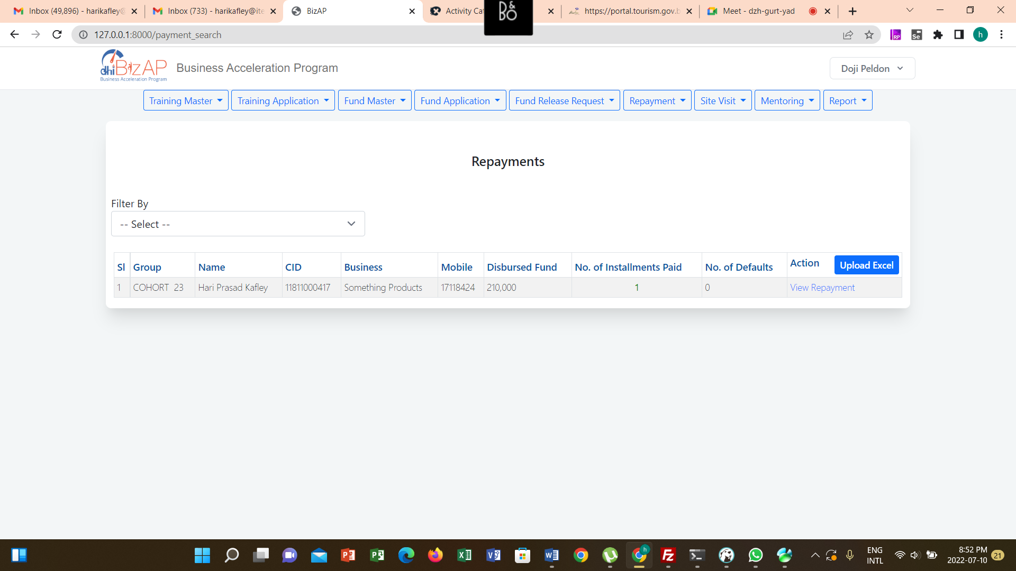

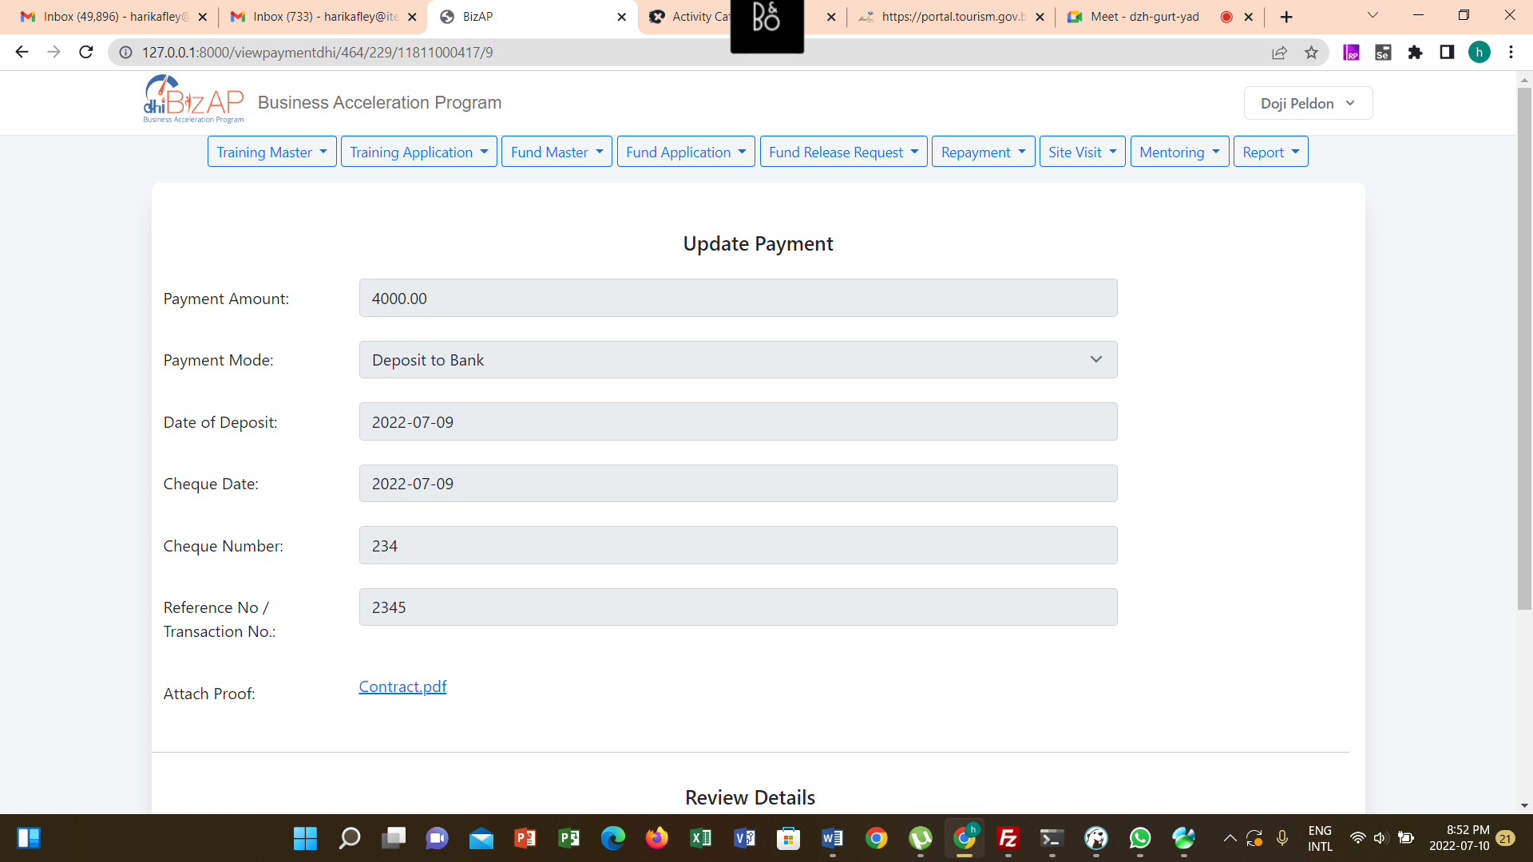

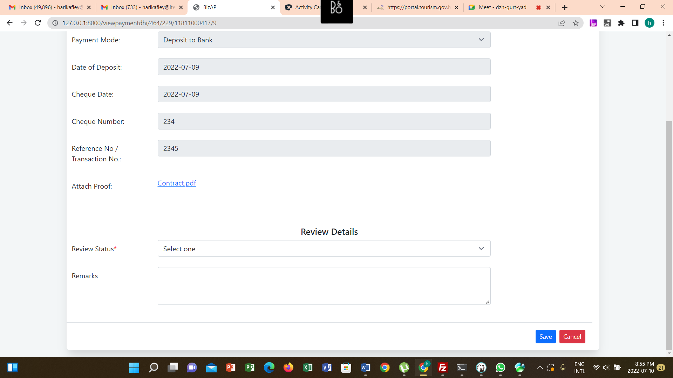

# Site Visit

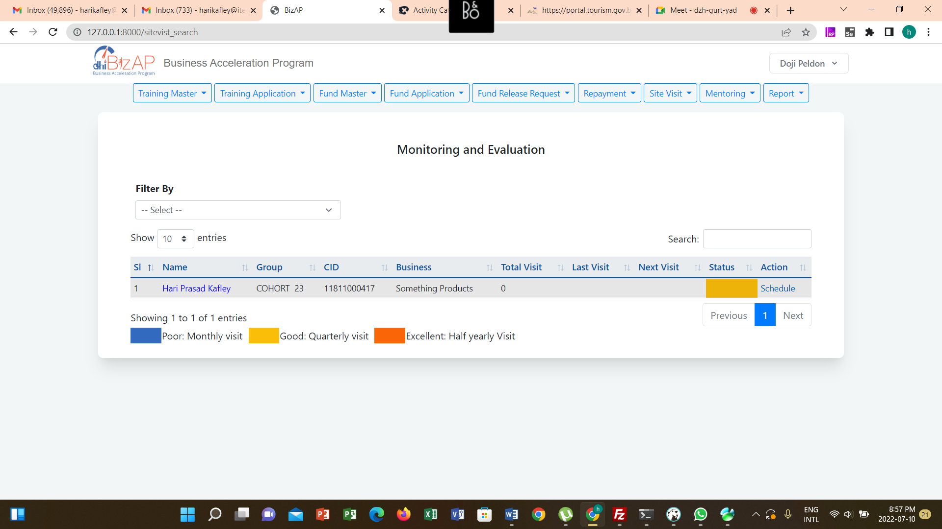

Schedule

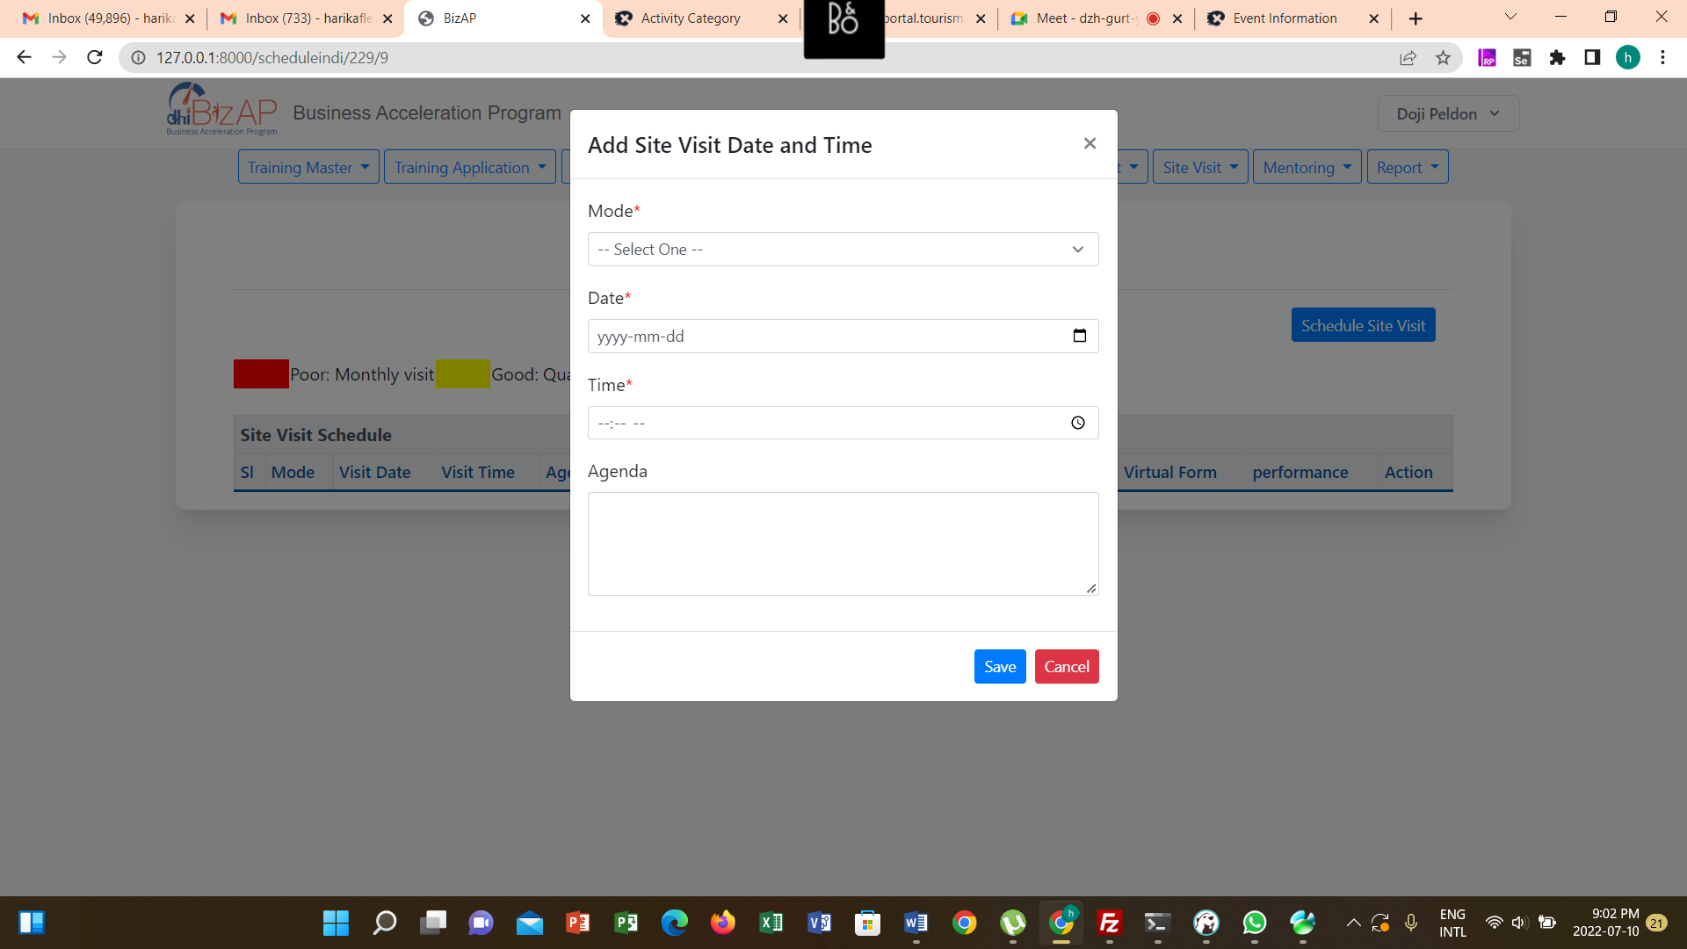

Schedule Information in Email

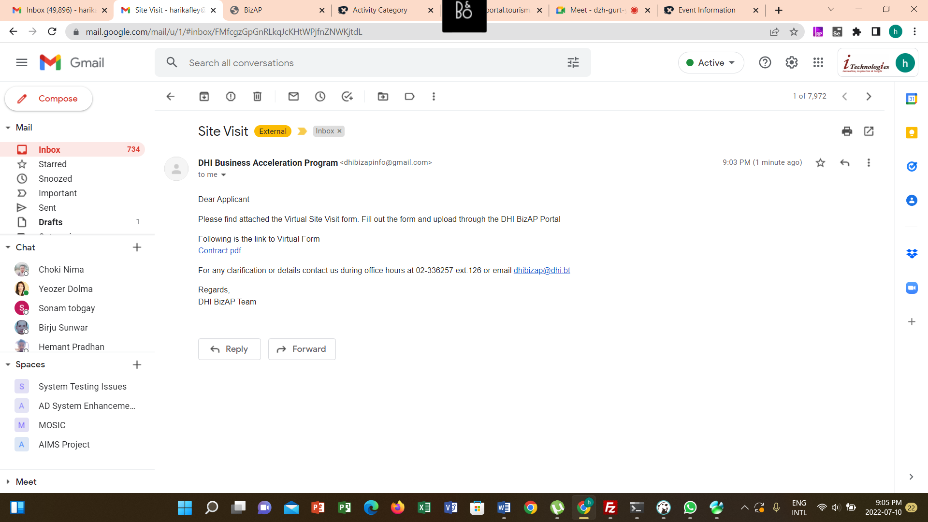

Update Site Visit Information

